[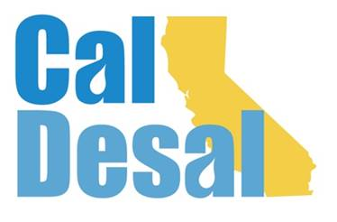](http://www.caldesal.org/)

**CalDesal State Legislative Committee Meeting**

**Monday, September 21, 2020**

**2:30-4:00 p.m.**

**conference call phone: (515) 604-9094, code: 1175-56965**

**Agenda**

* Chair E.J. Caldwell, West Basin Municipal Water District

**State Legislative Activity:**

* End of Session Discussion:
* The Legislature and the pandemic in 2021
* General Obligation Economic Stimulus Bond in 2021?
* Green and Blue (Water) Bond in 2021?

**Federal Legislative Activity:**

* H.R. 2 Moving Forward Act (DeFazio) Transportation and Infrastructure will become vehicle for desalination funding

**CalDesal Updates**

* Virtual Townhall on Friday, October 16 from 3:00 p.m.-4:30 p.m.
* Strategic Plan 2021-22
* Annual Conference -- February 2021
* New website content

Next State Legislative Committee Meeting: **December 21, 2020 from 3:00-4:00 p.m.**

**Adjourn**