[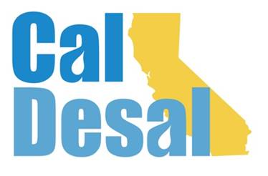](http://www.caldesal.org/)

**CalDesal State Legislative Committee Meeting**

**Monday, August 17, 2020**

**3:00-4:00 p.m.**

**conference call phone: (515) 604-9094, code: 1175-56965**

**Agenda**

* Chair E.J. Caldwell, West Basin Municipal Water District

**State Legislative Activity:**

* General Obligation Economic Stimulus Bond Status
* L.A. Waterkeeper v. State Water Resources Control Board court ruling – return of Senator Hertzberg ocean discharge legislation? (attached)

**Federal Legislative Activity:**

* Congressman Levin (D-San Juan Capistrano) Desalination Development Act (draft support letter attached)

**CalDesal Updates**

* Virtual Townhall on Friday, October 16 at 3:00 p.m. Governor’s Water Resilience Portfolio Director Nancy Vogel, desal bingo! No charge for members and associates
* New Members
* Website

Next State Legislative Committee Meeting: **Monday, September 21, 2020**

**Adjourn**