[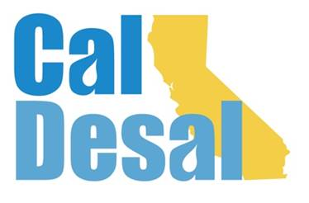](http://www.caldesal.org/)

**CalDesal State Legislative Committee Meeting Notes**

**Monday, August 17, 2020**

**Conference Call Meeting**

**3:00-4:00 p.m.**

**Members present:**

E.J. Caldwell, Chair, West Basin Municipal Water District

Heather Baez, Municipal Water District of Orange County

Danielle Coats, Eastern Municipal Water District

Christine Compton, Irvine Ranch Water District

Glenn Farrell, San Diego County Water Authority

Michael Hadley, Western Municipal Water District

Greg Morrison, Elsinore Valley Municipal Water District

Cory Temple, Eastern Municipal Water District

Rosalie Thompson, Metropolitan Water District of Southern California

**Guests:** Wendy Ridderbusch, Executive Director

The meeting began at 3:02 p.m. Chair E.J. Caldwell called the meeting to order.

**State Legislative Activity:**

* **General Obligation Economic Stimulus Bond Status** – Last communication from sponsors was in July. Last two weeks of session and everyone is waiting to see what may happen and if it will move forward. There is still no bill number assigned or language attached to a bill. Rosie Thompson was kind enough to share with the committee information that was given to ACWA Monday Morning Lobby Group attendees. Senator Hertzberg may have been working on convening a workgroup to develop language. Christine Compton had been hearing similar things and that the administration was still trying to figure out whether it will come together and what would the language actually look like?
* **L.A. Waterkeeper v. State Water Resources Control Board court ruling** – Wendy attached a copy of a legal ruling. Folks have been surmising that the State Water Board may feel like they have to do something about this. The question is whether Senator Hertzberg would move to revisit his former ocean discharge legislation? EJ Caldwell told the committee that the Southern California Water Dialogue was planning on featuring this court ruling at their upcoming September meeting and they may have Bruce Resnick as a panelist and are trying to get a State Water Board representative to participate as well.

**Federal Legislative Activity:**

* Congressman Levin (D-San Juan Capistrano) Desalination Development Act (draft support letter attached). The committee agreed to send a letter in support of this $250 million funding. Glenn Farrell noted that SDCWA took a support position on the bill. Both EJ and Michael Hadley stated that we should support these vehicles that contain funding for brackish and seawater desalination and salinity management.

**CalDesal Updates**

* Virtual Townhall on Friday, October 16 at 3:00 p.m. Governor’s Water Resilience Portfolio Director Nancy Vogel, desal bingo! No charge for members and associates
* We are continuing to expand our CalDesal family with new members and associates the latest is Las Virgenes Municipal Water District
* Work on overhauling the current CalDesal website continues with unveiling this winter

**The meeting was adjourned by EJ Caldwell at 3:35 p.m.**