[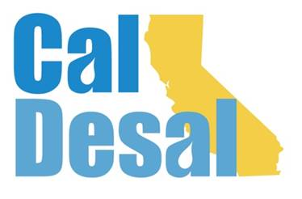](http://www.caldesal.org/)

**Outreach Communications Committee Meeting Agenda**

**Tuesday, October 6, 2020**

**2:00-3:00 p.m.**

**Zoom platform video conferencing**

**Agenda**

Chair Stacy Taylor, Mesa Water District

* **Southwest Strategies overview of homepage design options with full committee:**
* Hope Reilly, Senior Manager of Public Affairs & Chief Social Media Strategist, Southwest Strategies LLC

<https://xd.adobe.com/view/afb9836c-19c7-4a54-b48e-a83bc81e05dc-faea/>

* **Subcommittee Reports**
* Website – Chair Jessica Jones report
* Social Media – Chair Tiffany Baca report
* **CalDesal.org new website sneak peak during Virtual Townhall**
* **Website rollout plan brainstorm**
* Other items for discussion?

Next Outreach Communications Committee Meeting: **November 4 at 2:00 p.m.**

**Adjourn**