[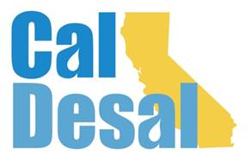](http://www.caldesal.org/)

**CalDesal Regulatory Committee Meeting**

**Wednesday, October 28, 2020**

**3:00-4:00 p.m. (new time)**

**conference call phone: (515) 604-9094, code: 1175-56965**

**Agenda**

1. Chair Kevin Thomas, Kimley-Horn, Welcome

**Regulatory Items:**

* State Water Board Tweet Outcome
* Ocean Plan Subcommittee Briefing
* CUWA & CA WateReuse Project Update (attachment)

**Recent Regulatory Activity:**

* Project Regulatory Permitting Updates:
* CalAm, Huntington Beach, Doheny, El Segundo and Carlsbad Lagoon Dredge

**CalDesal Update**

* Virtual Townhall Stats and Feedback
* CalDesal Annual Meeting going virtual – **February 10 & 11, 2021** (Wed p.m./Thurs a.m.)

**Any other issues?**

2020 Meeting Dates: 10/28, 11/18, and 12/16

Next Regulatory Committee Meeting: **Wednesday, November 18, 2020 at 3:00 p.m.**

**Adjourn**