[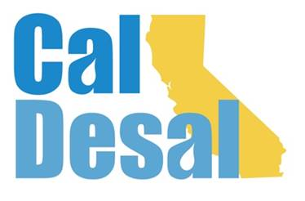](http://www.caldesal.org/)

**CalDesal Executive Committee Meeting Agenda**

**Monday, August 17, 2020**

**11:00 a.m.- 12:00 p.m.**

**conference call phone: (515) 604-9094, code: 1175-56965**

**Agenda**

1. Call to Order by Chair Bob Shaver, Alameda County WD
2. Wendy Ridderbusch, ED reports:

**CalDesal Virtual Townhall**

* Friday, October 16th 3:00-4:00 p.m. via Zoom platform with CAMS operating dashboard
* Will require registration in advance to receive Zoom link, program agenda, desal bingo sheet
* Director of Governor’s Water Portfolio Program at the Natural Resources Agency Nancy Vogel just committed to Townhall
* Sponsors?
* Twofold purpose: lost ACWA Spring Conference mixer revenue and possible virtual Annual Conference in February 2021

**Membership recapture, retention and recruitment efforts**

* Updated member/associate annual dues renewal excel spreadsheet (attached)
* Clean Water Invenergy declined to renew membership
* Successfully recruited Magna Imperio Systems
* Membership Committee Chair Shoenberger set first meeting on August 31, 2020

**Budget**

* Provided budget overview during July Executive Committee meeting
* Made suggested change by adding notation on SWS contract for pass through
* Updated 2020-21 budget (attached)
* Need a motion, a second, and vote to approve the budget

**Policy Committee Activity**

* California Urban Water Agencies (CUWA) request for a possible partnership with CA WateReuse and CalDesal (attached)
* Committee Chairs will be integrated into Executive Committee meetings as guests to present brief, relevant updates. Chair of Outreach Communications Committee is attending this meeting, Chair of Annual Conference Planning Joe Monaco will attend next month.

**Communications and Social Media**

* Short Southwest Strategies outreach communications contract update with Chair of Outreach and Communications Committee Stacy Taylor

**Governance**

* Strategic Planning Effort update – A Zoom calendar invite was sent to you for Friday, September 11 from 9:00 a.m.-noon to create the first CalDesal Strategic Plan.
* CalDesal 2020-21 Officers and Executive Committee Elections Nominating Committee and process timeline

**ED Activity: Invitations, Requests, Meetings**

* Virtual Networking: Southern California Water Coalition Stormwater Matters webinar
* ACWA State Legislative Committee meeting

Next Executive Committee Meeting: on Zoom platform is **Monday, September 21, 2020 11:00 a.m.-noon**

**Adjourn**