[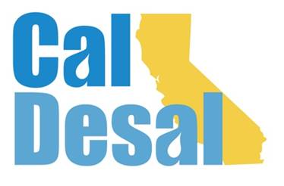](http://www.caldesal.org/)

**CalDesal Executive Committee Meeting Agenda**

**conference call phone: (515) 604-9094, code: 1175-56965**

**Monday, June 15, 2020**

**11:00 a.m.- 12:00 p.m.**

**Agenda**

1. Call to Order by Chair Bob Shaver, Alameda County WD
2. Wendy Ridderbusch, ED reports:

ACWA Summer Conference Alternative Sponsorship Opportunity Possibilities

* Investigating virtual programs and happy hours: WateReuse CA 6/24, Water Resources Research Center at University of Arizona 6/18 for a possible sponsored virtual standalone program this fall
* ACWA sponsorship opportunity for live music program during summer conference entertainment

Membership recapture, retention and recruitment efforts

* Annual Dues Renewal retention effort timeline: Letter w/hard copy and initial e-mail invoice, follow-up e-mail, then ED phone call by July 27
* Recruited Miller Marine Science and Consulting (Eric Miller) -- Associate level
* DRAFT Membership Plan document presentation and discussion
* Former CalDesal Members and Associates list and excel spreadsheet Recruitment grid
* Membership Committee

Policy Committee Activity

* Governor’s Water Resilience Portfolio (final version) release
* State Legislative, Regulatory, Outreach Communications, Innovative Technology, and Conference Planning Committee meetings highlights

Communications and Social Media

* Outreach Communications Contract Progress

Governance

* BOD Liability Insurance update
* CalDesal Officers and Executive Committee Elections Nominating Committee for 2021-2022
* Strategic Planning Effort update
* ED 6-month check-in evaluation, annual performance evaluation

ED Activity: Invitations, Requests, Meetings

* National WateReuse Conference panelist/program request
* Virtual Networking: Southern California Water Coalition, Urban Water Institute, Water Agencies of County of Orange (WACO)

Next Executive Committee Meeting: **Wednesday, July 29, 2020 from 7:00-8:00 a.m.**

**Adjourn**