[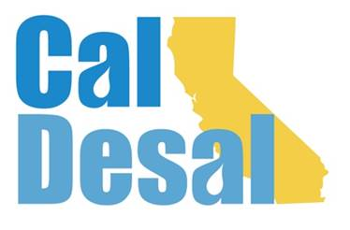](http://www.caldesal.org/)

**Outreach Communications Committee Meeting Agenda**

**Tuesday, January 5, 2021**

**2:00-3:00 p.m.**

**Via Zoom platform**

**Agenda**

Chair Stacy Taylor, Mesa Water District

* **Subcommittee Report**
* **Website** **& Social Media**– Chair Jessica Jones update on latest Subcommittee meeting, website progress
  + Content Email – [Content@caldesal.org](mailto:Content@caldesal.org)
  + DropBox Link – DropBox.com/l/scl/AAAVxvgYJZo-O_Z6QeemqePscozKAMn2cOA
* **Annual Conference** – February 10 & 11 (two half days)
* Agenda (attached)
* Registration Link: <https://events.r20.constantcontact.com/register/eventReg?oeidk=a07ehf3ln8j9c2da207&oseq=&c=&ch=>
* **Other** – Stacy/All

Next Outreach Communications Committee Meeting: **Tuesday, February 9, 2021 at 2:00 p.m. via Zoom platform.**

**Adjourn**