[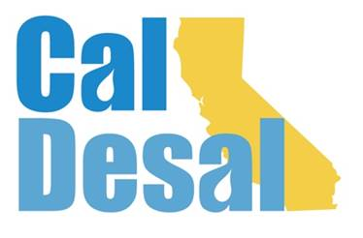](http://www.caldesal.org/)

**Outreach Communications Committee Meeting Agenda**

**Tuesday, December 8, 2020**

**2:00-3:00 p.m.**

**Call-in number: (515) 604-9094, code: 1175-56965**

**Agenda**

Chair Stacy Taylor, Mesa Water District

* **Virtual Townhall debrief** – Wendy/All
* **Subcommittee Reports**
* **Social Media** – Chair Tiffany Baca report
* **Website** – Chair Jessica Jones update on website progress, sneak peek power point presentation during November Executive Committee meeting
  + Website Content – checklist review
  + Content Email – [Content@caldesal.org](mailto:Content@caldesal.org)
  + DropBox Link – DropBox.com/l/scl/AAAVxvgYJZo-O_Z6QeemqePscozKAMn2cOA
* **Annual Conference** – February 10 & 11 (two half days)
* Agenda (attached)
* Registration Link: <https://events.r20.constantcontact.com/register/eventReg?oeidk=a07ehf3ln8j9c2da207&oseq=&c=&ch=>
* **Other** – Stacy/All
  + **CalDesal Art** – Guide & Logos: <https://spaces.hightail.com/receive/BQJLz7Y041#pageThumbnail-12>
  + **CalDesal PPT Template** (attached)

Next Outreach Communications Committee Meeting (Outlook invite to be mailed): **Tuesday, January 5, 2021 at 2:00 p.m. via Zoom platform.**

**Adjourn**