[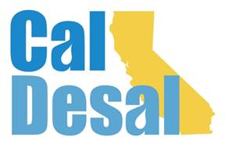](http://www.caldesal.org/)

**CalDesal Regulatory Committee Meeting**

**Wednesday, August 26, 2020**

**2:00-3:00 p.m.**

**conference call phone: (515) 604-9094, code: 1175-56965**

**Agenda**

1. Chair Kevin Thomas, Kimley-Horn, Welcome

* **Ocean Plan Review Subcommittee** **Update**– Highlights from the first August 4 Subcommittee meeting
* **L.A. Waterkeeper v State Water Resources Control Board** – Recent case decision may pave way for return of Senator Hertzberg’s ocean discharge state legislation.
* **Joint CUWA & CA WateReuse project** – Request to CalDesal to participate both financially and in a collaborative study to produce an issue brief and accompanying slide document (sample attached) regarding brine management as a challenge towards increased water recycling and desal in the state.
* **Seawater Desal FAQ progress** –
* Discussion regarding attached DRAFT Seawater Desal Myths & Facts document and timeline for completion.
* Receive continued input from committee members on second half to finish document and send to Outreach and Communications Committee

**Recent Regulatory Activity:**

* Relevant Project Regulatory Permitting Updates:
* CalAm, Huntington Beach, Doheny, El Segundo

2020 Meeting Dates: 9/23, 10/28, 11/25, and 12/16

Next Regulatory Committee Meeting: **Wednesday, September 23, 2020** **at 2:00 p.m.**

**Adjourn**