[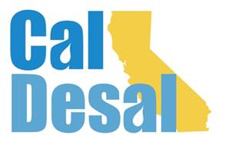](http://www.caldesal.org/)

**CalDesal Regulatory Committee Meeting**

**Wednesday, June 24, 2020**

**2:00-3:00 p.m.**

**conference call phone: (515) 604-9094, code: 1175-56965**

**Agenda**

1. Chair Kevin Thomas, Kimley-Horn, Welcome

* Urban Water Management Plan legislation which addresses loading orders
* Once-Through-Cooling mitigation calculations: comment opportunity

Recent Regulatory Activity:

* Project Regulatory Permitting Updates:
* CalAm, Huntington Beach, Doheny

Future Regulatory Activity:

* Coastal Commission Hearing on CalAm is set for August 12, 13, and 14
* Huntington Beach RWQCB vote expected on July 31, 2020
* Any hearings and workshops scheduled/rescheduled?

CalDesal Committees Update

2020 Meeting Dates: 6/24, 7/22, 8/26, 9/23, 10/28, 11/25, 12/16

Next Regulatory Committee Meeting: **Wednesday, July 22, 2020**

**Adjourn**