[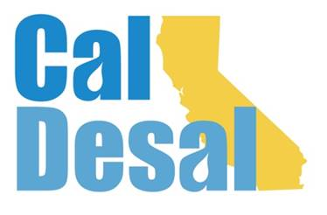](http://www.caldesal.org/)

**CalDesal Executive Committee Meeting Agenda**

**Monday, January 25, 2020**

**11:00 a.m.- 12:00 p.m.**

**Zoom video/phone platform**

**Agenda**

1. Call to Order and Welcome to new Executive Committee Members by **Chair Mark Donovan**
2. **Executive Director Wendy Ridderbusch** reports:

**Virtual Annual Conference**

* Agenda (attached)
* Registration and sponsorship targets
* External marketing communication activity (AMTA, ACWA)
* Accelevents platform
* IT compatibility checks

**Membership**

* Quarterly Membership Committee meeting: new member Director Bill Green
* Western Growers Assn. Zoom pitch
* Series of pitch meetings being scheduled for potential members/associates
* Annual Member Survey

**Communications**

* 2021 Calendar
* Improved Website Launch Update

**Collaboration**

* CUWA Issue Brief Update
* Pitching national WateReuse conference panel with CUWA stakeholders
* Pitching ACWA for CalDesal program for Spring or Fall 2021 conferences Regions 8, 9, or 10

**Governance**

* Appoint Makron Shatila who recently served on the 2019-20 Executive Committee from Michael Baker International to open Executive Committee seat (vote) (Bylaws attached)
* 2021-22 Strategic Plan (attached)
* Special Bylaws Committee paused
* Lobbyist Deregistering

**ED activity:**

* ACWA Region 10, ACWA Virtual Fall Conference, December 2 & 3, 2020
* ACWA Water Management Committee Meeting, December 17, 2020
* Maryann Warmerdam, Deputy Controller, Environmental Policy, Office of State Controller Betty Yee meeting regarding desal project status, January 5
* Governor Newsom Administration Interagency State Budget Briefing Call, January 8
* State Director of Finance Presentation at CalChamber virtual presentation, January 12

Next Executive Committee Meeting: is **Monday, February 22, 2021 via Zoom**

**Adjourn**