[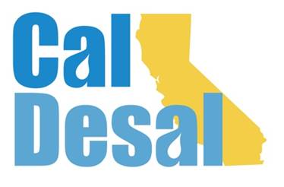](http://www.caldesal.org/)

**CalDesal Executive Committee Meeting Agenda**

**Monday, February 22, 2021**

**11:00 a.m.- 12:00 p.m.**

**Zoom video/phone platform**

**Agenda**

1. Call to Order by **Chair Mark Donovan**
2. **Executive Director Wendy Ridderbusch** reports:

**Events**

* **Virtual Annual Conference Debrief**

Conversation with Annual Conference Planning Committee Chair Joe Monaco including:

* + Mix of programs, moderators, and panelists
  + Accel Events platform vs. Zoom Webinar
  + Registration and Sponsorship numbers
  + Survey (attached)
  + Feedback from Executive Committee
* **Invitation to Innovate webinar** 
  + Friday, March 26 4:00-5:30 p.m.
  + No cost to members and associates
  + Non-member $50 fee
  + Technology Innovation Committee idea
* **Sponsorship improvement program**
* Paula Currie, PC Events

**Membership**

* Valley Water District (formerly known as Santa Clara Valley Water District) $5,000 member

**Communications**

* Improved Website
* Webflow Training Transition from Southwest Strategies to CAMS/Ridderbusch
* Members’ Only login/password information e-mailed
* 2021 CalDesal Calendar (attached)

**Collaboration**

* National WateReuse conference CUWA program: Facing Challenges to Maximizing Water Reuse
* National WateReuse June Desalination webinar program
* American Membrane Technology Association, ACWA, and Water Desalination Report advertising for CalDesal Annual Conference

**Governance**

* 2021-22 Strategic Plan (attached)

**ED activity:**

* ACWA State Legislative Committee Meeting January 22, 2021
* California Municipal Utility Association (CMUA) Lobby Days January 25 and 26, 2021
* California Association of Sanitation Agencies (CASA) Conference January 27 and 28, 2021
* ACWA Monday Morning Lobby Group Meeting February 1, 2021
* Urban Water Institute Virtual Water Conference February 17 and 18, 2021
* ACWA State Legislative Committee Meeting February 19, 2021

Next Executive Committee Meeting: is **Monday, March 15, 2021 via Zoom**

**Adjourn**