[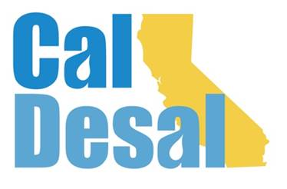](http://www.caldesal.org/)

**CalDesal Executive Committee Meeting Agenda**

**Monday, March 15, 2021**

**11:00 a.m.- 12:00 p.m.**

**Join Zoom Meeting**

[**https://us02web.zoom.us/j/7746824370**](https://us02web.zoom.us/j/7746824370)

**Meeting ID: 774 682 4370**

**One tap mobile**

**+16699009128,,7746824370# US (San Jose)**

**Meeting ID: 774 682 4370**

**Agenda**

1. Call to Order by **Chair Mark Donovan**
2. **Executive Director Wendy Ridderbusch** reports:

**Events**

* **Virtual Annual Conference Survey** deadline today COB
* **Invitation to Innovate webinar** 
  + Friday, March 26 4:00-5:30 p.m.
  + No cost to members and associates
  + Non-member $50 fee
  + Technology Innovation Committee idea
  + <https://events.r20.constantcontact.com/register/eventReg?oeidk=a07ehnmpsy6e6b7a918&oseq=&c=&ch=>

**Sponsorship improvement program**

* Paula Currie, PC Events update

**Membership**

* Energy Recovery Inc. pitch meeting last week
* Suez pitch meeting next week
* SaltWorks has asked to meet about membership
* Mark Donovan helping claw back Acciona

**Communications**

* Members’ Only login/password information (*attached*)
* Focus on website upgrades, Members’ Only page content

**Collaboration**

* National WateReuse conference CUWA program: Facing Challenges to Maximizing Water Reuse recorded on February 25, 2021
* Western States Water Council: California Desal power point presentation March 25

**Governance**

* CalDesal’s 2020-21 Budget Review
* Executive Committee Meeting in Maywill be moved from existing Monday, May 17 up to Wednesday, May 12 from 7:00 a.m.-8:00 a.m. to align with ACWA Virtual Spring Conference. New Zoom invite to be e-mailed this week, calendar cancellation will also be e-mailed via Outlook.

**ED activity:**

* Women in Desal – virtual planning meeting for rescheduled Thursday, October 2021 event
* ACWA State Legislative Committee meeting March 12
* ACWA Monday Morning Lobby Group meeting March 1 and 8
* ACWA Coalition Climate Change Resiliency Bond meeting March 3
* CAMS monthly Zoom meeting March 3
* WateReuse Legislative/Regulatory Committee meeting March 12

Next Executive Committee Meeting: is **Monday, April 19, 2021 via Zoom**

**Adjourn**