[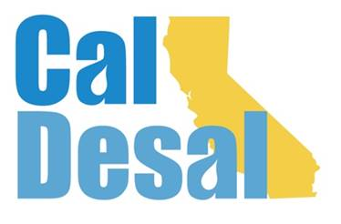](http://www.caldesal.org/)

**CalDesal Executive Committee Meeting Agenda**

**Monday, April 19, 2021**

**11:00 a.m.- 12:00 p.m.**

**Join Zoom Meeting**[**https://us02web.zoom.us/j/7746824370**](https://us02web.zoom.us/j/7746824370)

**Meeting ID: 774 682 4370   
One tap mobile   
+16699009128,,7746824370# US (San Jose)   
+12532158782,,7746824370# US (Tacoma)**

**Dial by your location   
        +1 669 900 9128 US (San Jose)**

**Agenda**

1. Call to Order by **Chair Mark Donovan**
2. **Executive Director Wendy Ridderbusch** reports:

**Events**

* **Virtual Annual Conference Survey Results** (attached)
* Chair Joe Monaco and committee will meet in early summer to plan 2022 Annual Conference
* **Invitation to Innovate Webinar Debrief**
* 65 registrations
* Non-registration: $550.00
* Thank you notes to participants
* Technology Innovation Committee follow-up
* **$pring Brief Breakout Update**
* Wednesday, May 11, 2021—3:00-4:30 p.m.
* No charge to members and associates
* Seeking sponsorship dollars to replace ACWA Spring Mixer $
* Dr. Peter Fiske NAWI and state/federal funding vehicles updates
* Zoom breakout rooms

**Membership**

* First Quarter Membership Committee Meeting April 15

**Communications**

* Latest Newsflash (attached)

**Policy**

* Letter to ACWA regarding Senator Atkins $2 billion drought funding effort (attached)

**Collaboration**

* Held meeting to confirm relationship/privilege for future in-person mixers
* ACWA associate member 2020, 2021
* Fall Conference 2021 in Pasadena: Sheraton, Westin, and Hilton hotels
* Tuesday-Friday -- November 30-December 3
* CalDesal Themed Mixer: Wednesday, December 1 in the evening

**Governance**

* CalDesal updated Income Statement (attached)
* Ongoing work with PC Events Paula Currie regarding Sponsorship Improvement Program
* Executive Committee Meeting in Maywas moved from previously scheduled Monday, May 17 up to Wednesday, May 12 from 7:00 a.m.-8:00 a.m. to align with ACWA Virtual Spring Conference. New Zoom invites were e-mailed, please accept invite to place it onto calendar.

**ED activity:**

Next Executive Committee Meeting: is **WEDNEDSAY, MAY 12, 2021 DURING ACWA VIRTUAL CONFERENCE WEEK via Zoom**

**Adjourn**