[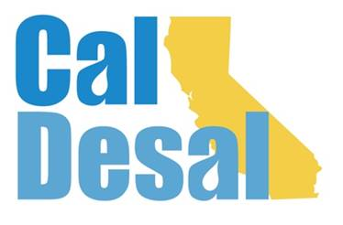](http://www.caldesal.org/)

**CalDesal Legislative Committee Meeting**

**Monday, January 25, 2021**

**3:00-4:00 p.m.**

**Zoom**

**Agenda**

* Chair E.J. Caldwell, West Basin Municipal Water District Welcome

**State Legislative Activity:**

* General Obligation Bond

**Federal Legislative Activity:**

* Infrastructure Bill Activity

**CalDesal Updates**

* Collaboration with CUWA: Issue Brief & National WateReuse conference program
* Virtual Annual Conference: February 10 & 11, 2021
* Website: soft launch
* Technology Innovation Committee Virtual Program: March 26, 2021 “Invitation to Innovate”

Next State Legislative Committee Meeting: **Monday, February 22, 2021**

**Adjourn**