[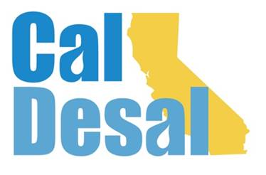](http://www.caldesal.org/)

**CalDesal Legislative Committee Meeting**

**Monday, March 15, 2021**

**3:00-4:00 p.m.**

[**https://us02web.zoom.us/j/7746824370**](https://us02web.zoom.us/j/7746824370)

**Meeting ID: 774 682 4370**

**One tap mobile**

**+16699009128,,7746824370# US (San Jose)**

**Agenda**

* Chair E.J. Caldwell, West Basin Municipal Water District

**State Legislative Activity:**

* General Obligation Bonds Discussion:
* SB 45 (Portantino/Allen/Hurtado/Stern) $5.5 billion
* AB 1500 (Garcia/Mullen) $6.7 billion $1.6 billion
* ACWA letter and language
* Any other bills CalDesal should track?

**Federal Legislative Activity:**

* Infrastructure Bill Activity

**CalDesal Updates**

* Continued membership growth
* Collaboration on CUWA Issue Brief, national WateReuse desal program, and Western States Water Council
* Virtual Annual Conference debrief
* New Website
* Technology Innovation Committee Virtual Program: March 26, 2021 “Invitation to Innovate” <https://events.r20.constantcontact.com/register/eventReg?oeidk=a07ehnmpsy6e6b7a918&oseq=&c=&ch=>
* Women in Desal: rescheduled to Thursday, October 7th at the Edward C. Little Water Recycling Facility, El Segundo

Next State Legislative Committee Meeting: **Monday, April 19, 2021**

**Adjourn**