[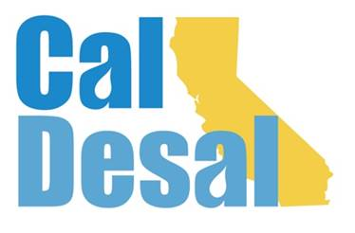](http://www.caldesal.org/)

**CalDesal Legislative Committee Meeting**

**Monday, April 19, 2021**

**3:00-4:00 p.m.**

**Zoom**

**Agenda**

* Chair E.J. Caldwell, West Basin Municipal Water District

**State Legislative Activity:**

* General Obligation Bonds Discussion:
* SB 45 (Portantino/Allen/Hurtado/Stern) April 8 amendments
* AB 1500 (Garcia/Mullen) April 14 amendments
* President Pro Tem Atkins $2 billion drought proposal – Letter to ACWA (attached)
* Any other bills CalDesal should track?

**Federal Legislative Activity:**

* Infrastructure Bill Activity

**CalDesal Updates**

* New member Suez
* $pring Brief Breakout: Tuesday, May 11, 3:00-4:30 p.m.
* Women in Desal: Thursday, October 7, 2021

Next State Legislative Committee Meeting: **Monday, May 17, 2021**

**Adjourn**