[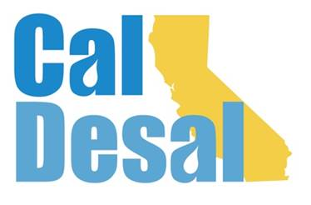](http://www.caldesal.org/)

**CalDesal Legislative Committee Meeting**

**Monday, May 17, 2021**

**3:00-4:00 p.m.**

**Zoom**

**Agenda**

* Chair E.J. Caldwell, West Basin Municipal Water District

**State Legislative Activity:**

* Climate Resiliency & Drought Relief state funding:
* SB 45 and AB 1500 status
* President Pro Tem Atkins: Senate Budget Plan on Drought, Safe Drinking Water, Water Supply Reliability, and Ratepayer Assistance update
* Governor Newsom’s Plan
* How will they all fit together?
* SB 351 (Caballero) CMUA-sponsored bill

**Federal Legislative Activity:**

* S. 914 (Duckworth) The Drinking Water and Wastewater Infrastructure Act of 2021

**CalDesal Updates**

* $pring Brief Breakout debrief
* National WateReuse California desal program
* PC Events working on Sponsorship Improvement Program (SIP)
* Annual Dues Invoices will be sent out in July

Next State Legislative Committee Meeting: **Monday, June 14, 2021**

**Adjourn**