[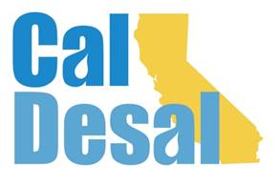](http://www.caldesal.org/)

**CalDesal Regulatory Committee Meeting**

**Thursday, March 25, 2021**

**10:00-11:00 a.m. NEW TIME on Zoom Platform**

**Agenda**

1. **Chair Kevin Thomas**, Kimley-Horn and **Vice-Chair Hannah Ake**, Metropolitan Water District of Southern California, Welcome

**Regulatory Items:**

* **CUWA Issue Brief:** [**https://www.cuwa.org/**](https://www.cuwa.org/)
* **National WateReuse Conference Program**
* **Summer California Desal Program** with National WateReuse

**Recent Project Activity:**

* **Project Regulatory Permitting Updates**:
* CalAm, Huntington Beach, Doheny, and El Segundo

**CalDesal Updates**

**Post-Virtual Conference Debrief**

**Invitation to Innovate Webinar Program**

* + Friday, March 26 3:00-4:30 p.m.
  + <https://events.r20.constantcontact.com/register/eventReg?oeidk=a07ehnmpsy6e6b7a918&oseq=&c=&ch=>

**Website Update**

* Members’ Only section (attached)

**May Briefing**

* Tuesday, May 11, 2021 3:00-4:30 p.m.
* Dr. Peter Fiske, NAWI & Update and Reconnection Breakout Rooms
* Attached to ACWA Virtual Spring Conference (May 12 & 13)
* Also connected to CalDesal Board of Directors Meeting Wednesday, May 12 7:00-8:00 a.m.

**Other issues?**

Next Regulatory Committee Meeting: **Thursday, April 21 at 10:00 a.m.**

**Adjourn**