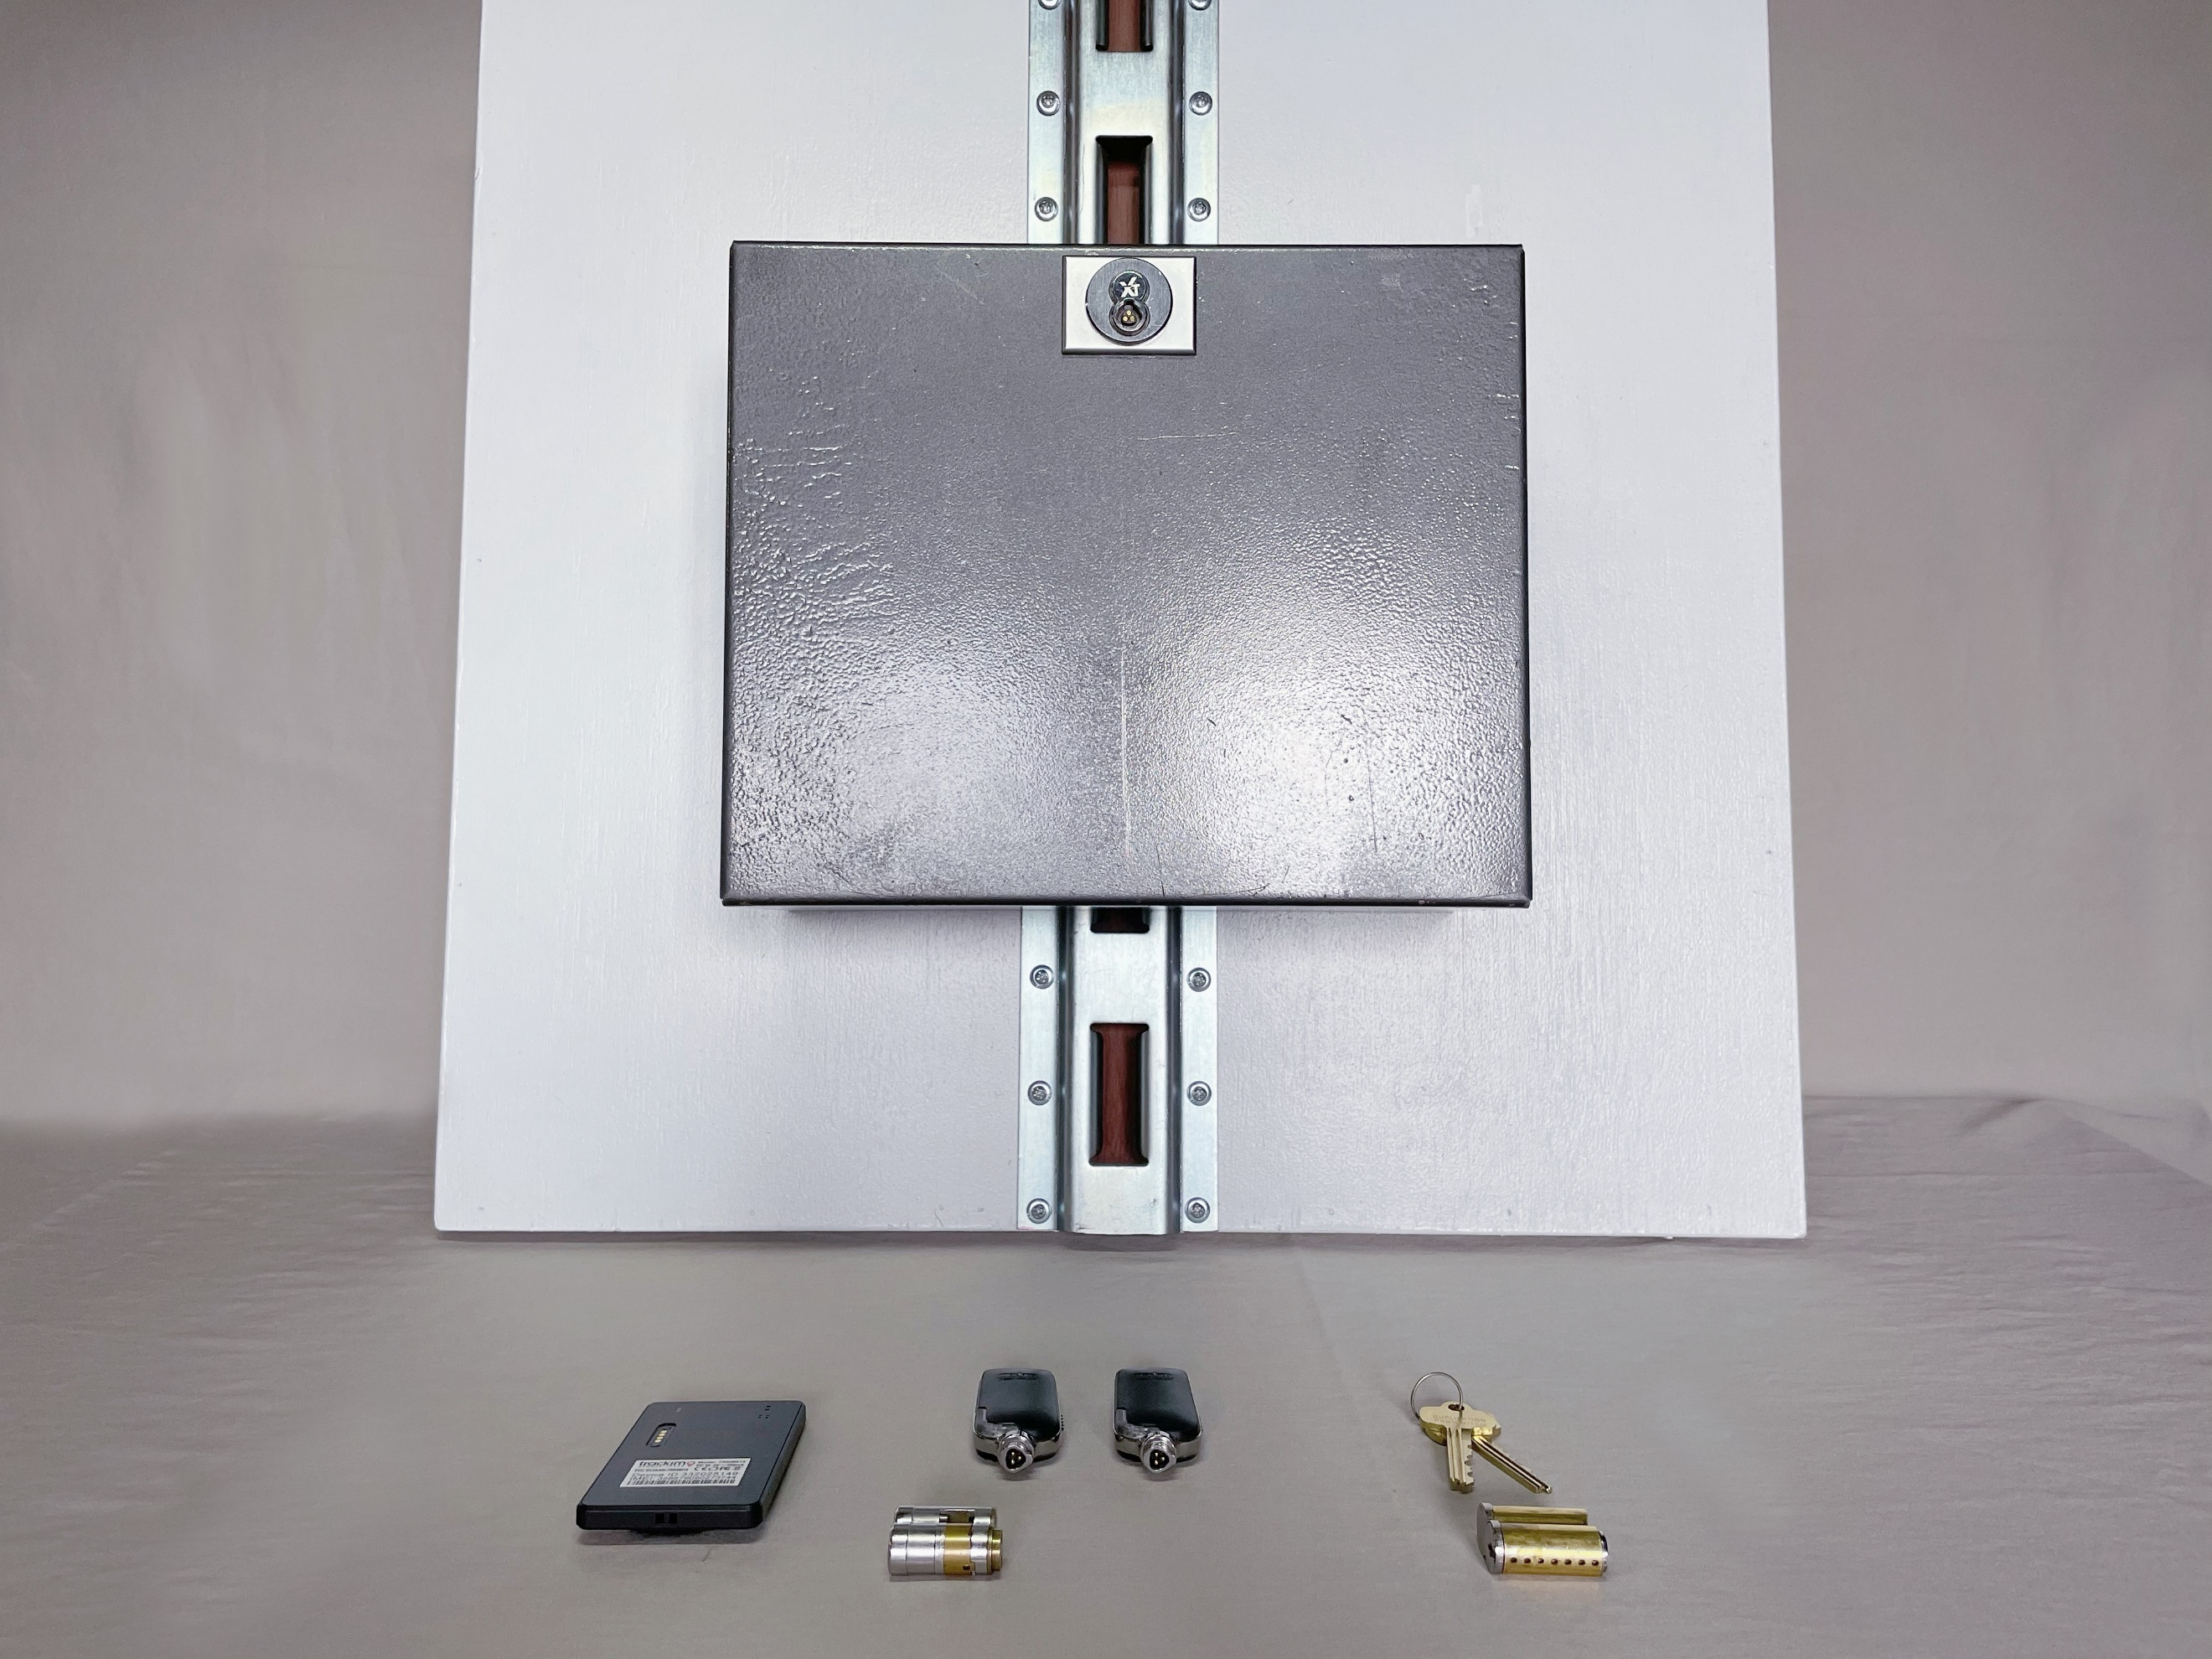  Application and Installation Instructions | Abstract  The ATB’s two step patent pending design makes the day to day transportation of assets very simple, and easy to install. The ATB was created to work in in almost every tractor trailer with a vertical “E” Track layout  CM Bryant Inc  2049 Neal Road Pylesville, Maryland 21132

Steps of Assembly/Installation Operation
- Place Asset Transit Box (ATB) front side down on flat surface with “E” Track hook facing up.
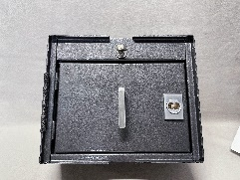
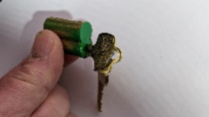
- Insert the Mechanical or Electronic Control Key into the small format interchangeable core (SFIC), turn right 15 degrees to draw back the control lug (the electronic control key may need to be
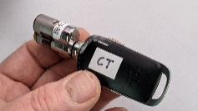
turned to the right twice quickly to retract the control lug, and insert the Mechanical or Electronic core into the access door lock housing.
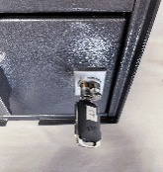
- Insert Mechanical or Electronic operating key into access door lock (turn to 3 O’clock position ) to retract locking latch, pull or lift door open to place contents inside, when finished close door completely, turn key back to top of core (12 o’clock position) and remove key.
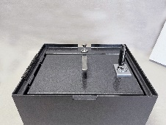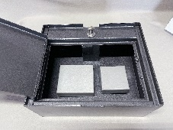
- Turn (ATB) bottom side of box down on flat surface with “E” Track hook facing away from you, Main Cylinder Lock Housing will be located on the top front of (ATB).
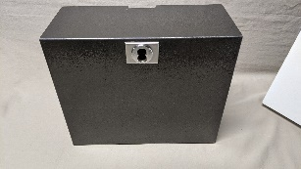
- Insert the Mechanical or Electronic Control Key into the (SFIC) core, turn right 15 degrees to draw back the control lug (the electronic control key may need to be turned to the right twice quickly to retract the control lug, and insert the Mechanical or Electronic core into the main (ATB) cylinder lock housing.
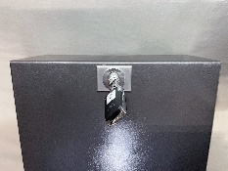
- Insert Mechanical or Electronic operating key into main (ATB) cylinder lock (turn to 3 O’clock position ) to rotate locking “T” Spindle, (this will retain key until locking process is finished).
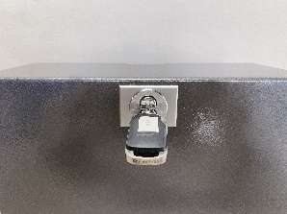

- When the locking “T” spindle (located on the back) is fully rotated it should be at the 12 o’clock-6 o’clock position (this is the open position).
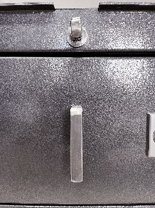
- Lift (ATB) with two hands (one on each side) to the desired height of the tractor trailer vertical “E” Track, slightly tilt top of (ATB) toward you and slip the “E” Track hook into a slot of the “E” Track,
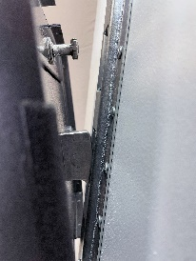
- Once “E” Track hook is seated in “E” Track slot, push top of (ATB) toward wall till the Locking “T” spindle is engaged into the second “E” Track Slot (This is the slot exactly above the slot the “E” Track hook is located in).
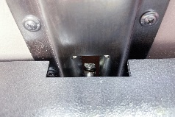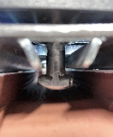
- Once the (ATB) is pressed firmly to the Trailer “E” Track and wall, turn key back to the 12 O’clock position to lock the (ATB) “T” Locking spindle into the trailer “E” Track (this will place the “T” Locking spindle in the 9 O’clock- 3 O’clock position).
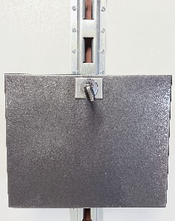
- The (ATB) is now secured to the trailer “E” Track.
- To remove ATB12 from the “E” Track, repeat steps 5-6
- Pull Top of ATB toward you and lift ATB upward till “E” Track hook is free from the Trailer “E” Track.
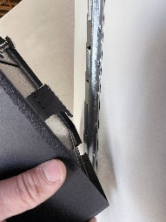
- Turn key back to the 12 O’clock position to remove key.
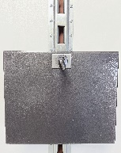
- To remove contents, Repeat steps 1 and 3

