Give your valuables The extra protection it demands with this revolutionary patent pending “E” Track “Asset Transit Box (ATB)”.

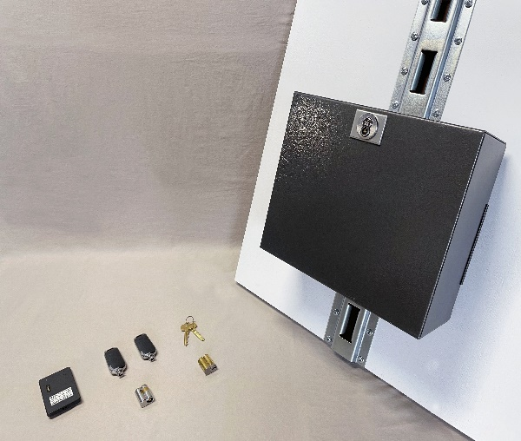
The ATB’s two step design makes the day to day transportation of assets very simple, and easy to install. The ATB’s patent pending design was created to work in almost every tractor trailer with a vertical “E” Track layout. Simply slide the “E” Track hook into the trailer “E” track slot and lock into place with the patent pending “E” Track locking “T” Spindle.

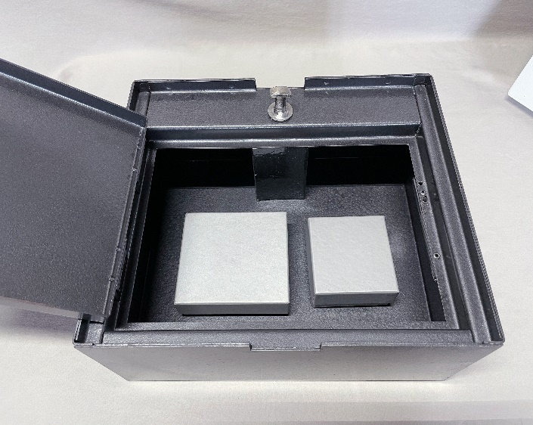
The ATB is constructed out of 16 gauge steel with a rigid door mounting panel design. The door mounting panel is fabricated with a lip for the door to seat tightly so that no contents can inadvertently fall out of the box. By design the door mounting frame is recessed a ½ inch in from the edge of the box. This is to conceal the compartment door and door lock on the trailer side and “E” Track, making it inaccessible during transit. Every piece of the ATB’s box structure is spot welded for added strength and durability. Each corner has (3) spot welds with the mounting panel having (4) spot welds per side. The ATB’s finish is a textured black powder coating that gives it a durable scratch resistant finish.

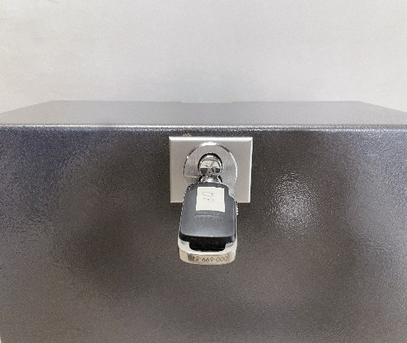
Designed specifically with the flexibility of a Small Format Interchangeable Core (SFIC) system in mind, the ATB comes with two SFIC lock housings for quick and easy core changes in the event there is a lost key. One of the safe guard features designed into the locking function is key retention. The key cannot be removed till the ATB’s “T” Spindle is in a lock position. The Lock housing for the “T” spindle is located on the front of the ATB and the second Lock housing is located on concealed side of the box. The ATB comes standard less core and key.
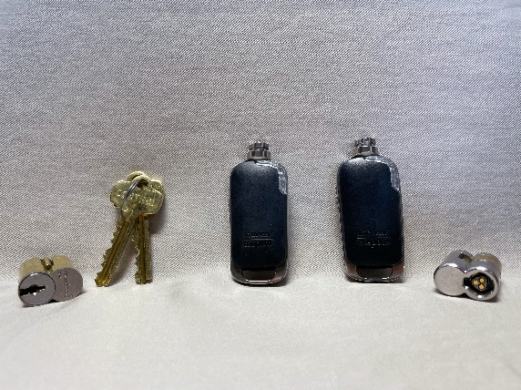
The ATB offers several options to increase security levels of the box itself. We can provide keys and cores if desired. A standard BEST key and core would be our entry level system (keep in mind that the standard keys can be duplicated by any locksmith or hardware store). Our next level would be a COREMAX patented core system, ensuring that no-one can supply and or cut your key without being authorized. Our top level keying system is an electronic key and core. The electronic key system has many different features making it a unique option. Programming individual keys to open the ATB can be done in several different ways, Creating time schedules to give them 24/7 access or create time limits. The key coordinator can program keys for example to work from 9 to 5, or expire at the end of a shift or day, or having each key renew their access rights daily. This is a great option if the individual keys leave the building and go home with the key holder. Unlike a mechanical key, when it is lost, the end-user is forced to rekey the box to ensure true security. With the Electronic Keying system you can remove the lost key through the software by deleting the key and programming in a new key. In the scenario of someone lending their key to a co-worker, and a theft occurs, a chain of events can be created using the audit trail history. The audit trail feature, gives you a history up to 1400 previous events (Access granted, Access denied, where the key was used before). If being there in person isn’t an option, program a key on the go using your cell phone app, There are many more situation applications and possibilities for the electronic keying system.
The ATB can also track, using a tracker with light sensor alert. When the ATB’s compartment door is opened, and a change of light is detected, an email or text (text may incur charges) is sent to key monitoring personal within 1 min. of an open door event. This gives a time stamp when it occurred and location via satellite tracker of the tractor trailer it was assigned to. Each ATB is serialized for individual tracking of each box. Each tracker has a monthly service subscription fee.
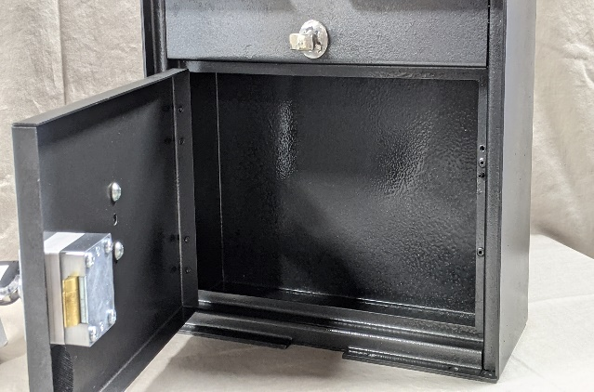

Features
- 16 Gage Steel Fabrication
- 26 Spot Welds for Rigidity and Strength
- 2) SFIC Lock Housings
- 2) Key Guards to protect Finish From Keys
- Patent Pending “E” Track Hook
- Patent Pending “T” Locking Spindle
- 2) Heavy Duty Pop Riveted Male Hinges
- 2) Heavy Duty Pop Riveted Female Hinges
- Custom Door Stop
- ¼ Compartment Locking Bar Support
- Door Stop Spreader Pin
- Black Powder Coat Finish
Specification
- 12 Inches Long
- 10 Inches Wide
- 5 Inches Deep Exterior
- 4.5 Inches Deep Interior
- Warranty: 1 yr.
- Country of Origin: United States
- Weight: 10 Lbs.
- Finish: Black Powder Coat

