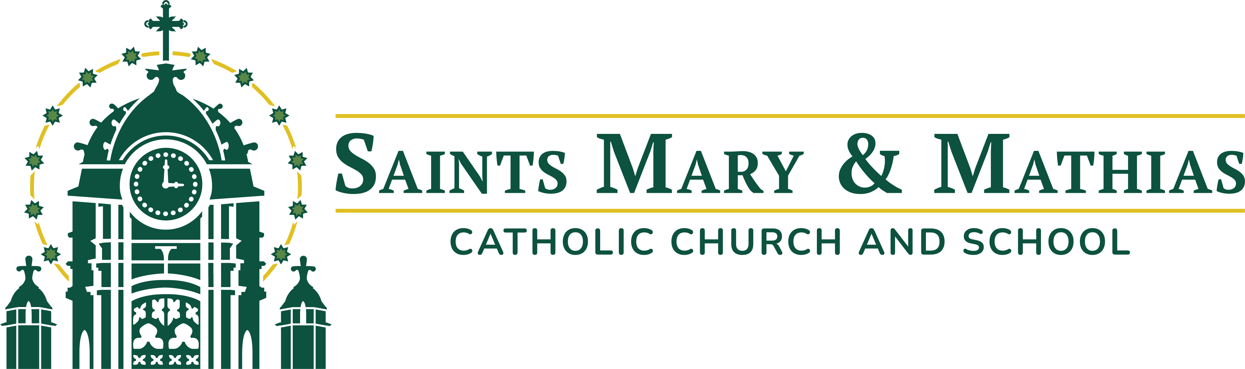

Position Description: Coordinator of Family Formation and Evangelization
Full-Time, Exempt

Job Summary:
The Coordinator of Family Formation and Evangelization supports the mission of Saints Mary and Mathias Catholic Church by accompanying families as they grow in their relationship with Jesus Christ and His Church. This role is responsible for planning, coordinating, and implementing parish-wide family faith formation and sacramental preparation programs. The Coordinator of Family Formation and Evangelization ought to be authentic, hospitable, available, and coachable.

Reporting Relationships:
- Reports to: Director of Formation and Evangelization
- Collaborates with: Coordinator of Youth Formation and Evangelization and other parish staff
- Facilitates Ministry of: Volunteers

Key Responsibilities:
- Develop, plan, organize. and implement Family Faith Formation programming for children K-8 and their parents, programming should have an emphasis on the parents' responsibility as their children’s first teachers of the faith
- Plan, organize, and implement a K-6 summer faith program, such as Vacation Bible School or Totus Tuus
- Coordinate and support the Baptism preparation process for families, including leading initial preparation classes, meeting with parents, and scheduling
- Plan, organize, and implement the parish’s First Confession and First Communion program, including overseeing The Search, teaching parents and children about the Sacraments, and relevant administrative tasks
- Recruit, train, and support volunteers
- Collaborate closely with the Director of Formation and Evangelization and the Coordinator of Youth Formation and Evangelization as part of a team-based ministry approach.
- Communicate effectively with families, volunteers, clergy, and staff through written, verbal, and digital means.
- Help galvanize members of the parish, encouraging participation, connection, and ongoing engagement in parish life.

Required Qualifications:
- An actively practicing Catholic with a strong sense of the importance of a life of discipleship
- Strong grounding in Catholic theology and ecclesiology, as evidenced by a minimum of a Bachelor’s Degree in Theology, Catholic Studies, Religious Education, or a related field, or other relevant coursework
- Demonstrated experience in relevant professional ministry settings
- Ability to relate effectively with staff, volunteers, parishioners, guests, adults, and young people
- Ability to work flexible hours, including nights and weekends as required
- Proficiency with or ability to learn Microsoft 365 applications
- Ability to pass criminal background and credit check, and complete Diocesan Safe Environment Training

Preferred Qualifications:
Fluency in Spanish or experience working in a Hispanic or multicultural setting

Hours and Compensation:
- Salary:
- Full-time, year-round, FLSA Exempt position
- Will require evening and occasional weekend duties
- Eligible for benefits package, including health insurance and 401(k) match

For more information, contact Fr. Chris Weber.
Fr. Chris Weber
cweber@marymathias.org
215 W 8th St.
Muscatine, IA 52761

