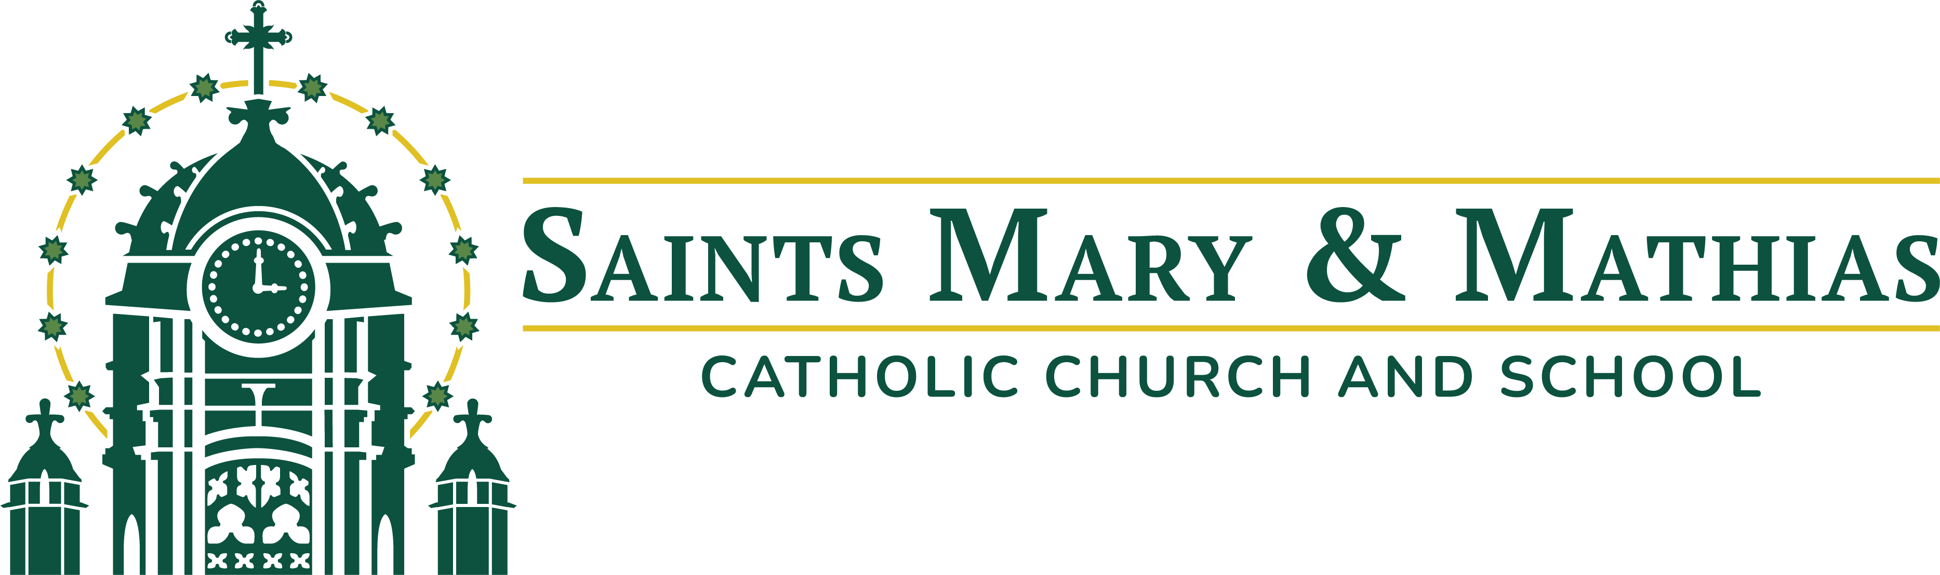

Position Description: Coordinator of Youth Formation and Evangelization
Full-Time, Exempt

Job Summary:
The Coordinator of Youth Formation and Evangelization supports the mission of Saints Mary and Mathias Catholic Church by accompanying middle and high schoolers as they grow in their relationship with Jesus Christ and His Church. This role is responsible for planning, coordinating, and implementing parish-wide youth formation, evangelization, and sacramental preparation programs. The Coordinator of Youth Formation and Evangelization ought to be authentic, hospitable, available, and coachable.

Reporting Relationships:
- Reports to: Director of Formation and Evangelization
- Collaborates with: Coordinator of Family Formation and Evangelization and other parish staff
- Facilitates Ministry of: Volunteers

Key Responsibilities:
- Organize and oversee YDisciple small groups for middle school and high school youth
- Recruit, train, support, and accompany YDisciple leaders from the parish, fostering confident, relational, and well-formed volunteers
- Organize and lead middle school Bible studies at the Catholic school during the school day, collaborating with school staff to support student faith formation.
- Organize, oversee, and accompany youth to conferences and retreat opportunities, including but not limited to Steubenville Youth Conference, Iowa Catholic Youth Conference (ICYC), and NET retreats.
- Develop, organize, and implement service projects for 6-12 graders
- Plan and coordinate regular large-group youth ministry gatherings for middle school and high school students, designed towards evangelization and helping teens encounter the Church
- Coordinate and support Confirmation preparation, including implementing The Search, teaching parents and children about the Sacraments, and relevant administrative tasks
- Collaborate closely with the Director of Formation and Evangelization and the Coordinator of Family Formation and Evangelization as part of a team-based ministry approach.
- Communicate effectively with teens, parents, volunteers, clergy, and staff through written, verbal, and digital means.
- Help galvanize members of the parish, encouraging participation, connection, and ongoing engagement in parish life.

Required Qualifications:
- An actively practicing Catholic with a strong sense of the importance of a life of discipleship
- Strong grounding in Catholic theology and ecclesiology, as evidenced by a minimum of a Bachelor’s Degree in Theology, Catholic Studies, Religious Education, or a related field, or other relevant coursework
- Demonstrated experience in relevant professional ministry settings
- Ability to relate effectively with staff, volunteers, parishioners, guests, adults, and young people
- Ability to work flexible hours, including nights and weekends as required
- Proficiency with or ability to learn Microsoft 365 applications
- Ability to pass criminal background and credit check, and complete Diocesan Safe Environment Training

Preferred Qualifications:
- Fluency in Spanish or experience working in a Hispanic or multicultural setting

Hours and Compensation:
- Salary:
- Full-Time, year-round, FLSA Exempt position
- Will require regular evening and weekend duties
- Eligible for benefits package, including health insurance and 401(k) match
For more information, contact Fr. Chris Weber.
Fr. Chris Weber
cweber@marymathias.org
215 W 8th St.
Muscatine, IA 52761

