Perfect for guided safaris with up to three passengers, this iconic African vehicle is built to handle the toughest terrain with confidence and ease.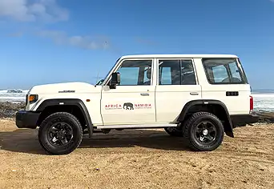

|  |  |  |
| --- | --- | --- |
| Specifications   * 3 passengers (plus guide) * Air conditioning * Electric windows * Radio/CD player/USB/Bluetooth * Navigation * Air bags * ABS brakes * 5-speed manual gearbox * 2,8 litre diesel engine * 4-wheel drive * 230mm ground clearance * Low range * Diff lock * Traction control | Included   * Zero Excess * Unlimited kilometres * Cooler box * GPS vehicle tracker * Additional driver * 1 spare tyre * First aid kit * All standard vehicle accessories * Breakdown triangles * Fire extinguisher * Tyre gauge * Standard insurance excess * Collision and Theft Cover * Tyre and windscreen insurance * Passenger liability * Vehicle procedures and information * GPS navigation system * [Day room facilitie](https://www.namibia-tours-safaris.com/about-us/windhoek-day-room)s at our Windhoek depot * 24/7 Assistance * Passengers are insured with [EVAC](https://www.namibia-tours-safaris.com/about-us/emed-rescue-24), providing 24/7 emergency medical response | Extra Options   * One-way rental * Extra spare tyre * Child and booster seats * Fridge * Luggage trailer * Air compressor * Jumper cables * Satellite phone * Airport return transfers |

Configuration

