This custom safari-converted vehicle is 4-wheel drive and large enough for most passengers to have their own window seat. It’s the ideal private guided safari vehicle for a larger group or family travelling together. It comes with a luggage trailer, so you’ll have ample space and comfort.

|  |  |
| --- | --- |
| 10-seater safari car exterior |  |

|  |  |  |
| --- | --- | --- |
| Specifications   * 11 seats (8 window seats excluding the front passenger seat) * Air conditioning * Pop-up rooftop * Music player * ABS brakes * Extra fuel tank (≈2,000km range) * 4 litre petrol engine * 4-wheel drive * Low range * Diff lock * Luggage trailer | Included   * Unlimited kilometres * Cooler box * GPS vehicle tracker * 2 spare tyres * First aid kit * Breakdown triangles * Fire extinguisher * Tyre gauge * Standard insurance excess * Collision and Theft Cover * Tyre and windscreen insurance * Passenger liability * Vehicle procedures and information * GPS navigation system * [Day room facilities](https://www.namibia-tours-safaris.com/about-us/windhoek-day-room) at our Windhoek depot * 24/7 Assistance * NTS vehicles are insured for an EVAC or to call the centre for help when sick | Extra Options   * One-way rental * Extra spare tyre * Child and booster seats * Luggage trailer * Air compressor * Jumper cables * Jerry cans * Satellite phone * 12V fridge |

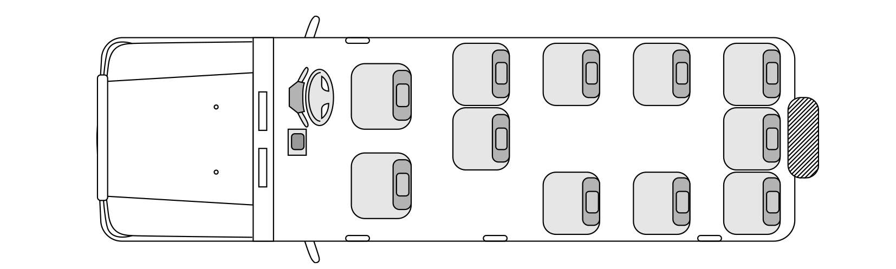Configuration

Notes

With its extended bulk, this vehicle may only be driven by a qualified driver/guide and is not available for self-drive hire.