This compact 4x4 safari vehicle will easily navigate the gravel roads. With a pop-up roof, large sliding windows and being higher off the ground, you’re better positioned for epic wildlife viewing and unobstructed panoramic photographs of the incredible landscape that surrounds you.

|  |  |
| --- | --- |
| Safari vehicle with pop-up roof |  |

|  |  |  |
| --- | --- | --- |
| Specifications   * 6 or 7 passenger seats including driver (4 window seats excluding the front passenger seat ) * Air conditioning (front only) * Power steering * Electric windows (front only) * Pop-up rooftop * Radio/CD player/USB * Air bags (front only) * ABS brakes * Manual gearbox (5 forward gears) * 80 litre fuel tank(≈650km range) * 2.5 litre diesel engine * 4-wheel drive * Low range * Diff lock * Traction control (except in one vehicle) * Tyre size 17” | Included   * Unlimited kilometres * Cooler box * GPS vehicle tracker * Additional driver * 2 spare tyres * First aid kit * Breakdown triangles * Fire extinguisher * Tyre gauge * Standard insurance excess * Collision and Theft Cover * Tyre and windscreen insurance * Passenger liability * Vehicle procedures and information * GPS navigation system * [Day room facilities](https://www.namibia-tours-safaris.com/about-us/windhoek-day-room) at our Windhoek depot * 24/7 Assistance * NTS vehicles are insured for an EVAC or to call the centre for help when sick | Extra Options   * One-way rental * Extra spare tyre * Driver/guide * Child and booster seats * Luggage trailer * Air compressor * Jumper cables * Jerry cans * Satellite phone * Cross border permission letter (no additional charge) * 12v fridge * Airport return transfers |

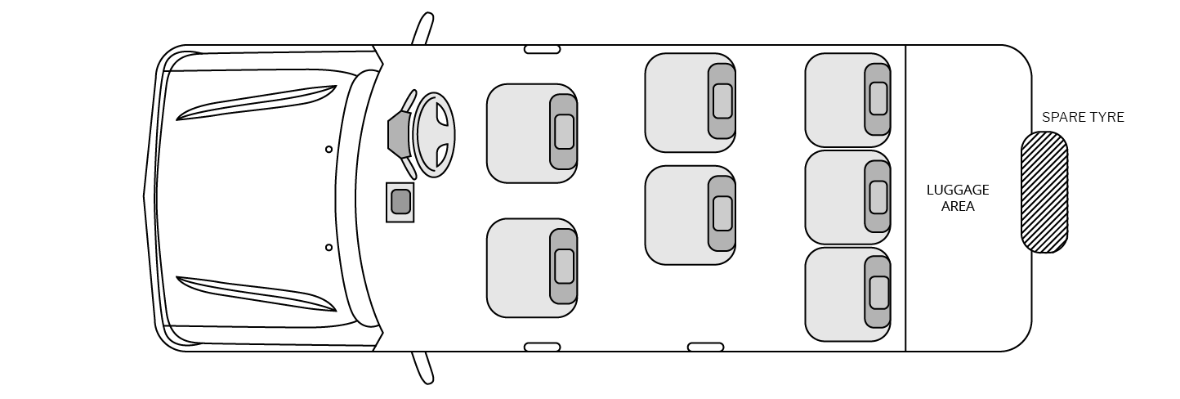Configuration