This custom-built safari vehicle offers exceptional comfort and visibility paired with the reliability and power of a 4x4. Six of the eight passenger seats have large windows, the roof pops up and we've thrown in air conditioning to sweeten the deal.

|  |  |
| --- | --- |
|  |  |

|  |  |  |
| --- | --- | --- |
| Specifications   * 9 seats (6 window seats) * Air conditioning * Pop-up rooftop * Music player * ABS brakes * Extra fuel tank (≈2,000km range) * 4.2 litre diesel engine * 4-wheel drive * Low range * Diff lock | Included   * Unlimited kilometres * Cooler box * GPS vehicle tracker * Additional driver * 2 spare tyres * First aid kit * Breakdown triangles * Fire extinguisher * Tyre gauge * Standard insurance excess * Collision and Theft Cover * Tyre and windscreen insurance * Passenger liability * Vehicle procedures and information * GPS navigation system * [Day room facilities](https://www.namibia-tours-safaris.com/about-us/windhoek-day-room) at our Windhoek depot * 24/7 Assistance * NTS vehicles are insured for an EVAC or to call the centre for help when sick | Extra Options   * Reduced excess * One-way rental * Extra spare tyre * Child and booster seats * Luggage trailer * Air compressor * Jumper cables * Jerry cans * Satellite phone * 12v fridge |

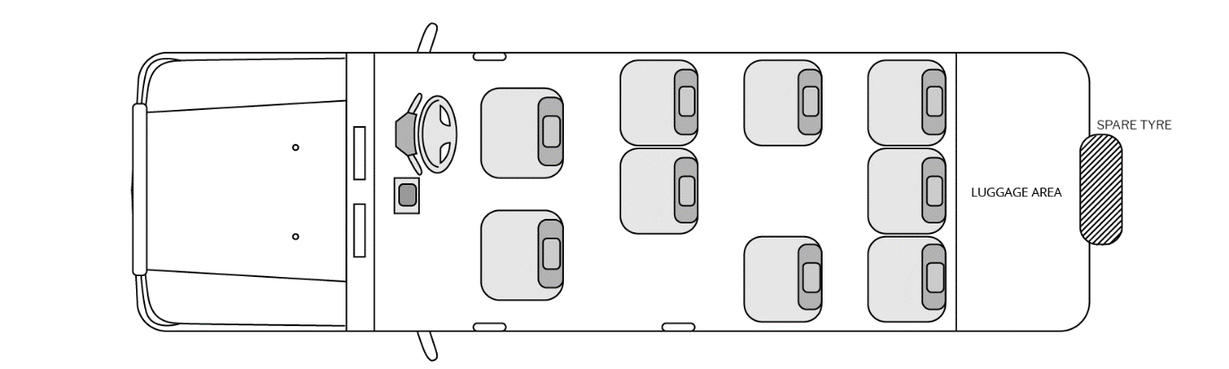Configuration

Notes

With its extended bulk, this vehicle may only be driven by a qualified driver/guide and is not available for self-drive hire.