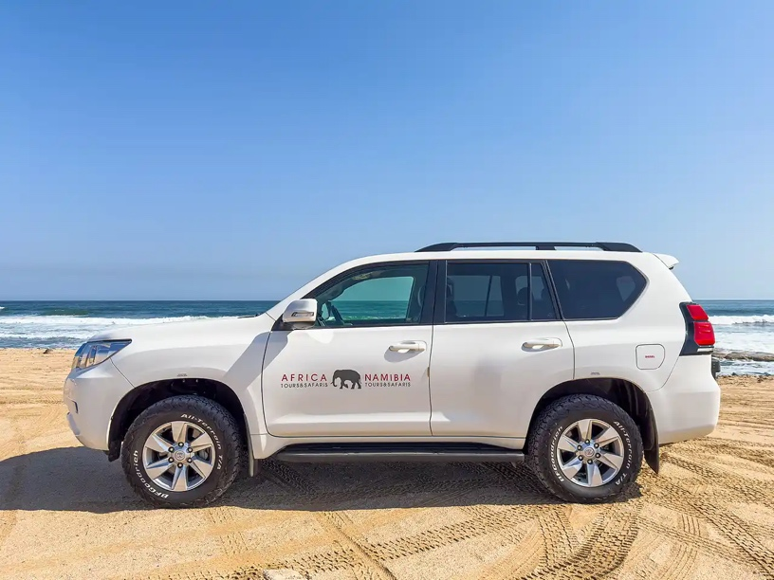Our Toyota Prado 4x4 rental vehicles offer a great combination of comfort, space and rugged off-road capability for your Namibian safari.

|  |  |  |
| --- | --- | --- |
| Specifications   * 4 seats (max 3 passengers plus guide) * Air conditioning * Music player * ABS brakes * Automatic gearbox * 150 litre fuel tank * 3 litre diesel engine * 4-wheel drive * Low range * Diff lock | Included   * Zero Excess * Unlimited kilometres * Cooler box * GPS vehicle tracker * 1 spare tyre * First aid kit * All standard vehicle accessories * Breakdown triangles * Fire extinguisher * Tyre gauge * Standard insurance excess * Collision and Theft Cover * Tyre and windscreen insurance * Passenger liability * GPS navigation system * [Day room facilities](https://www.namibia-tours-safaris.com/about-us/windhoek-day-room) at our Windhoek depot * 24/7 Assistance * NTS vehicles are insured for an EVAC or to call the centre for help when sick\ | Extra Options   * One-way rental * Extra spare tyre * Child and booster seats * Fridge * Luggage trailer * Air compressor * Jumper cables * Jerry cans * Satellite phone * Airport return transfers |

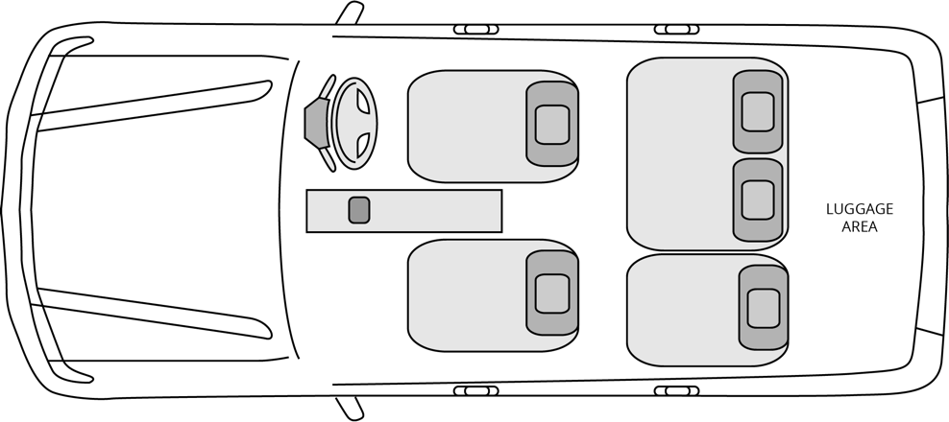

Configuration