Ideal for 2 travelers, this comfortable vehicle has good on- and off-road performance and is fully equipped for camping with rooftop tent.
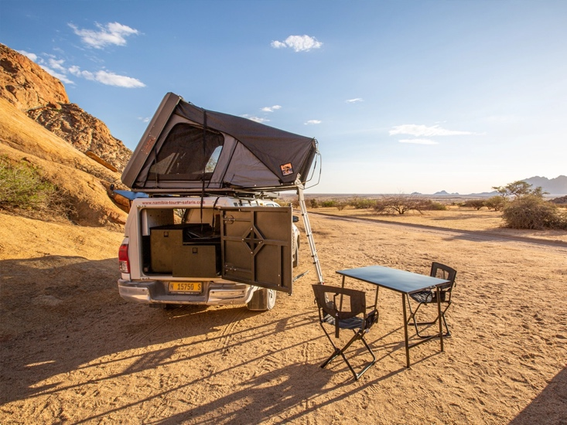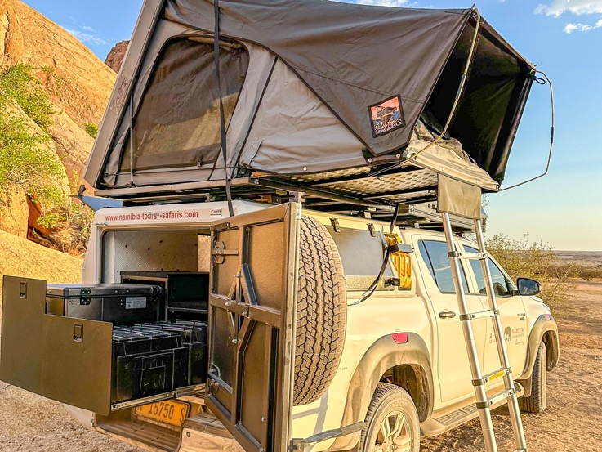

Specifications  - 2 passengers  - Air conditioning  - Power steering  - Electric windows  - Radio/CD player/USB  - Air bags  - ABS brakes  - Automatic gearbox  - 80 litre fuel tank(≈750km range)  - Additional 80 litre fuel tank  - 2,4 litre diesel engine  - 4-wheel drive  - Low range  - Diff lock  - Cruise control  - Traction control  - Tyre size 17” | Included  - Unlimited kilometres  - Cooler box  - GPS vehicle tracker  - Additional driver  - 2 spare tyres  - First aid kit  - Breakdown triangles  - Fire extinguisher  - Tyre gauge  - Jumper cables  - Standard insurance excess  - Collision and Theft Cover  - Tyre and windscreen insurance  - Passenger liability  - Vehicle procedures and information  - GPS navigation system  - Day room facilities at our Windhoek depot  - 24/7 Assistance  - Camping equipment for 2 people (see list below)  - Jerry Can (on request)  - Air compressor  - NTS vehicles are insured for an EVAC or to call the centre for help when sick | Extra Options  - Reduced excess  - One-way rental  - Extra spare tyre  - Child and booster seats  - Luggage trailer  - Satellite phone  - Cross border permission letter (no additional charge)  - Airport return transfers

Camping equipment for 2 people includes:
Camping Equipment  - Custom Leisure Tech Tent / Standard Tentco 2.5m x 1.3m  - Mattresses  - Camping table  - Camping chairs  - 55 litre water tank  - 3kg gas cylinder & cooker top  - Fridge  - Fridge spare fuses (20 amp)  - Flashlight & Outside Lamp  - BBQ grid & BBQ utensils  - Collapsible dishwashing bowl  - Collapsible tripod  - Sleeping bags  - Small broom with dustpan  - Pillows & Pillowcases  - Mattress sheet  - Bedding  - Towels  Vehicle Equipment  - Storage box  - Spade  - Booster cable set  - Tyre pressure gauge  - Tyre repair kit  - First aid kit  - Fire extinguisher  - Jumper cables  - Tow rope  - Tyre  - Air compressor | Kitchen Equipment  - Plates, side plates & bowls  - Forks, knives, tablespoons & teaspoons  - Medium cooks knife & small knife  - Scissors  - Glasses  - Coffee / tea mugs  - 1L Flask  - Aluminium kettle  - Coffee plunger  - Can & bottle opener  - Potato peeler  - Spatula  - Strainer  - Plastic cutting boards  - Wooden trivet  - Aluminium bowls  - Aluminium BBQ Casserole  - Jug  - Cooking pots  - Small cast iron frying pan  - Braai Mitten  - Kitchen towel  - Dishcloth  - Gas lighter

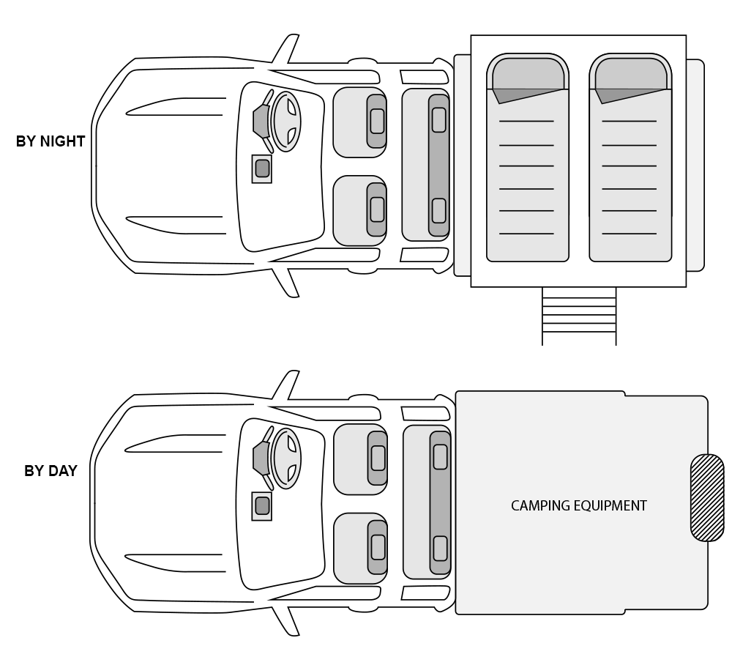
Vehicle Configuration

