[Insert Project Title]
Procurement Plan
[Insert month year]

Document Control
[This section is to keep track of who prepared the document, who reviewed it and who it was intended to be distributed to.]

Version History

Version No | Description | Date
0
1
2

Distribution

This Procurement Plan is prepared for distribution to:
Copy | Name | Position | Organisation
1
2

Authorisation Record

Prepared By
Project Manager | Name | Signature | Date
Review By
Project Director | Name | Signature | Date

Table of Contents
2 Introduction 4
2.1 Purpose of the Plan 4
3 Key Principles & Objectives 5
4 Procurement Delegations and Thresholds 5
5 Key Dates and Works 6
5.1 Key Dates 6
5.2 Key Project Works Packages 6
6 Contract 7
6.1 Contract Options 7
6.2 Contract Matrix 7
7 Decision Criteria 8
7.1 The Criteria 8
7.2 Contract Methodology Assessment 8
8 Procurement Risks, Management & Constraints 9
8.1 Procurement Risks 9
8.2 Procurement Risk Management 9
8.3 Procurement Constraints 9
9 Approval Process 10
10 Vendor Management 11
10.1 Tracking Vendor Procurements 11
10.2 Roles and Responsibilities 11
11 Performance Metrics 12
12 Standardised Procurement Documentation 12
13 Procurement Administration 12
Appendices 13
13.1 Appendix 1 13

Introduction
[Succinctly summarise the purpose of the plan in relation to the Organisational governance and the project.]

Purpose of the Plan
The Procurement Plan is the primary document used for planning and tracking the project’s procurements. It describes how procurements will be throughout the project lifecycle.
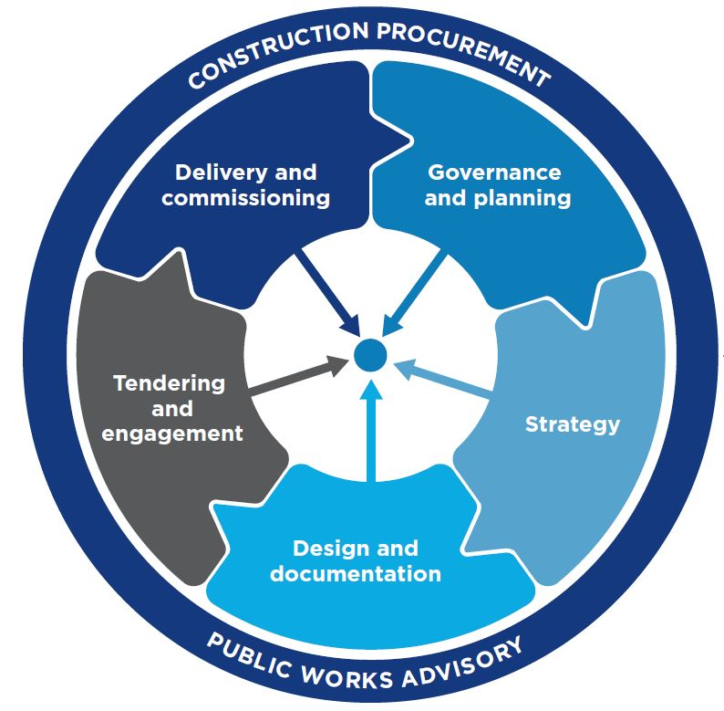

This project will apply the project management practices outlined in the PMBOK Project Management models, including relevant processes, governance and controls that are appropriate to the level of complexity of the project.

The Mastt System will be utilised to support the management of this project at a portfolio, program and/or project level.

This document does not replace, detract, or eliminate any existing Organisational policies and procedures, and is intended to be used in conjunction with relevant policies and procedures already in place.

The Procurement Plan is designed to be reviewed periodically and kept current and will be updated where material changes occur that impact the business case on which the project is based.

The Procurement Plan is a key management deliverable. The Project Manager is responsible for its production and upkeep during the project lifecycle, seeking input as required.

Methodology
The Procurement Plan outlines the following 10 stages of a proposed Procurement Lifecycle

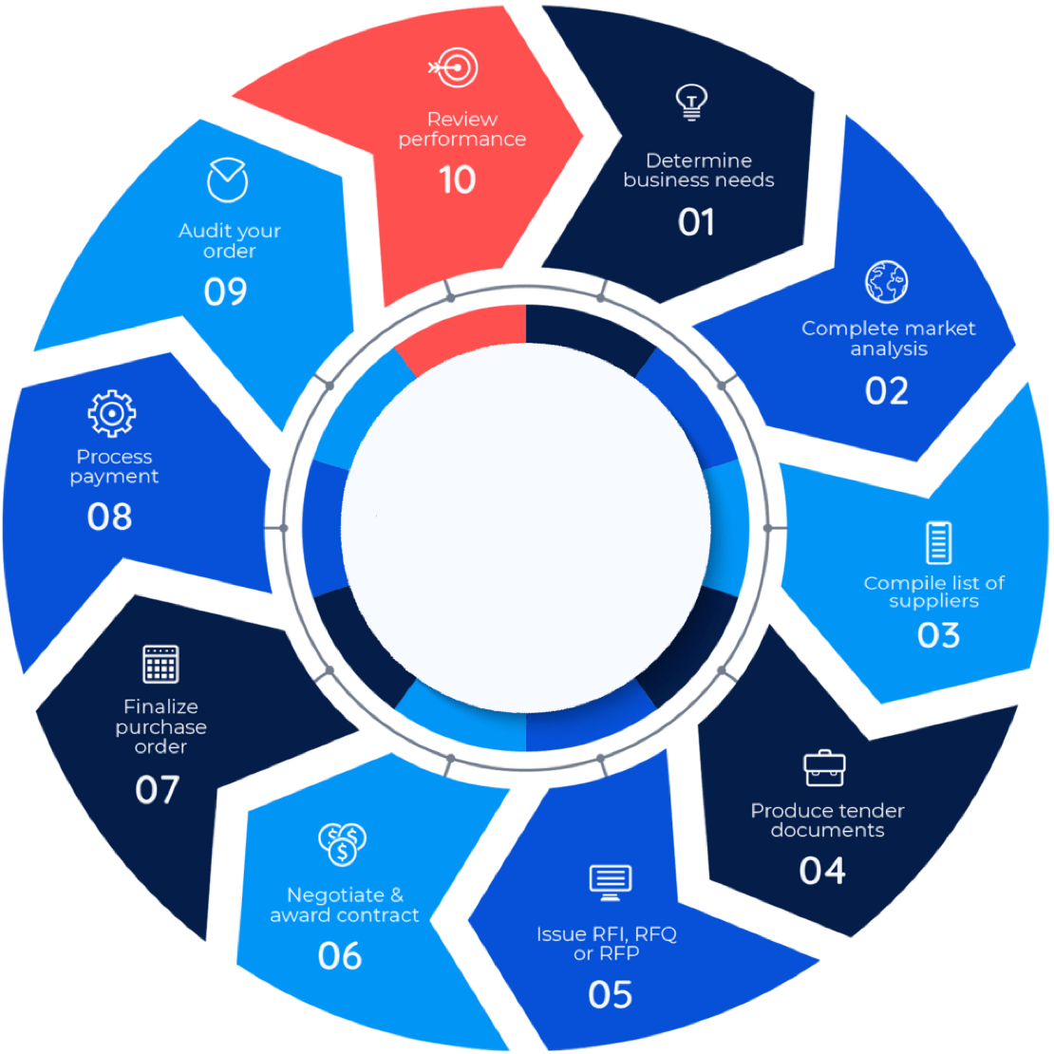

Key Principles & Objectives
[Outline the key principles for the project procurement and list the objectives of the Plan.]

The following key principles to be considered in this procurement plan:
- Value for money
- Probity and Fairness
- Conflict of Interest
- Assessment of Value and Risk
- …

The Procurement Plan objectives are:
- …

Procurement Delegations and Thresholds
[Identify the breakdown of monetary approvals within the organisational governance structure.]

The project procurement will be carried out with the delegated approval structure and procurement thresholds per the following diagram:

Procurement Value | Authority to Approve | Process
Up to $100k | CFO
$100k - $250k | CEO
Greater than $250k | Board
…

Key Dates and Works
[Summarise the completed/forecast milestone dates as well as the works packages that need to be completed. This will provide an understanding key metrics for procurement.]

Key Dates
The milestones for the project are as follows:

Milestone Description | Forecast Completion Date
…

Key Project Works Packages
The project will consider the following key works:

Contract
[Outline the types of contracts that could be used with the risks and benefits to understand which contract is most appropriate, based on project objectives.]

Contract Options
The following contracts could be considered for the procurement and delivery of the project:
- Construct Only
- Design & Construct (D&C)
- Early Contractor Involvement (ECI)
- …

Contract Matrix
Contract Types | When to use | Risks | Benefits
Construct Only
Design and Construct (D&C)
Early Contractor Involvement (ECI)

Decision Criteria
[Outline the criteria to assess the methodologies and the possible options to provide the best outcome for the project.]

The Criteria
The procurement will be assessed based on:
- Cost
- Schedule
- Risk
- Quality
- …

Contract Methodology Assessment
To choose which procurement and delivery methodology would best align the program to deliver the project, the following options were formulated:

The comparison of these to the achievement of key project milestones is as follows:
Options | Milestone 1 | Milestone 2 | Milestone 3 | Notes
1
2
3

Procurement Risks, Management & Constraints
[Identify the specific procurement risks for the project and how these will be managed, as well as the constraints.

Procurement Risks
The following procurement risks have been identified:

Procurement Risk Management
The procurement risks will be managed by:

Procurement Constraints
Procurement constraints should be identified and considered as part of the procurement management process. The constraints specific to this project include:
- Schedule
- Cost
- Scope
- Resources
- …

Approval Process
[Detail the workflow i.e., how the Project Manager and Organisation will work together to recommend and approve the procurements.]

The approval process for contracts is as follows:
- …

Vendor Management
[Track the procurement status of the vendors and outline roles and responsibilities of the project team to keep this on track.]

Tracking Vendor Procurements
The following table lists the procurement activities for this project:

Name | Procurement Type | Closed Date | Awarded To | Stage

Roles and Responsibilities
A register of the roles and responsibilities for those involved in the procurement process and vendor management is below:

Role | Name/s | Contact Details | Responsibilities
Project Manager
…

Performance Metrics
[Explain how the vendors’ performance will be evaluated.]

To evaluate the performance of the vendors post-engagement, the following metrics will be applied:
- Schedule
- Quality
- Cost
- …

Standardised Procurement Documentation
[Detail which documents will be used, i.e. if there is an organisational template preferred or otherwise.]

For this project and the selected procurement and delivery methodology, the standard procurement documentation will include:
- Request For Quotation
- Request For Tender
- Letter of Award
- …

Procurement Administration
[Briefly outline other procurement expectations in terms of general tasks and activities.]

Records of all actions and decisions for any procurement is important and should be kept in a manner that facilitates auditing and other processes of accountability.

Appendices

Appendix 1
[insert]

