[Insert Project Title]
[INsert company name] | [Insert Company Address]
project charter
[Insert month year]
Document Control
[This section is to keep track of who prepared the document, who reviewed it and who it was intended to be distributed to.]

Version History

Version No | Description | Date
0 | Draft | DD/MM/YYYY
1 | Revised Draft | DD/MM/YYYY
2 | Final | DD/MM/YYYY

Distribution

This Project Charter is prepared for distribution to:
Copy | Name | Position | Organisation
1
2

Authorisation Record

Prepared By |  |  | DD/MM/YYYY
Project Manager | Name | Signature | Date
Review By |  |  | DD/MM/YYYY
Project Director | Name | Signature | Date

Table of Contents
1. Introduction 4
2. Scope of Responsibilities 5
2.1 Values and Behaviours 5
2.2 Project Health Responsibilities 5
2.3 Risk 7
2.4 Stakeholders 8
2.5 Boundaries 8
2.6 Milestones 9
2.7 Resources 9
2.8 Quality 10
2.9 Reporting 10
2.10 Deliverables for Gate [Insert Name…] 10
2.11 Delegations 12
3. Agreement 13
Appendices 15

Guidance Notes
[The primary purpose of a project charter is to formally authorise the initiation of a project and establish its high-level objectives, scope, stakeholders, and key deliverables. It provides a roadmap for the project team to follow throughout the project lifecycle. This section is to be deleted]
- Project Charters can be provided to a project team or an individual.
- The choice in providing a charter to the team or the individual is formally determining the project structure, how value is derived, complexity of achieving the outcome and constraints.
- These decisions are designed to avoid scope creep and maintain clarity of purpose amongst the stakeholders.
- These individual charters are designed for moderate to complex projects and should be used in conjunction with the Governance Plan.
- The parties to the Charter are the signatories in the Agreement and include the Board representative and the individual referred in this Charter as ‘Board’ and ‘Your’.
- The project charter should be reviewed at each gate in conjunction with the project health descriptors.

Introduction
[Complete the below marked sections to provide a succinct Introduction to your Project Charter. Example text has been included in the below.]
The Project [...] was formally requested by [‘I. Need’] (the Sponsor) and approved by the Board on [...] at decision [...]. The project will be a success if […]. The Project […] Governance Plan (PGP) provides the outcomes and outputs for this project. The Board has assigned project health criteria to individuals through charters. This Charter is issued to […] for Gate […].

This Project Charter follows a method outlined in the diagram below. Central to this Project Charter is structure (this document), scope, best practices, processes, communication and definitions.
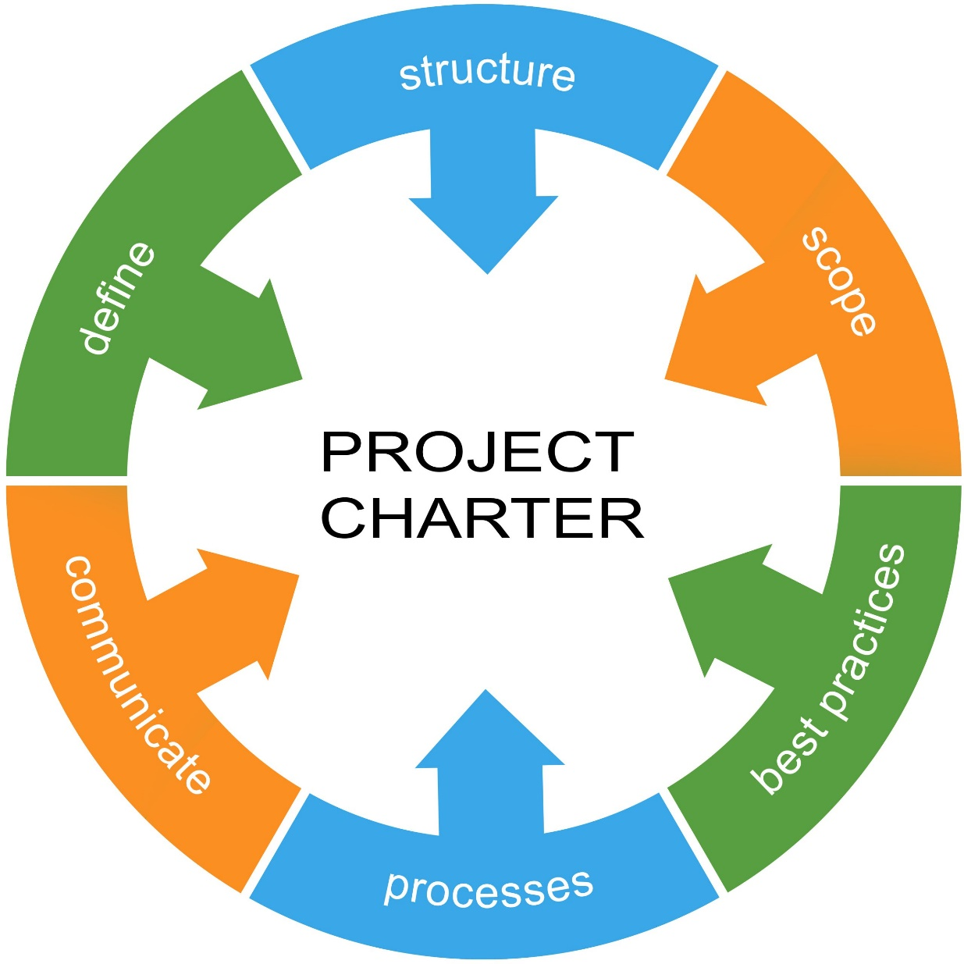

Scope of Responsibilities
[Provide a high-level overview of the project, outlining key objectives, scope, stakeholders, and deliverables etc. Example sections and supporting text has been included in the below.]

Values and Behaviours
Duty of Care
The Board and the individual agree that a duty of care exists to avoid any behaviours or omissions that could reasonably be foreseen to cause harm to other people and organisations. Harm is used in the broadest sense to include all project health criteria in the Governance Plan.

Conflicts of Interest
A conflict of interest (perceived, potential, actual) exists where a situation arises where the concerns or aims of two parties are incompatible. The Board and the individual agree that prudent identification of upcoming activities will consider conflicts of interest. If a conflict of interest is identified the Board and Individual will jointly take steps to document mitigation measures.

Access to Information
The Board is responsible for establishing the information access protocols. The individual agrees that they will only access information relevant to their role in a manner authorised by the Board. Any issues will be reported at the earliest opportunity.

Single Source of Truth
The Board has authorised the Project Management Information System (PMIS) is the authoritative information source. You are responsible for validating any corporate system information into the Project Management Information System.

Project Health Responsibilities
The Board remains accountable for all Project Health Criteria.

The Board has allocated responsibility in this Charter for the following Project Health Criteria: [The following list and associated criteria are examples that can be used and amended accordingly].

Health Item | Green | Amber | Red
Safety – Injuries | No LTIs | A single dangerous or notifiable incident | One or more dangerous or notifiable incidents
Safety – Safe System of Work | Safe systems of work are specifically identified for all legislated and project activities | Safe systems of work are implied without specific individual responsibilities allocated | No safe systems of work are evident
Security – Breaches | No breaches of any information | Isolated breach resulting from error, but system is functioning | More than one breach demonstrating an ineffective system that requires remedial activities
Financial – Forecast | Uses WBS with formal contingency planning | Uses WBS | Uses extrapolation
Financial – Cashflow | Uses extant planning baseline with suitably skilled people identifying integrated WBS risks (including cascading) and predictive algorithms | Uses WBS without integrated cascading risks | Uses some other method
Risk | Risks (after treatment) remain within acceptable limits that continue to deliver the accepted outcomes | Risks are identified and treatment plans are established. Minor compromise to a component of the intended benefit may occur but the project will deliver a better outcome than the next best option in the business case. | Risks emerge outside of other health criteria that compromise the project delivery. Consideration is given to terminating project as it either fails to deliver the intended outcomes OR the next best option of the business case becomes viable.
Scope | Expected to deliver all baseline approved scope. Contingency potentially but not fully used and returned or used in benefit enhancements. | Variations within budget are required to deliver baseline scope. Variations may defer ancillary items, reduce quality and transfer to higher maintenance or operational costs, impose a higher risk profile on project delivery, create stress within the stakeholder team, require indemnities or delay timing of the benefit realisation. | Scope change (rather than variations) is required outside the business case. Project delegations are exceeded. Late identification may incur ongoing costs and deferment of benefit realisation.
Time | Meet or exceed target. Less than 2 months (or 20%) variation from approved schedule. | Variation of > 2 months (or > 20% of total project duration) | Variation of more than 6 months (or >50%) impacting construction completion.
Quality | Issues are being managed without flow-on impacts. No other risks relating to, e.g.: - quality/compliance - site specific conditions - community | Indicates risks that will require extra attention and increased vigilance. Issues are being managed with some flow-on impacts. | Indicates risks that require immediate attention or are of major concern. Issues are unable to be managed without significant impacts.

Risk
Project risks outside your delegation must be identified on the risk register. You are responsible for identifying all risks related to your assigned project Health criteria including subsequent gates. All deliverables (outputs) that you support but are not responsible for must be identified in the risk register.
Project risks that are within your delegation are not required to be recorded in the risk register. You may choose to record specific risks as a communication tool or to justify resources for mitigation.

Stakeholders
Stakeholders you are authorised to consult with are identified within the communications annex of the Project Management Plan (PMP).
All silent stakeholders must include suitable hypotheses testing. Silent stakeholders are a broad group of individuals that are likely to exist in subsequent gates or are vulnerable (lack of capability). In developing recommendations for Board decisions suitable plans must be developed that include all relevant information regarding their expected interests. Whilst this does not need to be correct, recommendations need to enable the board to understand and make decisions around project success and in the worst case employ the ‘business judgement rule’ if there are deleterious consequences.
Project staff often have shared responsibilities. If a charter is issued to a person on this project providing you information, then you are not required to check its accuracy. However, if you receive information from a person or organisation that does not have a charter then you must truth check the information.

Boundaries
Assumptions
Assumptions are progressively tested as project information becomes available. During the early gates assumptions are accepted as plausible. Assumption, if untrue, have a material effect on the outcome or outputs or both. If you receive information that contradicts project assumptions these are to be provided to the Governance Board. During this gate, the Board has directed you to make the following assumptions:
- [Insert assumption…]
- […]

Constraints
You are authorised to do all things pertaining to your delegation except:
- Making agreements beyond this gate without prior approval of the Board.
- Providing scope changes (additions or reductions) without prior Board approval. For the avoidance of doubt, the Board authorises you to approve variations in accordance with your delegations.
- You are not authorised to provide media comment.
- You are not authorised to release information to people outside the project except on a need-to-know basis for a relevant statutory authority.
- […]

Milestones
The Gate has been set by the Board. The Board has balanced outcomes [list relevant outcomes] to establish the gate date of [DD/MONTH/YEAR]. The milestones established within this gate are:
- [List milestones…]
- […]
- […]

If you are unable to achieve any milestones, you are to immediately advise the Governance Board. For the avoidance of any doubt this includes if the appropriate people do not attend scheduled meetings or fail to provide suitable information. Similarly, you must provide suitable time for people to assemble the required information.

Resources
Money
You are allocated the following budget [$..] for each milestone. Contingency has been allocated in the amount of [$…] for use against risks [List key risk numbers…].
If risks are realised and the contingency used is likely to exceed the allocated contingency the Board must be notified including options based upon trade-offs with deliverables.

Human Resources
Human resources are all those non-procured project resources. This includes project volunteers within the organisation that to attribute their resources to the capitalised project cost. It also includes stakeholders and other volunteers outside of the organisation.
You are responsible for satisfying all volunteer stakeholders, so they remain engaged in a timely manner to support project activities. You must support their activities so that their contributions are manageable within their project resource commitment.

Quality
Quality is differentiated into product (outcomes) and process (outputs). Quality of product manifests at project completion when the asset is capitalised. Quality of process relates to your activities to achieve the outcome. Any proposed quality trade-offs must be reported to the Board.
Your quality of product responsibilities include:
- Functionality of purpose
- Minimising the total cost of ownership by balancing build costs with operating and maintenance costs using the organisational policies [e.g. Outturn or discounted cashflow]
- [….]
Your quality of process responsibilities include:
- Ensuring all information provided to other stakeholders is truthful and relevant for their purpose.
- Assumptions are tested based upon available information.

Reporting
Reporting relies on each person with a charter entering information into the Project Management Information System as it becomes available. No routine reports are required for stakeholders as the information can be extracted when required.
By exception reporting occurs when the health criteria is not green. A by exception report must include: an earned value management component for time and cost along with an appropriate quality and HR considerations.
Quarterly reports are required for the Board. These include your forecast of achievement of each outcome and output based upon documentary evidence. You are not authorised to make a forecast without suitable documentary evidence.

Deliverables for Gate [Insert Name…]
Your deliverables are integrated through the Project Management Plan. Any changes to the Project Management Plan trigger a review of your deliverables. If a change is required, you are to inform the Board Chair. The deliverables for this project gate are: [The following list and supporting text are examples that can be used and amended accordingly].

Specific Deliverable | Formal authority provided by | How Measured | Provided to | When
Board Report | Charter | Board recommendations have the lowest opportunity cost. | Board | Quarterly
Conflict of Interest | Charter | Assumed no conflict of Interest unless a declaration is made | Board | On occurrence
Health Criteria Deviation | PGP | Project Health descriptors of green, amber and red. | Board | On occurrence
Update Risk Register | Charter | All use of mitigation resources are included | Board | As directed
Stakeholder engagement (this gate) | PMP | Board directed surveys | Board | As directed
Silent Stakeholder engagement | PGP Outputs & Outcomes | Future phase plans | Board | Next phase PMP
Assumptions testing | PGP Outputs | All courses of action recommendations operate within the Green Project Health Criteria after accounting for uncertainty. | Board | Next phase PGP & PMP
Volunteer Resources | PGP | Surveys against tasks allocated or requested | Board | Quarterly
Money | Output (Cashflow) | Purchase Order (total amount) | Board | Quarterly
Quality (Outcome) | PGP Outcome | Deviation | Board | On occurrence
Quality (Output) | PGP Output | Included statement in PGB report | Board | Monthly
Quality (Output) | PGP Output | Deviation | Board | On occurrence
Delegations | Charter | Recorded on PMIS | Board | As directed
Continuous Improvement | PGP | Post event analysis of the opportunity cost of each Board recommendation | Board | Each milestone

Delegations
You [are/not] permitted to delegate responsibility for a deliverable. You must provide written documentation of the delegation on the Project Management Information System. You are still accountable to the Board for the deliverable.

Agreement
[This section details the agreement between the key personnel, with each acknowledging the terms of the Project Charter. Example text has been included in the below.]

The Board representative affirms that they have:
- Identified all outcomes and outputs for this project and included these in the Project […] Governance Plan.
- The approved Project […] Management Plan is aligned with the Project […] Governance Plan for this Gate […]
- Other charters are integrated with this charter especially related to shared risks and delegations.

The Individual issued this Project Charter affirms that they:
- Understand the scope of their responsibilities, and
- Have made the appropriate consultations with:
  - [List all the stakeholders…].
  - […]; and
  - […].
- Have the necessary skills and resources to perform their responsibilities, and
- There is no ethical impediment to undertake their duties, and
- There are no other responsibilities that are no known or likely to impact on their activities for this Gate.

Board Representative |  | Individual issued Project Charter
Name |  | Name
Role |  | Role
Signature |  | Signature
Date |  | Date

If an integrated project team exists between entities the following Agreement should be used to confirm that the obligations in the contract are consistent with this charter. Contract clauses impacting on this Agreement between the Board and the Individual identified include:
- Specified Personal [Clause …] [do not align/align] with this Charter.
- Scope of Responsibilities [Clause …] are consistent with this Charter.
- Notices of potential variations will be identified by the Board and the Individual and provided to the Contractor Authorised representatives.
- Management of risk, especially shared risk, effecting claims will have documentary evidence provided.

Client Authorised Representative |  | Authorised Employer Representative
Name |  | Name
Role |  | Role
Signature |  | Signature
Date |  | Date

Appendices

