[Insert Project Title]
[INsert company name] | [Insert Company Address]
Project Control Group Report
[Insert month year]
Document Control
[This section is to keep track of who prepared the document, who reviewed it and who it was intended to be distributed to. This report is populated with example text as a guide. Use the Mastt Project Report Template for your own information.]

Version History
Version No | Description | Date
0 | Draft | DD/MM/YYYY
1 | Revised Draft | DD/MM/YYYY
2 | Final | DD/MM/YYYY

Distribution
This PCG is prepared for distribution to:
Copy | Name | Position | Organisation
1 | Max Power | Program Manager | Globetrotters Pty Ltd
2 | …

Authorisation Record

Prepared By | Jackson Mulét |  | DD/MM/YYYY
Project Manager | Name | Signature | Date
Review By | Jay Walken |  | DD/MM/YYYY
Project Director | Name | Signature | Date

Table of Contents
1. Executive Summary 5
1.1 Project Current Status 5
1.2 Major Program and Project Concerns, Risks and Opportunities 5
1.3 Project Look Ahead 6
2. Actions from Previous Meeting 7
2.1 Forthcoming Decisions and Actions 7
2.2 Approvals Schedule 7
3. Compliance 8
3.1 Summary of Compliance 8
3.2 Work Health and Safety (WHS) 8
3.3 Declaration of WHS Compliance 8
3.4 Dispensations and Alternative Solutions 8
3.5 Environment and Biodiversity 8
3.6 Property 8
3.7 Security 8
3.8 Anti-Bribery and Corruption 8
3.9 Modern Slavery 9
3.10 Heritage 9
3.11 Quality 9
3.12 Complaints 9
3.13 Media Releases 9
4. Legal Matters 10
4.1 Landowner’s Consent 10
4.2 Lease Agreements 10
5. Authorities 11
5.1 Statutory Approvals 11
5.2 Utilities 11
6. Procurement 12
6.1 Consultant Appointments 12
6.2 Head Contractor Appointment 12
7. Design 13
7.1 Design Status 13
7.2 Value Engineering 13
7.3 Requests for Information 13
8. Construction 14
8.1 Construction Status 14
8.2 Upcoming Activities 14
9. Program / Schedule 15
9.1 Program / Schedule Status 15
9.2 Milestones 15
9.3 Foreseen Delays 16
9.4 Notice of Delays 16
9.5 Extensions of Time 16
10. Cost 17
10.1 Project Budget 17
10.2 Cash Flow 17
10.3 Final Forecast Cost 18
10.4 Reimbursables / Provisional Sums 19
10.5 Variations 19
11. Risk, Issues & Opportunities 20
11.1 High Risks 20
11.2 Realised Risks & Issues 20
11.3 Opportunities 20
12. Stakeholders 22
12.1 Stakeholder Register 22
12.2 Engagement Update 22
13. Project Closure 23
13.1 Commissioning & Handover Plan 23
13.2 Defects Management & Maintenance Summary 23
14. Lessons Learned 24
APPENDICES 25
APPENDIX A – Risk Register 25
APPENDIX B – Previous Meeting Minutes 25
APPENDIX C – RFI Register 25
APPENDIX D – Schedule 25
APPENDIX E – Cash Flow 25
APPENDIX F – Cost Report 25
APPENDIX G – Variations 25
APPENDIX H – Stakeholder Register 25
APPENDIX I – Contractor Report 25

Executive Summary
[Summarise the key activities in the last reporting period with a brief overview and Red/Amber/Green health status. The intent is to enable the Reporting Group to quickly identify activities, issues, and upcoming works.]
This is the Monthly Project Report for the New Hospital Development for February 2022.

Project Current Status
The following is a status of items in the last period:
Item | Status (RAG) | Description
Scope |  | Significant change in scope to integrate the new HVAC system with the existing building services.
Time |  | Some delays to update the design and undertake investigations for the new HVAC system.
Risk |  | Risks identified and mitigated.
Safety
Quality
Cost
Cashflow

Major Program and Project Concerns, Risks and Opportunities
The project Risk Register is included at Appendix A, with an overview as follows:
- A total of 23 project risks recorded.
  - 3 have a risk rating of ‘very high’
  - 7 have a risk rating of ‘high’

The most significant risks to the project are currently:
01 Covid 19 Issues
As a consequence of the Covid 19 pandemic, restrictions were imposed which have caused major project delays and incurred additional costs to the project…
02 Contamination Issue
The contamination report identified the presence of non-friable asbestos in various locations…

Project Look Ahead
The key activities forecasted to be complete in the next period are as follows:
- Site establishment, scheduled for 12/03/2022.
- Tree removal works
- Services location

Below is a “One Click Mastt Project Report” – With Mastt you can eliminate the hours spent manually creating this report and create it with one click.

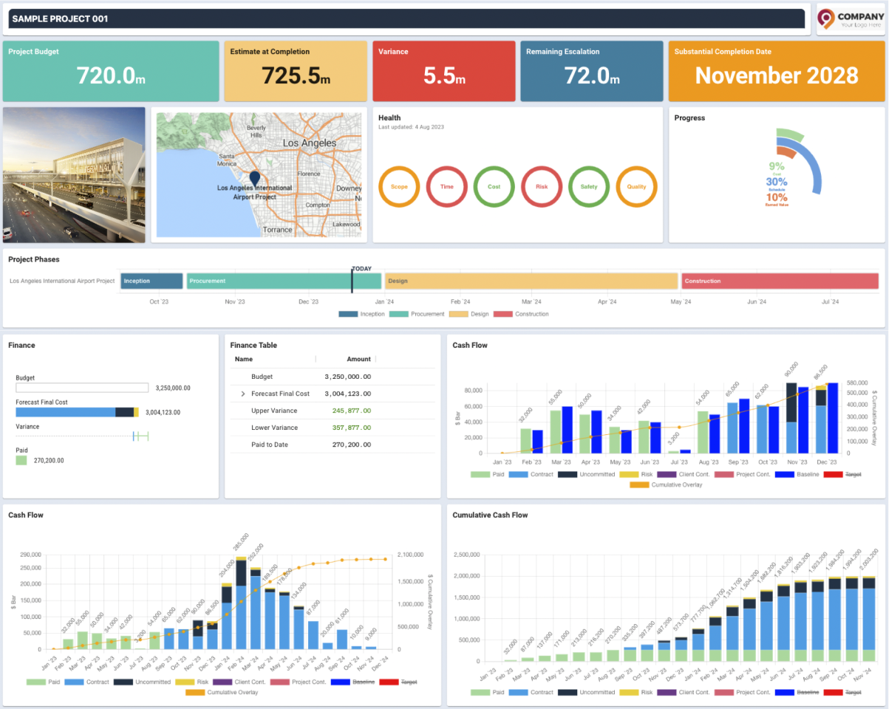

Actions from Previous Meeting
[Include the actions from previous monthly meeting minutes and/or include as an appendix.]
Please see Minutes from the Previous Meeting dated 30 January 2022 in
Appendix B.
n the right is an
[Summarise the forthcoming decisions and actions the Reporting Group is required to make to progress the project, as well as show the previously confirmed decisions for record purposes and clarity. It’s good practice to keep descriptions brief with a clear actioner and target date for the decision to be made.]

Forthcoming Decisions and Actions
The following key decisions and actions are required in the next period:
Item | Description | Action | Target Date
1 | Agreement to engage Lead Design Consultant | Client | 30/05/2021
2 | …

Approvals Schedule
The following schedule captures the key approvals:
Item | Description | PCG Approved | Comments
1 | Engagement of PMCA | 21/02/2021 | Completed
2 | Proceed with feasibility works | 03/04/2021 | Completed (agreed in workshop)
3 | …

Compliance
[Legislation often requires projects to meet compliance items listed below and provide a status against each in the previous period.]

Summary of Compliance
In the last period there have been 12 reportable compliance matters.

Work Health and Safety (WHS)
The following WHS incidents were reported in the last period:
- A first aid incident, 22/01/2021 – A carpenter lost balance while loosening a tie and cut their arm on formwork. The carpenter was taken to a clinic where the wound was cleaned, no stitches were required. The carpenter was back at work the same day.

Declaration of WHS Compliance
In the last period there were nil outstanding issues relating to compliance.

Dispensations and Alternative Solutions
Nil new dispensations are currently sought.

Environment and Biodiversity
Nil environmental and biodiversity incidents to report in the last period.

Property
Nil property incidents to report in the last period.

Security
Nil security incidents to report in the last period.

Anti-Bribery and Corruption
Nil anti-bribery and corruption incidents to report in the last period.

Modern Slavery
Nil modern slavery incidents to report in the last period.

Heritage
Nil heritage conservation incidents to report in the last period.

Quality
Audit & Inspection Test Points conducted the last period:
- Clearing, grubbing and excavation works – 7 January 2021

Complaints
Summary of formal complaints in connection with the works is as follows:
Item | Company | Remarks Made | Date Raised | Date of Response | Open / Closed
1 | PesterMe | The spreadsheets were so slow and weren’t macro-enabled. | Ongoing
2
3

Media Releases
Summary of media releases is as follows:
Item | Description | Release Date
1 | Notification of planned procurement shown on ‘Get with The Mastt Times’ Newspaper | 22 April 2021
2 | Request For Mastt Radio and Newspaper adverts issued | 24 July 2021
3 | …

Legal Matters
[Engagement of a lawyer may be necessary, along with landowner’s consent as part of the project’s initial go / no-go decision. Example text has been included in the below.]

Landowner’s Consent
The Project Manager requested the Landowner’s Consent from Crown Lands via email on the 2 December 2021. This is currently awaiting response from Crown Lands.

Lease Agreements
The Heads of Agreements (HOA) has been signed off by the Council. The construction lease and ground lease processes are continuing as follows:
- Construction lease terms have been reviewed and agreed between the Client and Landowner.
- Ground lease terms have been agreed in-principle, awaiting formal sign off from the Landowner.

Authorities
[Detail any authority-related items that affect the project such as statutory approvals and utilities. These authorities should be identified and consulted early to avoid delays. Example text has been included in the below.]

Statutory Approvals
The State Significant Development Application (SSDA) was approved by the Department of Planning, Industries and Environment (DPIE) on 15/01/2022. The conditions of consent have been issued to the Contractor, noting any changes to the consent will need to be applied for through a formal modification to the application submitted to DPIE.
A Principal Certifying Authority (PCA) has been engaged for the project and a Construction Certificate (CC) checklist is being prepared.

Utilities
The following utility coordination is to be finalised with the Head Contractor:
- Sydney Water (Water Connection)
- Sydney Water (Sewer Connection)
- Endeavour Energy (High-Voltage Electricity)
- Jemena (Gas)
- NBN & Telstra (Telecommunications)

Procurement
[Include a register of the procurement status for the consultants and the contractor(s) to show how engagements are progressing.]

Consultant Appointments
All consultants have been appointed, per consultant register:

Type | Name | Close Date | Stage
Project Manager | Test Pty Ltd | 12/12/2021 | Awarded
Architect | DesignMe Pty Ltd | 01/01/2022 | Awarded
Electrical Engineer | MrSparkle Pty Ltd | 02/01/2022 | Awarded
Mechanical Engineer | HVAC Pty Ltd |  | Client to approve
Cost Planner | Dolla Bills Yo Pty Ltd |  | RFT issued

Example Mastt Contract Register

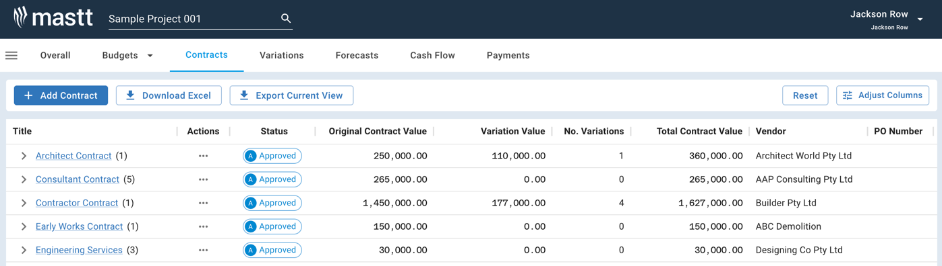

Head Contractor Appointment
The Head Contractor’s submission has been reviewed and is awaiting the formal endorsement of the Tender Evaluation Recommendation Report.

Design
[Provide an update of all design activities and upcoming activities to convey what design is happening, issues and upcoming items. Example text has been included in the below.]

Design Status
The design has progressed with the following activities undertaken in the last period:
- Architectural 70% package prepared and coordinated with services consultants
- …

Value Engineering
Value engineering options have been sought from consultants to reduce the cost estimate within the approved budget. These will be put into a tracker to be developed and reported against.

Requests for Information
See Appendix C for the RFI register.
There are currently 101 outstanding Requests for Information (RFIs).

Construction
[Provide an update of all construction activities and upcoming activities to convey what is happening on site and what is coming up to mitigate any foreseeable issues. Example text has been included in the below.]

Construction Status
Key construction activities in the last period are as follows:
- Commenced detailed excavation to subbase level.
- …

Upcoming Activities
Key construction activities in the next period are:
- Laying of formwork and reo, concrete pour.
- …

Program / Schedule
[Provide an overview of how the project is progressing against the approved schedule, showing a breakdown of milestones achieved and upcoming. Identify any foreseen delays, notices, or extensions of time. Good practice to include notes under each table to explain or justify changes to the schedule. Example text has been included in the below.]

Program / Schedule Status
See detailed Program / Schedule in Appendix D.
The Program / Schedule is currently on track.

Milestones
A summary of the key project milestones and forecast completion dates can be seen per the below schedule.

Milestone | Phase | Start | Baseline | Planned | Actual | Status
Appoint Project Manager | Initiation | 1/01/21 | 1/01/21 | 1/01/21 | 1/01/21 | Complete
Appoint Design Team | Planning | 14/02/21 | 14/02/21 | 14/01/21 | 14/01/21 | Complete
Lodge SSDA | Planning | 10/05/21 | 10/05/21 | 10/05/21 | 15/05/21 | Complete
Receive SSDA Approval | Planning | 1/12/21 | 1/12/21 | 1/12/21 | 1/12/21 | Complete
Complete 70% Design | Design | 14/12/21 | 14/12/21 | 14/12/21 | 14/12/21 | Complete
Tender Recommendation to Award Head Contractor | Procurement | 10/12/21 | 1/02/21 | 1/02/21 | 1/02/21 | Complete
Appoint Contractor | Procurement | 20/12/21 | 20/12/21 | 15/02/22 | 16/02/22 | Complete
Commence Construction | Construction | 31/01/22 | 31/01/22 | 17/02/22 |  | In Progress
Complete Construction | Construction | 1/12/22 | 1/12/22 | 1/02/23 |  | Not Started
End DLP | DLP | 1/12/23 | 1/12/23 | 1/02/24 |  | Not Started

Notes:
- The commencement of construction is dependent on the approval from Council have site access.

Foreseen Delays
The following foreseen delays have been raised:
- Inclement weather possibility

Notice of Delays
The Notice of Delays have been raised per below:

Item | Description | Notification Date | No days
1 | Covid 19 Delay | 20 July 2021 | 3
2 | …
3

Extensions of Time
The Extension of Time (EOT) register is summarised below:

Item | Description | Claim Date | No days | No Days Approved | Date Assessed
1 | Inclement Weather | 13/03/21 | 3 | 3 | 16/03/21
2 | …
3

Cost
[Provide an overview of project budget, cashflow for the current and future financial years, the forecast final cost, reimbursables, variations and the earned value assessment. These should be a summary of the cost registers included in the Appendix. Example text has been included in the below.]

Project Budget
The Project Budget status is as follows:
Endorsed Project Budget | ($)
Federal Government | 20,000,000
State Government | 10,000,000
Mastt Fun Managers Pty Ltd | 5,000,000
Client | 10,000,000
TOTAL | 45,000,000
Risk Provision | TBC

Cash Flow
Forecast Cashflow for the project can be seen in Appendix E.

Element | Forecast Completion Cost | Spend to Date | FY 21/22 | FY 22/23 | FY 23/24
Client Costs | $10,000,000 | $1,000,000
Design Costs | $10,000,000 | $1,000,000
Construction Costs | $15,000,000 | $1,500,000
Contingency | $5,000,000 | $500,000
Escalation | $2,000,000 | $200,000
Risk Provision | $3,000,000 | $300,000
Total | $45,000,000 | $4,500,000 | $0 | $0 | $0

The above table summarises the Project cashflow forecasts for this reporting period, with the following changes to the cashflow in the last period:
- The forecast spend for August 2021 was less than forecasted by $100,000 due to a lack of progress in delivery of contracted scope.
- …

The following assumptions are made in the above table:
- Instruction to commence with the works was received from the Client on 12 July 2021, behind the scheduled date.
- …

Final Forecast Cost
The Cost Report is in Appendix F, which shows the project costs and expenditures to date and forecast.

Cost Description | Approved Budget | Final Forecast Cost  Previous Month | Final Forecast Cost  This Month | Variance
Client Costs | $10,000,000 | $10,000,000 | $5,000,000 | ($5,000,000)
Design Costs | $10,000,000 | $10,000,000 | $10,000,000 | $0
Construction Costs | $15,000,000 | $15,000,000 | $15,000,000 | $0
Contingency | $5,000,000 | $5,000,000 | $10,000,000 | $5,000,000
Escalation | $2,000,000 | $2,000,000 | $2,000,000 | $0
Risk Provision | $3,000,000 | $3,000,000 | $3,000,000 | $0
Total | $45,000,000 | $45,000,000 | $45,000,000 | $0

Example Mastt CashFlow Reports
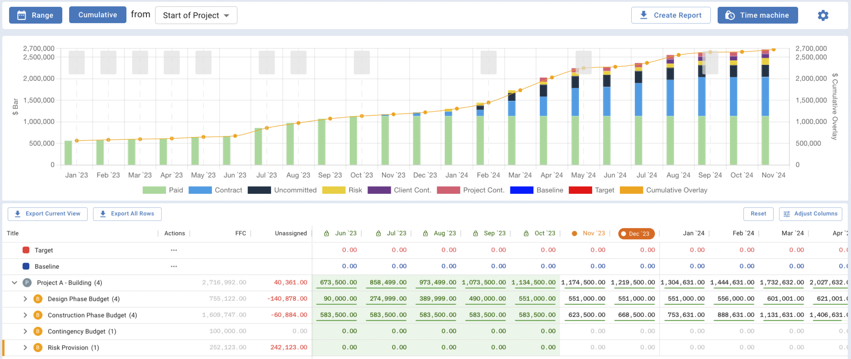

Reimbursables / Provisional Sums
The following reimbursables / provisional sums in the contract:
No. | Description | Value ($) | Status | Comments
1 | In ground electrical works | $50,000 | Pending
2 | …

Variations
See the Variation Register in Appendix G
Approved Variations in the last period:
Title | Contract | Contract Variation No. | Value ($) | Status
Contamination | Head Contractor | 1 | 20,000 | Approved

Forecast Variations:
Title | Contract | Contract Variation No. | Forecast Value ($) | Status
Scope Change | Head Contractor | 2 | 5,000 | Pending

Risk, Issues & Opportunities
[For this section, outline the key project risks from the risk register, update the table showing the realised risks in the last period and identify any upcoming risk requirements such as workshops or audits. Example text has been included in the below.]

High Risks
The following risks are high for this month:
- Covid 19 supply chain delay – this has an estimated impact of $30,000 and delay of 40 days to the project completion.
- Contaminated fill …
- Delayed authority approvals …

Realised Risks & Issues
The following table captures realised risks and issues:
No. | Realised Risk | Value | Critical Path Impact | Comments
1 | Reduced scope of works | $20,000 | 0 days
2 | …

Example Mastt Risk Report
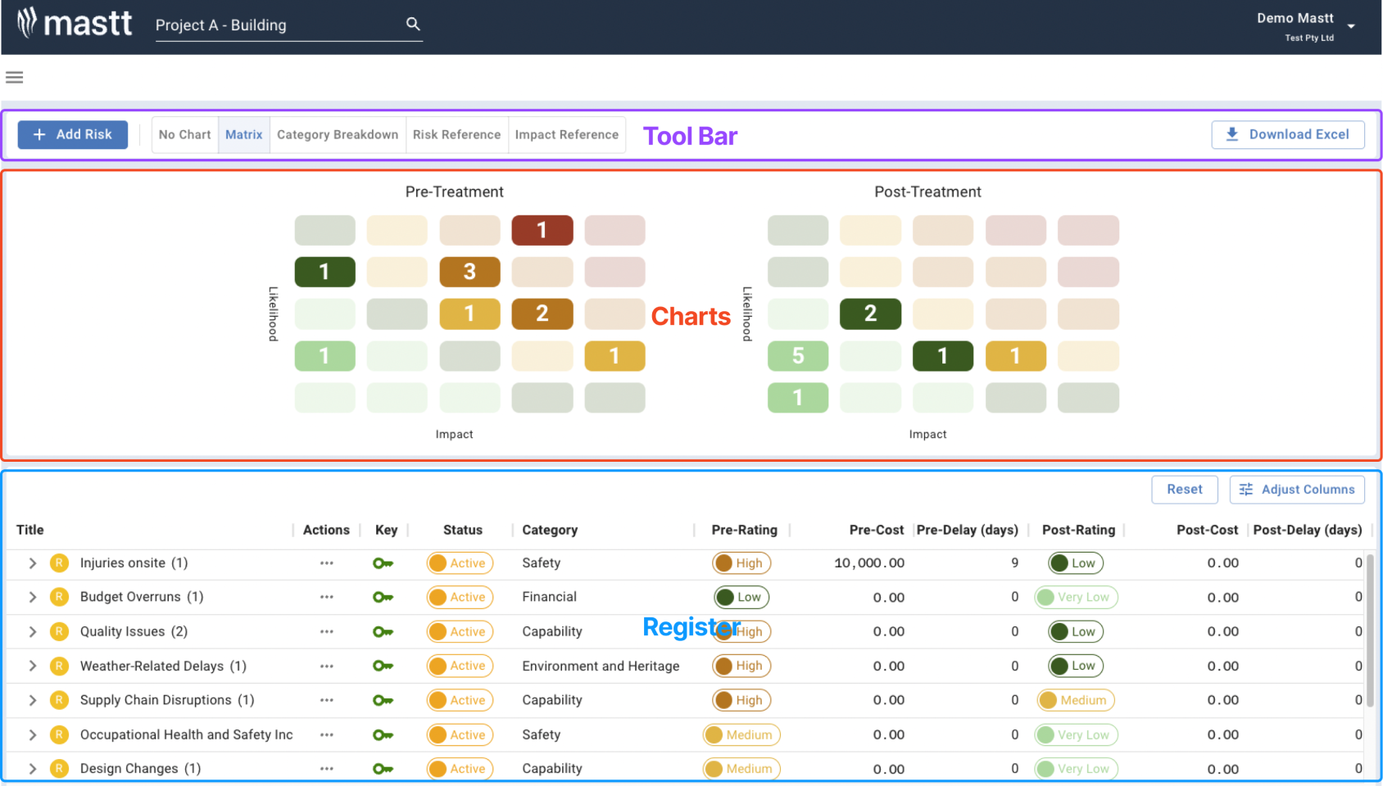

Opportunities
The following table summarises the current opportunities identified for the project:
No. | Opportunity | Value | Critical Path Impact | Comments
1 | Early completion | $75,000 | -12 days
2 | …

Workshops
A risk workshop will be organised during each phase of the project and prior to a Gate Review, per project governance requirements.

Stakeholders
[Identify and list the Stakeholder changes in the last period and identify any stakeholder engagements i.e., with community, governments etc.]

Stakeholder Register
See Appendix H for the Stakeholder Register.

Engagement Update
The project communications strategy is based around key project meetings and workshops, per the Communications Plan.

The following engagements have been undertaken in the last period:
- Letter Drop – on 1 July 2021 the letter drop was carried out to neighbours to provide notice of appointment of the Head Contractor and brief schedule for the works
- …

Project Closure
[Early planning and discussion of the Commissioning & Handover stage can significantly help meet all requirements in time for Completion. This section should include a status update on the plan and defect management. Example text has been included below.]

Commissioning & Handover Plan
The defects, commissioning, training, and handover plan is to be developed ongoing.

Defects Management & Maintenance Summary
The Early Works have been completed and entered the Defects Liability Period (DLP), which will expire 01/02/2024.

Lessons Learned
[To show continuous improvement from an organisational, project and personal development level, a reflection on the issues and challenges throughout could form part of the ‘lessons learned’ segment. A formal workshop is typically conducted at the end of a project; however, incremental notes can lead to a cumulative list of lessons to benefit all personnel involved. Example text has been included in the below.]

Lessons Learned workshops will be conducted to ensure key lessons are captured and actions can be taken to improve the project delivery for future projects. The workshop is scheduled to be held at project close on 01/02/2023.

An ongoing register of lessons learned is as follows:

No. | Category | Problem/Success Description | Impact | Recommendation
1 | Communication | Early notice of variations and delays were not provided to the Client. | The Client was surprised by the sudden changes. | Provide early warning to the Client in Monthly Project Reports and emails.

APPENDICES
[Update each Appendix line to correspond with a key document to be included for reference. The intent is to provide a high-level summary within the report and keep the detailed registers in the Appendices to refer to for more detail.]

APPENDIX A – Risk Register

APPENDIX B – Previous Meeting Minutes

APPENDIX C – RFI Register

APPENDIX D – Schedule

APPENDIX E – Cash Flow

APPENDIX F – Cost Report

APPENDIX G – Variations

APPENDIX H – Stakeholder Register

APPENDIX I – Contractor Report

