[Insert Project Title]
Quality Management Plan
[Insert month year]
Document Control
[This section is to keep track of who prepared the document, who reviewed it and who it was intended to be distributed to.]

Version History

Version No | Description | Date
0
1
2

Distribution

This Quality Management Plan is prepared for distribution to:
Copy | Name | Position | Organisation
1
2

Authorisation Record

Prepared By
Project Manager | Name | Signature | Date
Review By
Project Director | Name | Signature | Date

Table of Contents
1 Introduction 4
1.1 Purpose of the Plan 4
1.2 Objectives of the Plan 4
1. Project Quality Objectives 5
2 Quality Planning 6
2.1 Project Metrics 6
2.2 Roles and Responsibilities 6
3 Quality Assurance 7
3.1 Measurement System 7
3.2 Process analysis 7
3.3 Tools and Techniques 7
4 Quality Control 8
4.1 Quality Reviews 8
4.2 Deliverables Reviews 8
4.3 Assessment 8
4.4 Improvements 8

Introduction
[Succinctly summarise the purpose of the plan in relation to the governance and the quality management of the project.]

Purpose of the Plan
The Quality Management Plan (QMP) is the primary document used for quality planning, quality assurance and quality control and describes how a project will incorporate these aspects of quality throughout the project lifecycle.

This project will apply the project management practices outlined in the AS/ISO 9001:2015 and PMBOK Project Management models, including relevant processes, governance and controls that are appropriate to the level of complexity of the project.

The Mastt System will be utilised to support the management of this project at a portfolio, program and/or project level.

This document does not replace, detract, or eliminate any existing Organisational policies and procedures, and is intended to be used in conjunction with relevant policies and procedures already in place.

The QMP is designed to be reviewed periodically and kept current and will be updated where material changes occur that impact the business case on which the project is based.

The QMP is a key management deliverable. The Project Manager is responsible for its production and its upkeep during the project lifecycle, seeking input as required.

Objectives of the Plan
The objectives of this QMP are to:
- Outline the quality strategy, approach and process for the project;
- Identify the roles and responsibilities for quality management;
- Identify major project management artefacts and deliverables;
- Define the quality assurance and control activities for the project and plan them;
- Support quality requirements, reviews and evaluations over the project; and
- Specify the methodology, standards, tools and techniques to support quality management.

Project Quality Objectives
[Provide an overview of the quality objectives the project wants to achieve.]
This Project Quality Plan recognises Quality is achieved as part of a wider system of Management Plans.

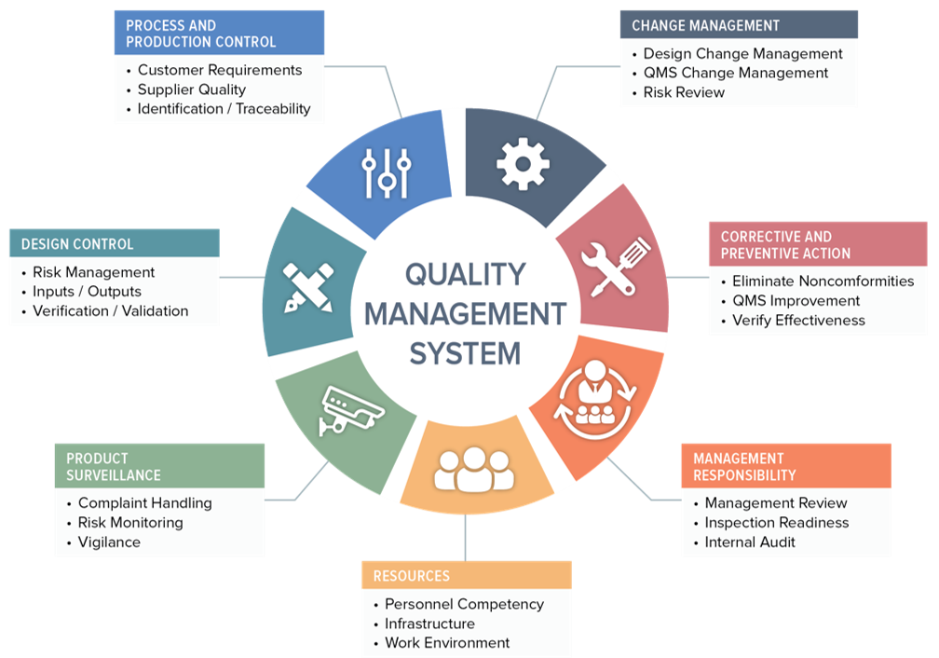

The main project quality objectives include:

Quality Planning
[Provide a list of metrics or techniques to benchmark aspects of quality across the project such as scope, time and cost but also link to the strategic objectives of the organisation.]

The project will establish quality metrics to make sure there is a continuous improvement to the organisation and benefit in line with the business case.

Project Metrics
The techniques to be used for quality planning include the following:
- Cost-benefit analysis;
- Cost of Quality comparison;
- Benchmarking;
- …

Roles and Responsibilities
The following roles and responsibilities for project personnel will be carried out with respect to quality:
Role | Description
Project Manager

Quality Assurance
[Outline how the project will analyse the existing processes to collect data for quality purposes. This includes the measurement system, what it will measure and how it will measure project quality.]

The project manager will routinely measure the existing processes across different areas of the project to collect and measure data.

Measurement System
The project will establish a good measurement system that is both accurate and credible, incorporating the following components:
- Accuracy – data reflects the true value of the property or what is being measured;
- Precision – data is precisely measuring what it is supposed to measure;
- Repeatability – successive measurements by the same appraiser should be the same; and
- Reproducibility – different appraisers measuring the same item get the same result.

Process analysis
Quality assurance will be performed by evaluating:
- The design of project controls, their implementation and operational effectiveness with consideration of the quality objectives and project risks.
- Adherence to design standards, industry standards etc.
- Compliance with the organisation’s governance documentation and specifications, rules and regulations, and legislation.

Quality assurance activities will be carried out:
- Internally by:
- Externally by:

The results of quality assurance investigations will be documented in the monthly project report.

Tools and Techniques
The following techniques will be used for the project’s quality management:
- Audits;
- Walkthroughs;
- Benchmarking;
- Peer Reviews;
- Acceptance testing
- …
The following tools will be used for project quality management:
- Quality Management Plan
- Monthly Project Reports
- Construction Defect Register
- …

Quality Control
[Explain how the project will monitor the quality assurance, assess it and make changes as required to show continuous improvement.]

The project quality will be controlled through reviews to monitor and consolidate results of quality assurance activities. This will be used to assess compliance and performance, recommend changes, and plan or refine existing quality assurance activities.

Quality Reviews
The following quality reviews will take place

Deliverables Reviews
The following review of deliverables will take place:

Assessment
The assessment of the quality and deliverables review revealed:

Improvements
Improvements to the process to be made include:

