Past Due Courses

What’s New:
- With the ability to set course completion due dates, there is a chance that your learner’s assigned course(s) will be past due.
- Courses that are past due will show up with the “Past Due” tag on the learner’s “My Courses” page.
- Learners will get an email saying their course is past due. The credit union Admin will also receive an email when a learner’s course is past due. **Note that credit union Sub-Admin’s do not receive the past due notification email when a learner is past due, unless it’s them that is past due – then they’ll receive the learner email.**
- Course reporting has been updated to show past due courses along with due dates, and the reporting date filter how filters by course “assignment” date rather than course “enrollment” date.
When a course is past due, it will show up with the red “Past Due” tag on the learner’s “My Courses” page. | 
The learner will receive an email letting them know they have a course that is past due. | 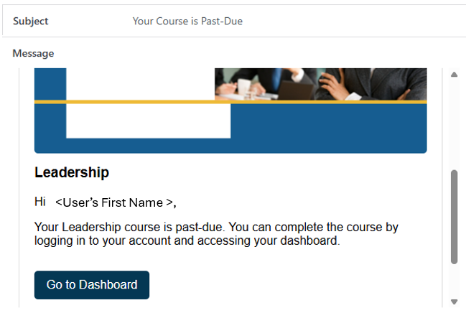
The designated credit union admin will receive an email letting them know the learner has a course that is past due. | 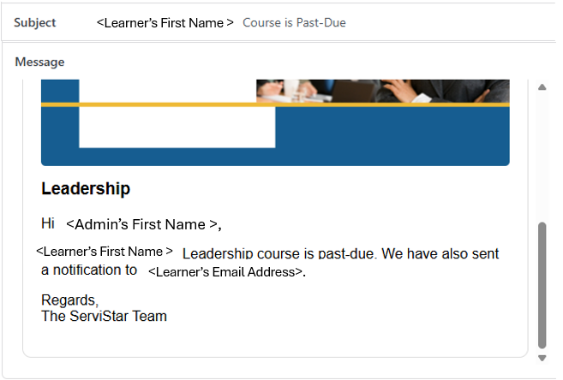
Course Reporting has been updated so Admin’s and Sub-Admin’s can see course completion status, including past due courses, based on the course assignment date.

As the Admin, select “Course Reporting” at the top of the screen

If you’d like, you can filter your report by the date you assigned courses to your learner. | 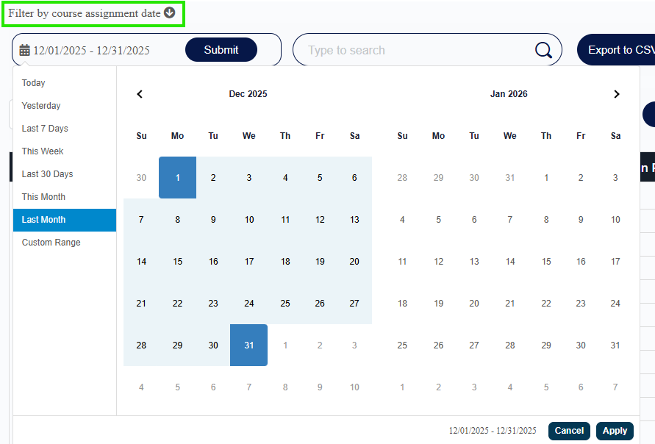
To select a “custom range” for dates, select “Custom Range”, enter your start and end date, and hit “Apply”. | 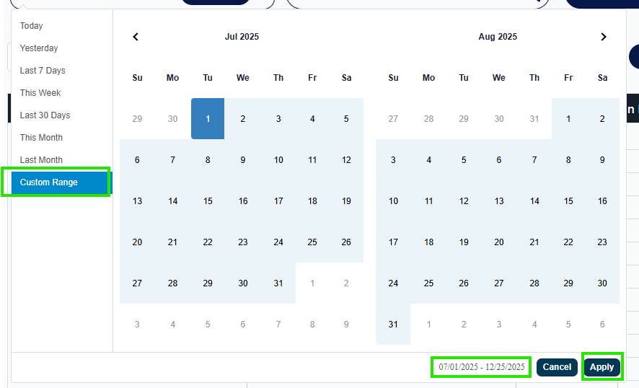
You can filter by course name. Select “uncheck all courses” to deselect all and select individual courses | 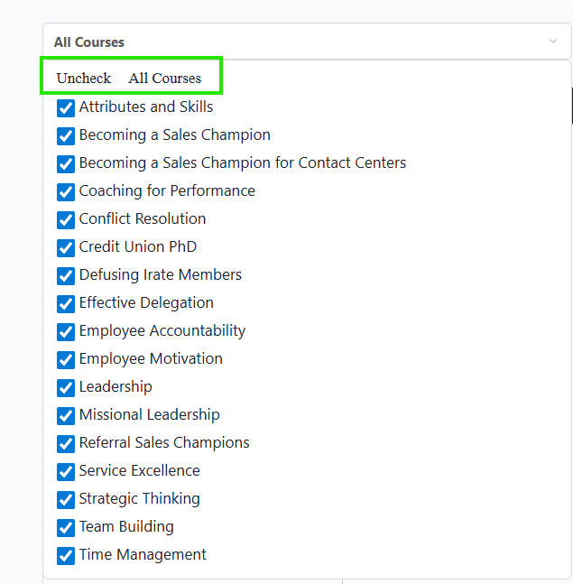
You can filter by course status by using the course status drop down box | 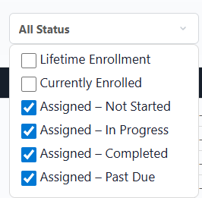
You are able to see that this user is past due on Missional Leadership, which was due on 1/13/2026. | 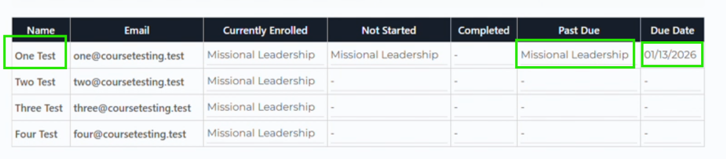
You also have the option to export the course report to a csv file, which makes it easy to run pivot tables based on learner name, course name, status, etc. if that’s your preference. | 