Updating Course Due Dates and Resetting Course Progress

What’s new:
- Admins are able to update course due dates for their learners.
- When updating a due date, there is an option to require your learner to start the course over again and re-take the course.
- This functionality comes in handy whenever you want to push a course due date out into the future, or whenever you want your learners to take a course as part of an annual course completion requirement.
From the Client Hub, choose “Manage Courses” | 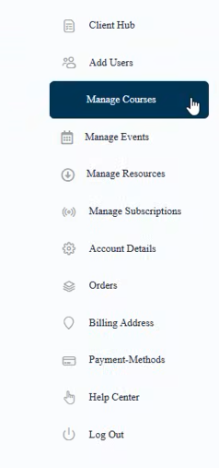
Select the “Manage Due Dates” tab | 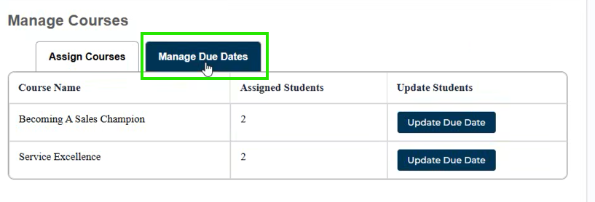
Select the “Update Due Date” option for course you’d like to update | 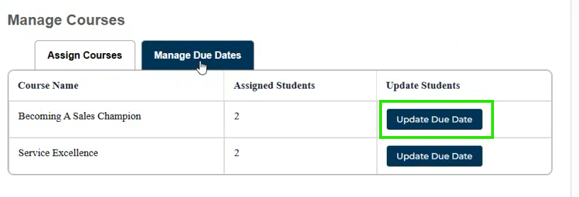
You can enter a new due date, and you also have the option to reset the users course progress, which will require them to start the course over again.  **Note that resetting course progress is optional. You can update the due date without requiring someone to restart the course** | 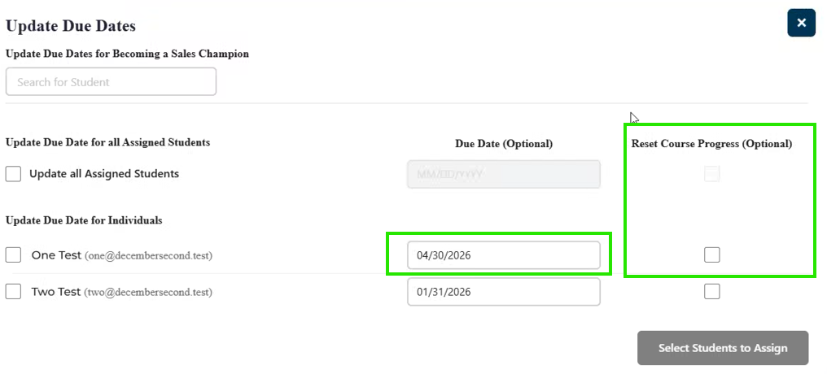  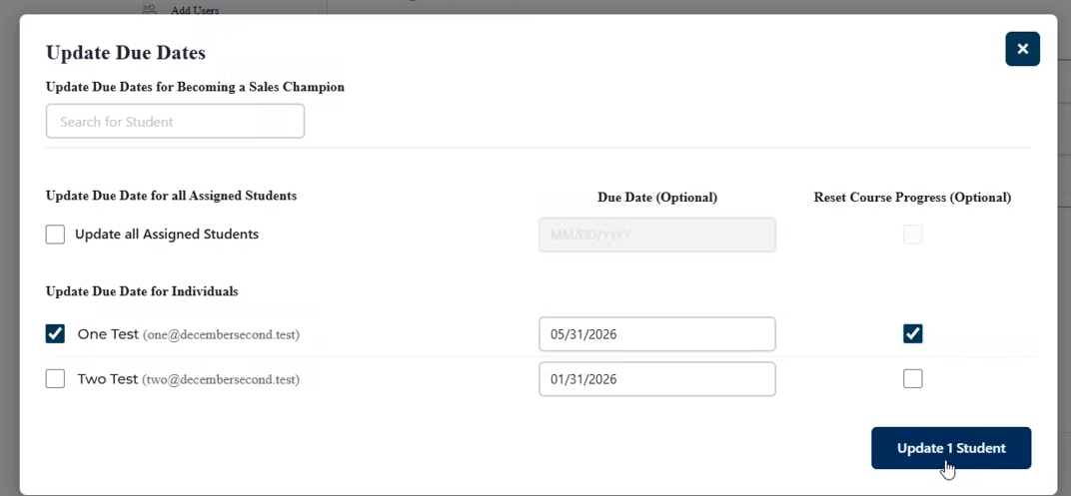
If you are resetting course progress, you’ll need to select “Yes” on the pop-up message. | 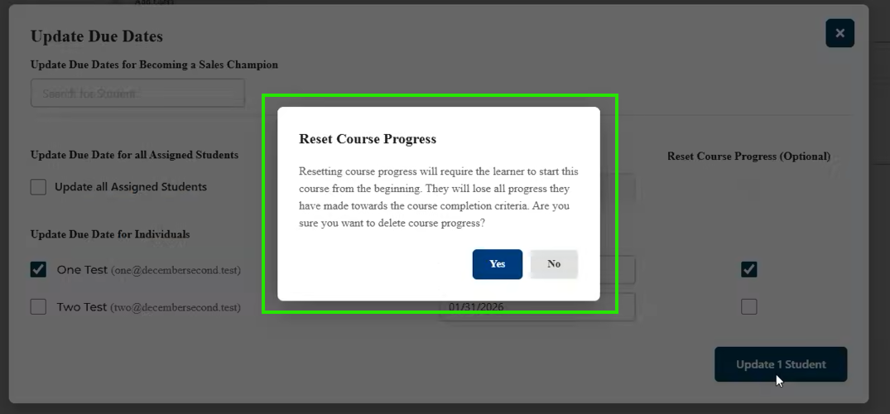
After selecting yes, you’ll see the confirmation badge, and the user will receive a notification email with the new due date. | 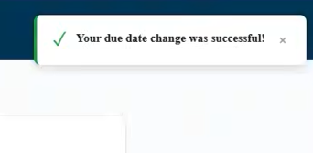
Your learner(s) will get an email with their course due date | 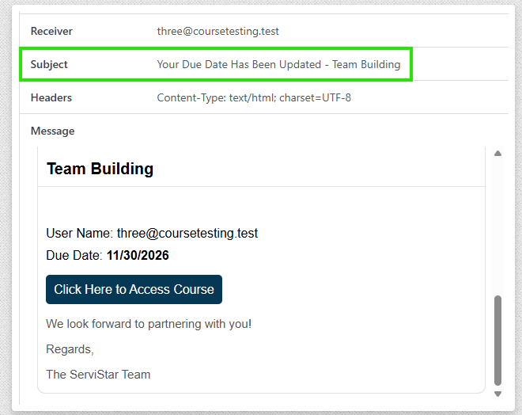
Your learner will see when the course is due when they view their “My Courses” page | 
If you chose not to reset course progress, your learner would see the course progress on their course page | 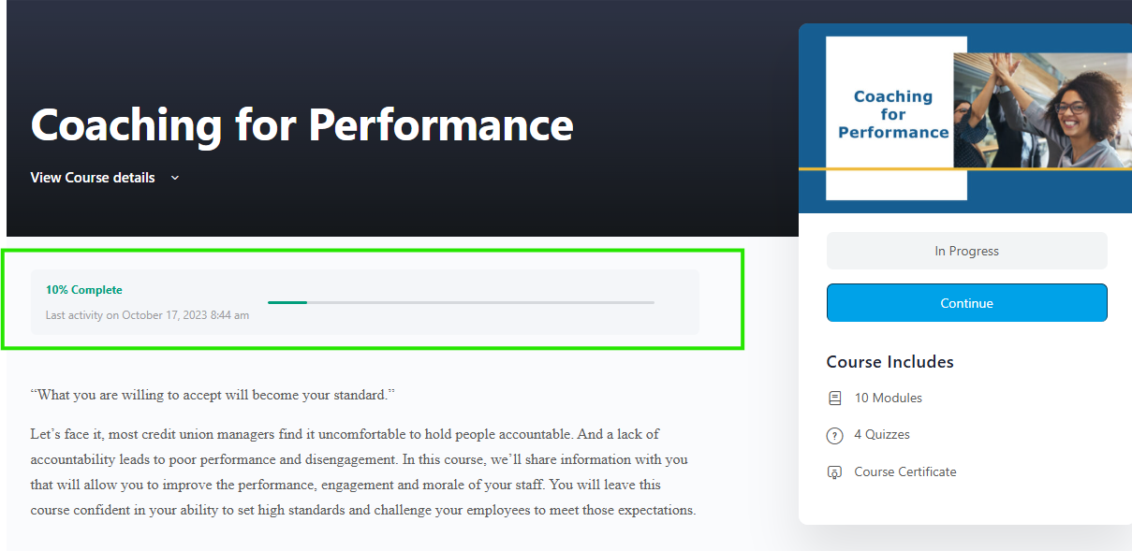
If you chose to reset their course progress, your learner will start the course over again from 0% complete | 
Important Consideration:
- If you’ve assigned a course to a learner at any time in the past, and want to ask them to complete the course again (e.g. your credit union took Service Excellence last year as part of an annual requirement and/or as part of new employee onboarding, and you want them to take it again this year), you don’t have to “Assign” the course out again through the “Assign Courses” tab. Simply use the “Update Due Date” tab and use the “Select All” feature, and input the new due date. With this, you’ll be “Re-Assigning” the course to your learners with the new due date.

