Unlimited Course Access for Individuals/Teams License

What’s changing:
- After assigning a license to a user, you can assign specific courses with optional due dates.
- You can update due dates for learners with assigned courses.
- When you update a due date, you can require the learner to restart the course again.
From the Client Hub, Select Add Users and go through the steps to create a new user. | 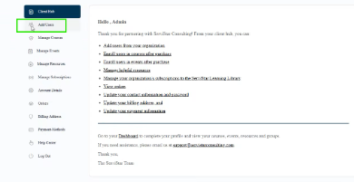  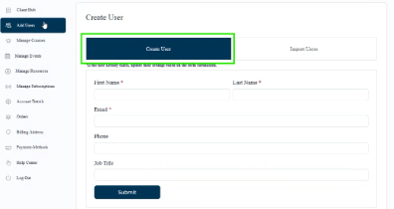  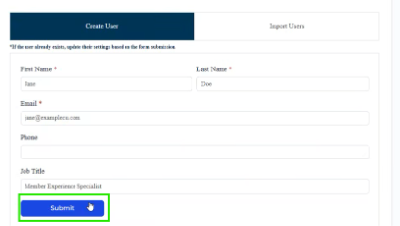
If you purchased multiple licenses to assign to your employees, select Manage Courses and then Assign Licenses to assign a license to the user. | 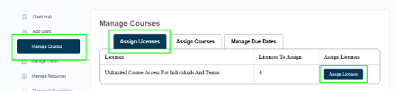  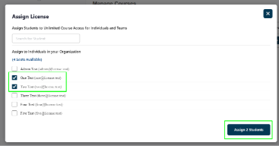
If you do not have licenses remaining, you can purchase a license by navigating to “Courses” and selecting “Unlimited Access for Individuals & Teams.” You have the option to purchase a single license for an individual or multiple licenses for your team. | 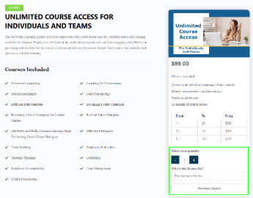
Users who have been assigned a license will receive a notification email and will have access to all courses in their dashboard. | 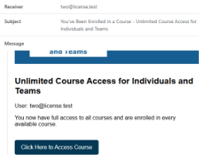  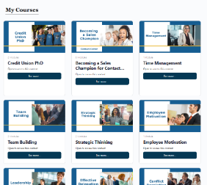
You can assign individual courses with optional due dates by navigating to the Client Hub and selecting Manage Courses. | 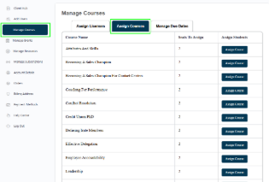
In the Assign Courses tab, select the course you want to assign. | 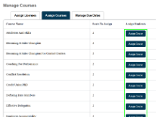
Select the users you want to assign the course to from the “Assign to Unlimited Course Access License Holders” section. You can optionally provide a due date. Then choose “Assign Students.” | 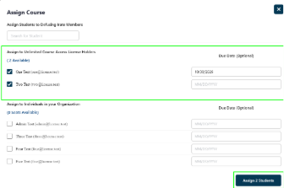
You’ll see a badge saying “Your course assignment was successful!” | 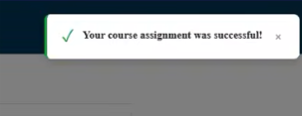
The user will get an email saying which course has been assigned. If there is a due date, it will appear in the email. | 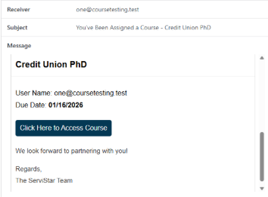
The user will see the course has been assigned as “Due in XX Days” on their Dashboard and My Courses list. | 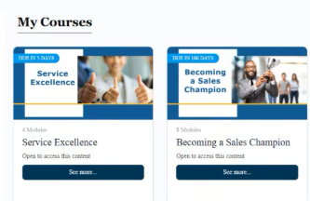
You can manage your learners’ due dates by selecting the “Manage Due Dates” tab at the top | 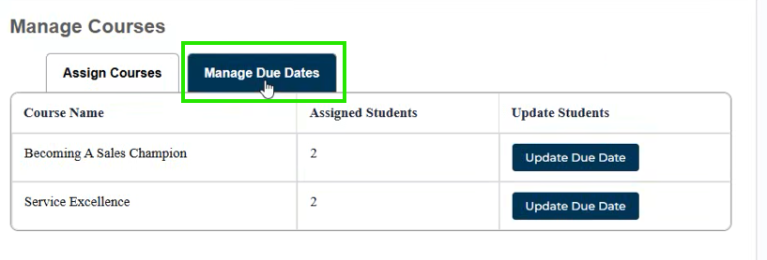
Select the “Update Due Date” option for course you’d like to update | 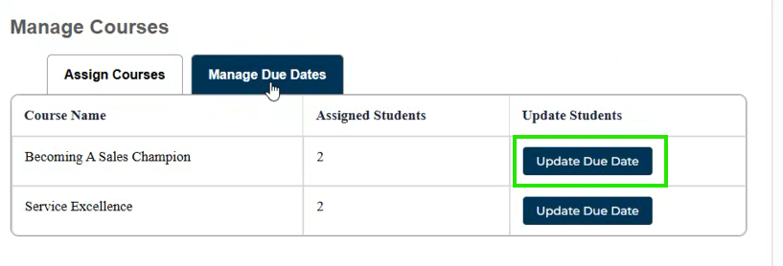
You can enter a new due date, and you also have the option to reset the users’ course progress, which will require them to start the course over again. | 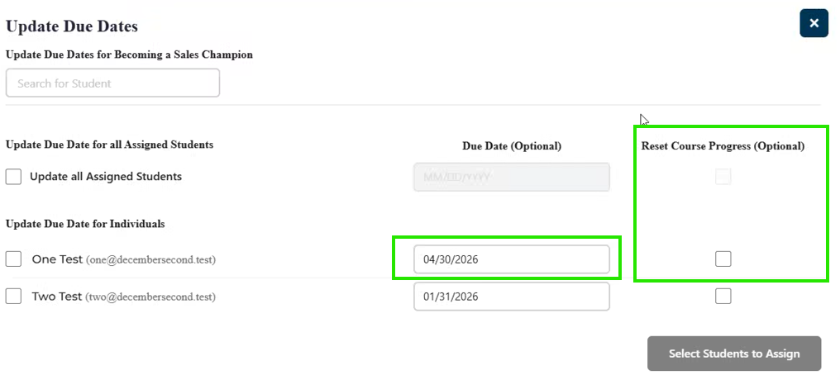  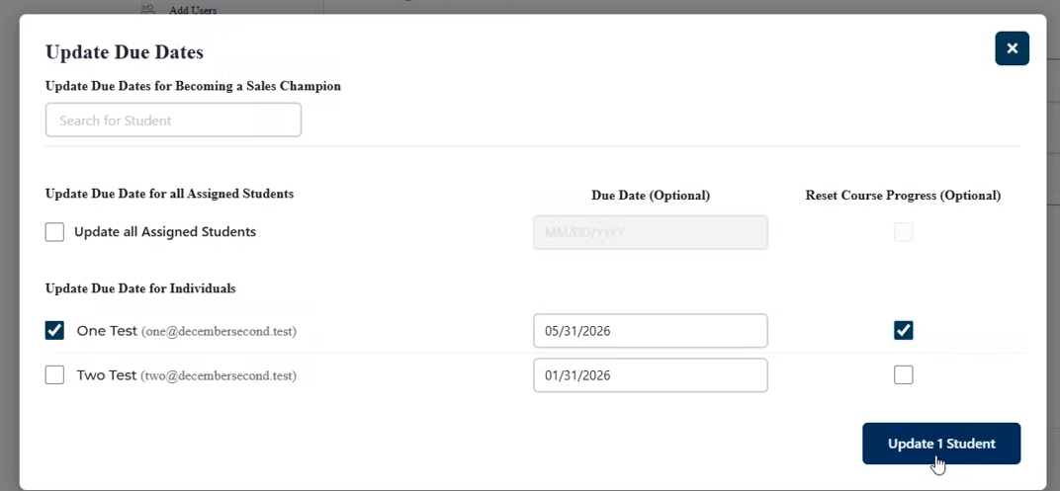
If you are resetting course progress, you’ll need to select “Yes” on the pop-up message. | 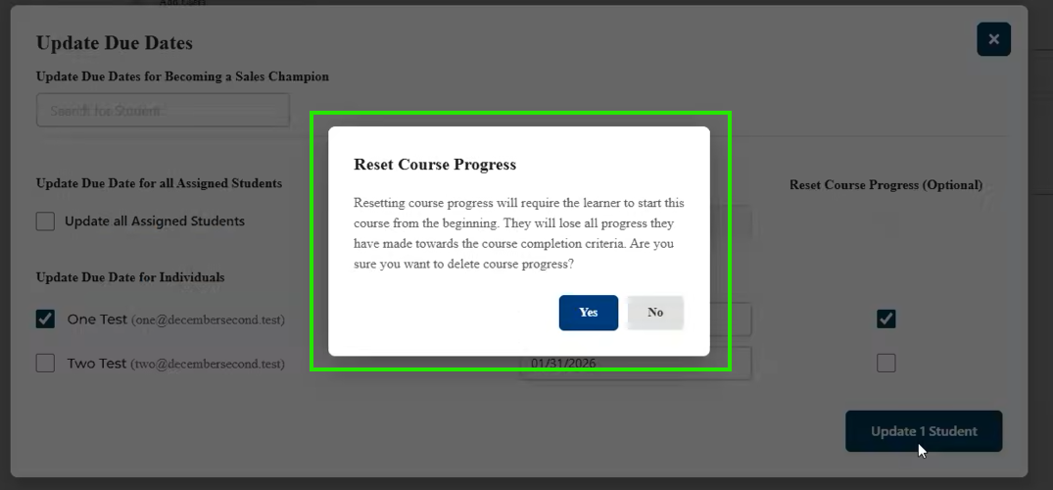
After selecting yes, you’ll see the confirmation badge. | 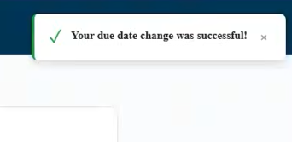
The learner will receive a notification email with the new due date. | 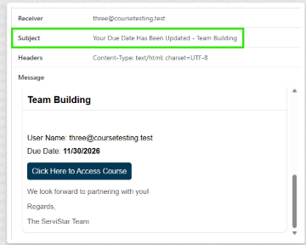
Your learner will see when the course is due when they view their “My Courses” page | 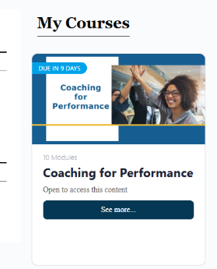
If you chose not to reset course progress, your learner would see the course progress on their course page | 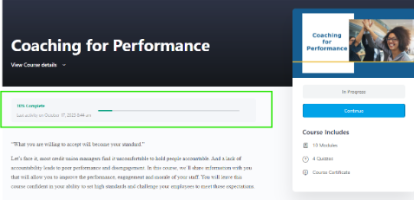
If you chose to reset their course progress, your learner will start the course over again from 0% complete | 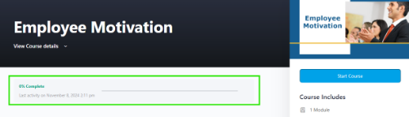
Select the “Update Due Date” option for course you’d like to update
Important Consideration:
If you’ve assigned a course to a learner at any time in the past, and want to ask them to complete the course again (e.g. you assign Service Excellence this year as part of an annual requirement and/or as part of new employee onboarding, and you want them to take it again in 6 months as a refresher), you don’t have to “Assign” the course out again through the “Assign Courses” tab. Simply use the “Update Due Date” tab and use the “Select All” feature, and input the new due date. With this, you’ll be “Re-Assigning” the course to your learners with the new due date.

