Single or Bulk Quantity Courses (No License)

What’s Changing:
- When you purchase a single course, you have the option to assign a due date for course completion during the purchase process.
- When you purchase courses in bulk quantity, you have the option to assign courses out through the “Manage Courses” area of the Client Hub.
- You can update due dates for learners with assigned courses.
- When you update a due date, you can require the learner to restart the course again.
When purchasing a single course, you’ll be assigning a course to your employee.  You’ll be able to enter an optional course completion due date as part of the purchase process. | 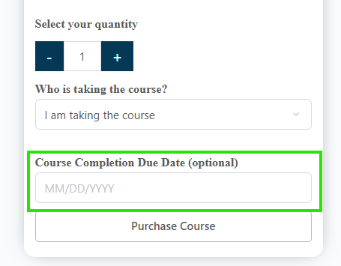
When you purchase courses in multiple quantities, you can assign courses with optional due dates:  From the Client Hub, choose “Manage Courses” | 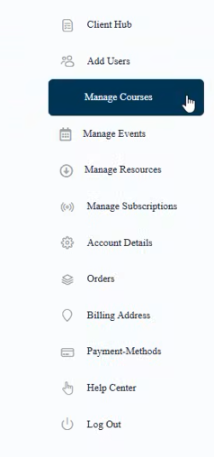
Then select “Assign Courses” | 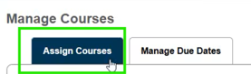
You’ll see the courses along with the number of seats you have to assign.  Click on “Assign Course” | 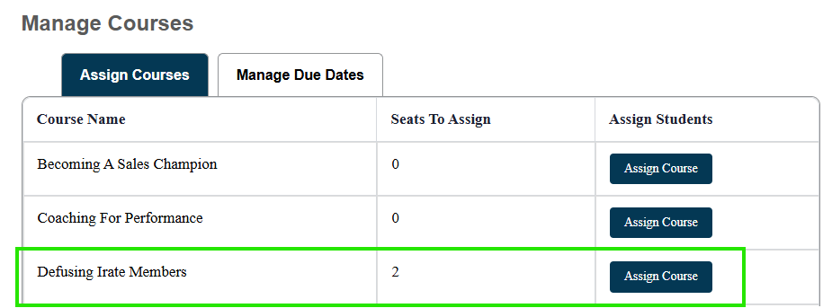
You’ll see where you can assign the course to individuals in your organization, along with assigning an optional due date | 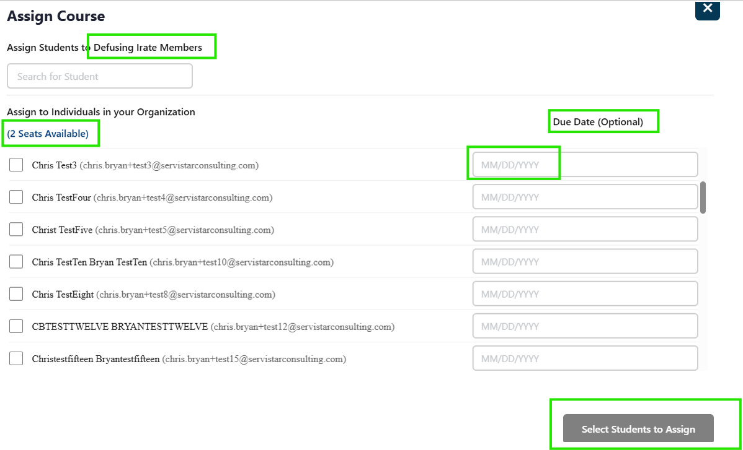
You’ll see a badge saying, “Your course assignment was successful!” | 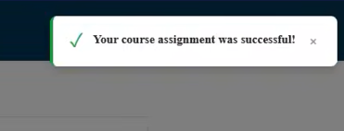
The user will get an email saying which course has been assigned.  If there is a due date, it will appear in the email. | 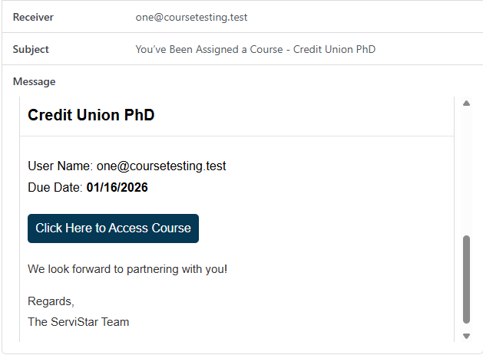
The user will see the course that has been assigned as “Due in XX Days” on their Dashboard and My Courses list. | 
You can manage your learners’ due dates by selecting the “Manage Due Dates” tab at the top | 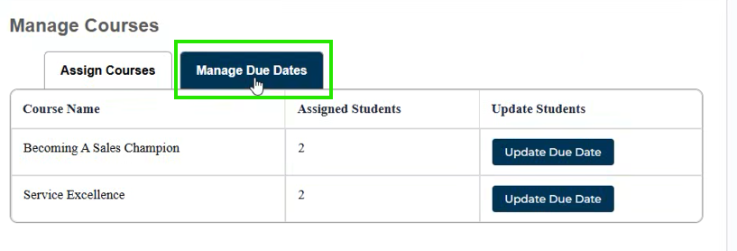
You can enter a new due date, and you also have the option to reset the users’ course progress, which will require them to start the course over again. | 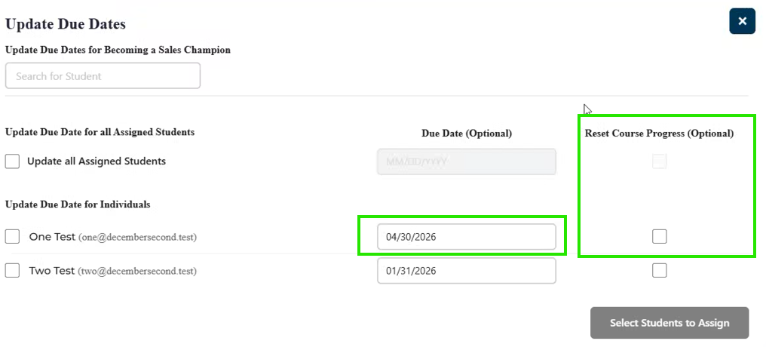  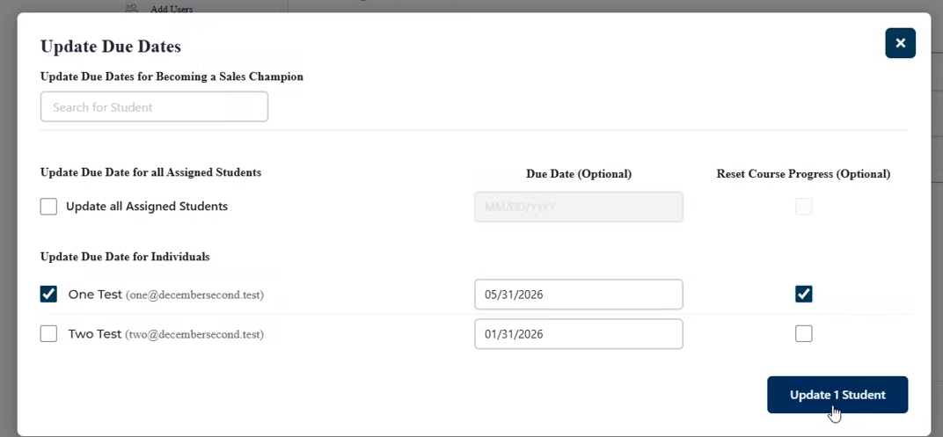
If you are resetting course progress, you’ll need to select “Yes” on the pop-up message. | 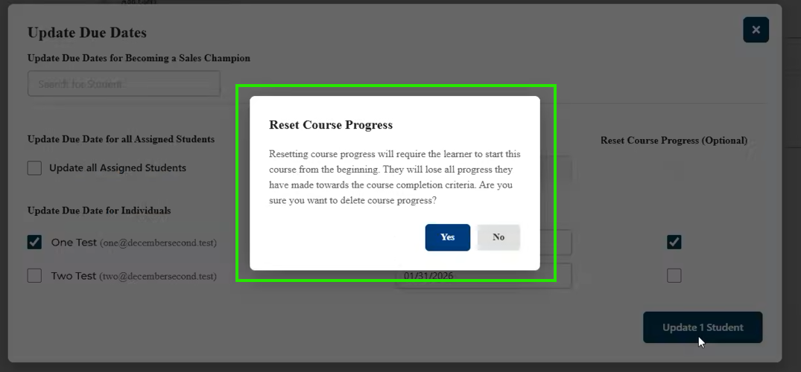
After selecting yes, you’ll see the confirmation badge. | 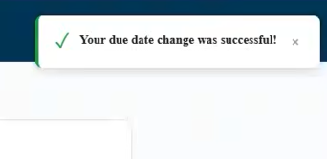
The learner will receive a notification email with the new due date. | 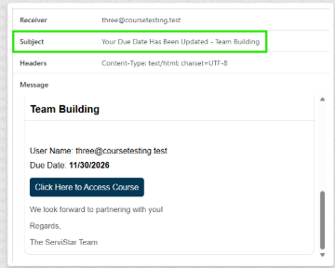
Your learner will see when the course is due when they view their “My Courses” page | 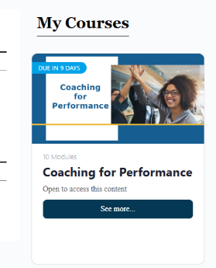
If you chose not to reset course progress, your learner would see the course progress on their course page | 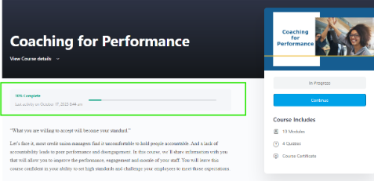
If you chose to reset their course progress, your learner will start the course over again from 0% complete | 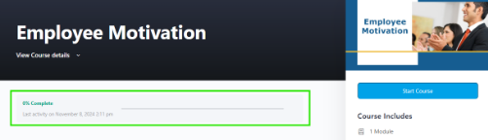
Important Consideration:
To “re-assign” a course you’ve already assigned out to your learner, use the “Update Due Date” tab, find their name and input the new due date. With this, you’ll be “Re-Assigning” the course to your learners with the new due date.

If you cannot find your learner on the list, it may be that their course access has expired if it’s been more than 12 months since you originally purchased the seat. In that case, purchase another seat and assign the course during the purchase process.

