Unlimited Course Access for Organizations License
What’s Changing:
- You no longer have to allocate a course license to people on your team. All of your employees will have access to all courses on their Dashboard by default.
- As long as your organization keeps the license, New Users will automatically have access to all courses.
- You can assign individual courses with optional due dates.
- You can update due dates for learners with assigned courses.
- When you update a due date, you can require the learner to restart the course again.
To give your new employees access to courses, Add your new employee:  From the Client Hub, Select Add Users and go through the steps to create a new user | 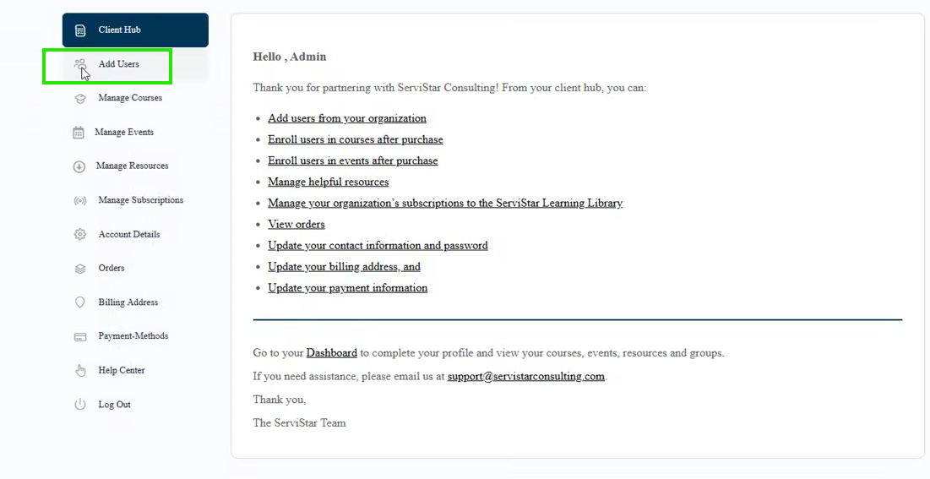  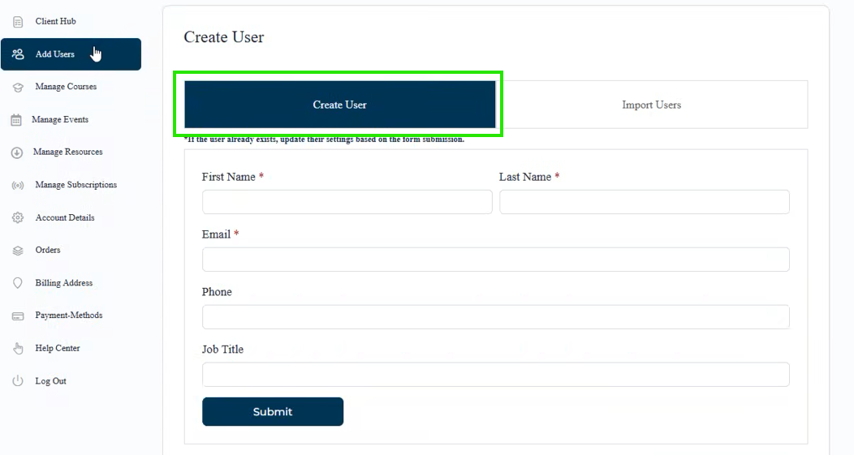  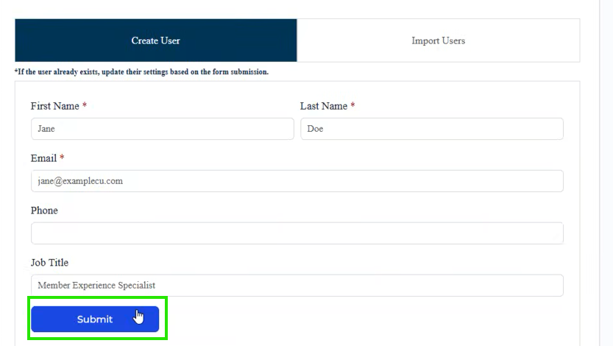
Your new user will see all of the courses available on their Dashboard and the My Courses list. You do not need to assign them a course license. | 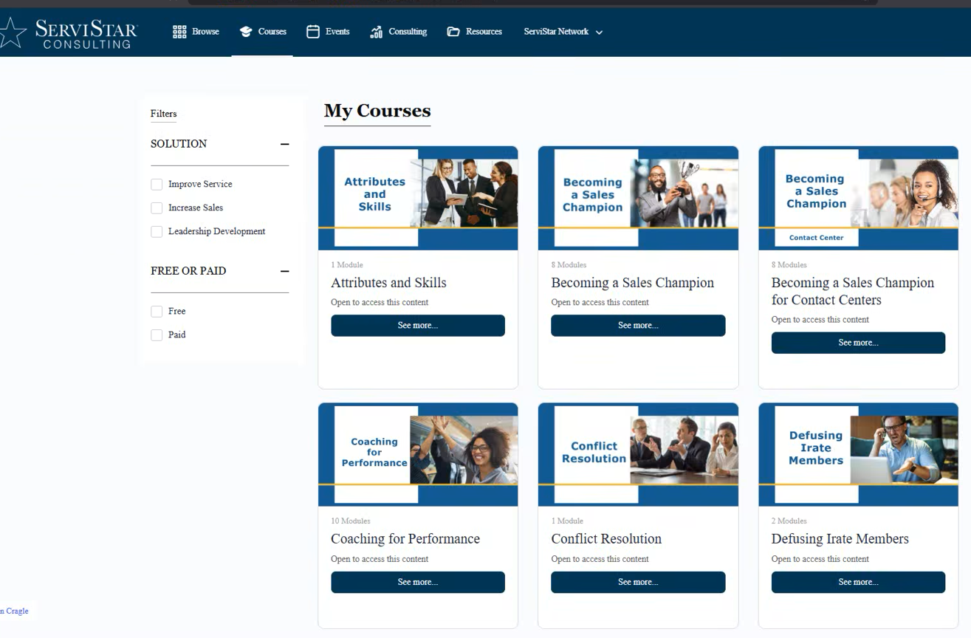
You can assign courses with optional due dates:  From the Client Hub, choose “Manage Courses” | 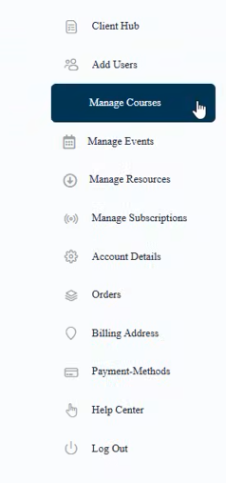
You’ll land on the “Assign Courses” tab. Select a course that you want to assign. For this example, we’ll use Becoming a Sales Champion. | 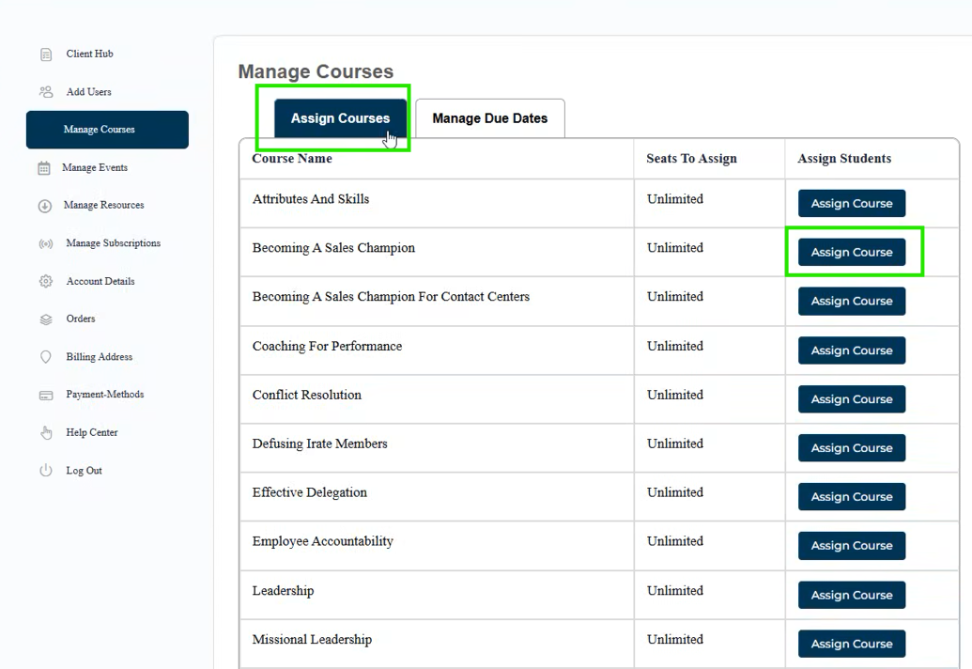
Then you can assign this course to everyone in your organization, with an optional due date.  Or you can assign the course to individuals, with optional due dates. | 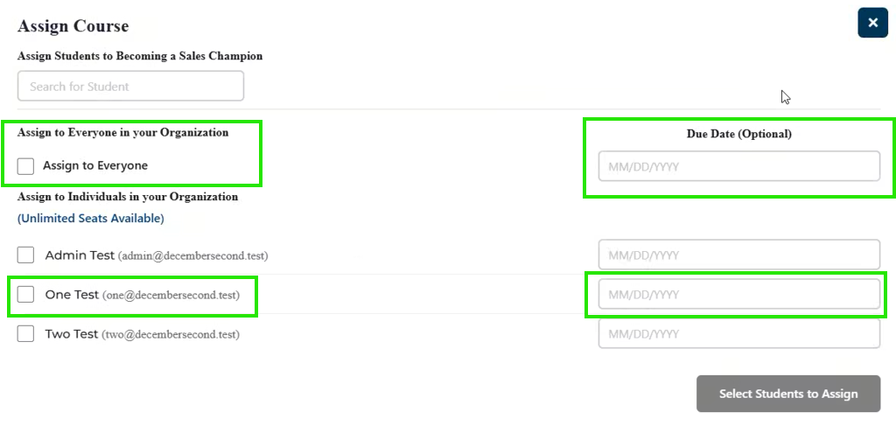
After you’vee selected the learners you want to assign, click on “Assign Students” at the bottom. | 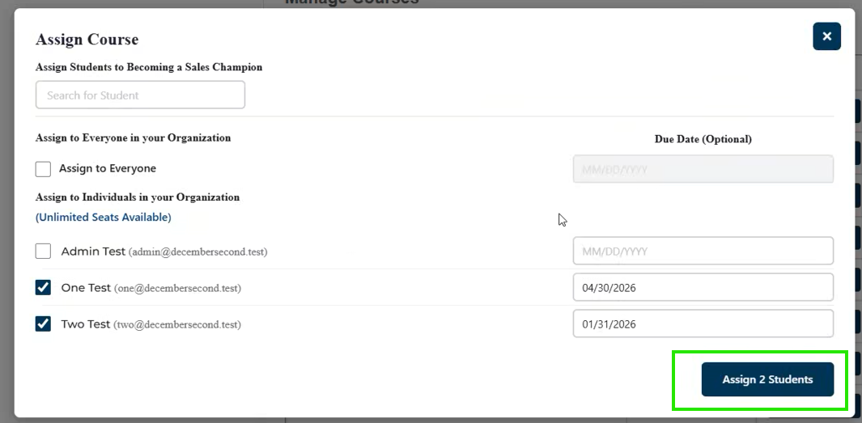
You’ll see a badge saying, “Your course assignment was successful!” | 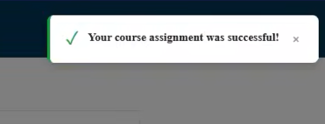
The user will get an email saying which course has been assigned.  If there is a due date, it will appear in the email. | 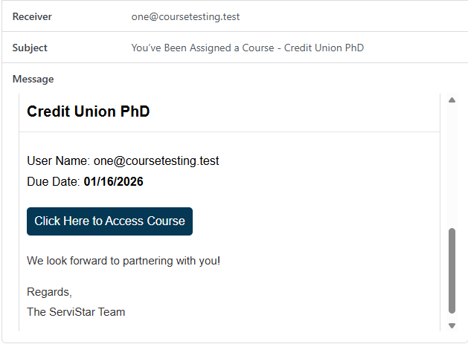
The user will see the course that has been assigned as “Due in XX Days” on their Dashboard and My Courses list. | 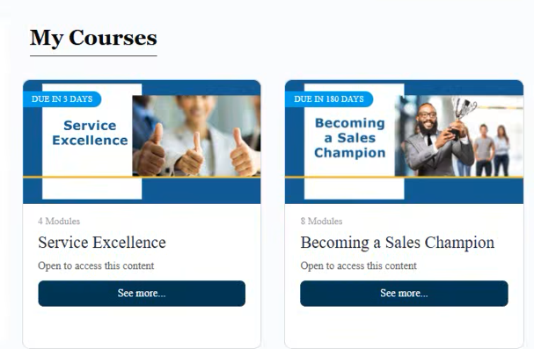
You can manage your learners’ due dates by selecting the “Manage Due Dates” tab at the top | 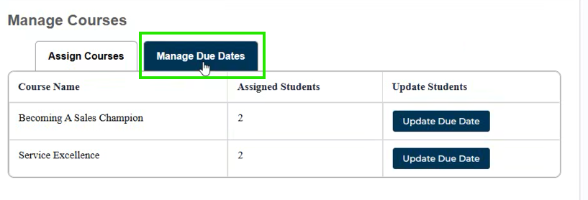
Select the “Update Due Date” option for course you’d like to update | 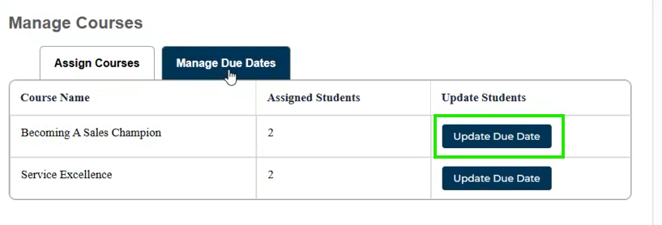
You can enter a new due date, and you also have the option to reset the users’ course progress, which will require them to start the course over again. | 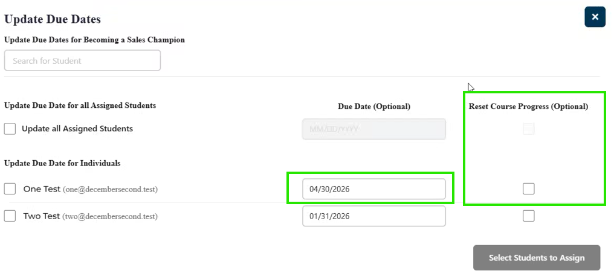  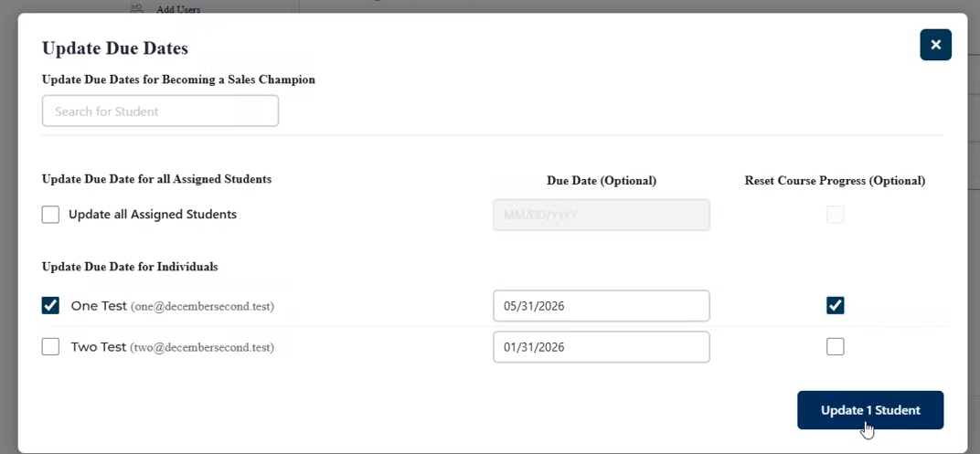
If you are resetting course progress, you’ll need to select “Yes” on the pop-up message. | 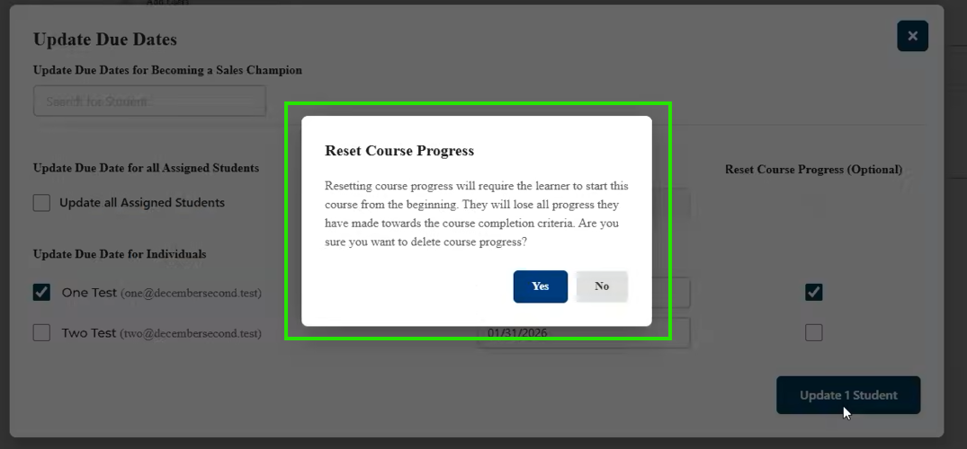
After selecting yes, you’ll see the confirmation badge. | 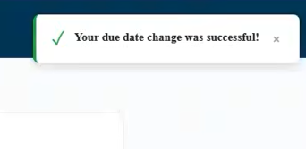
The learner will receive a notification email with the new due date. | 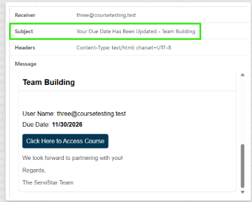
Your learner will see when the course is due when they view their “My Courses” page | 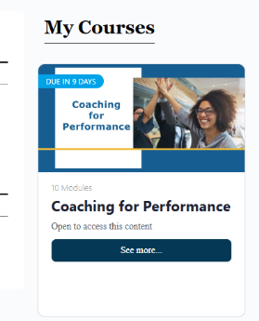
If you chose not to reset course progress, your learner would see the course progress on their course page | 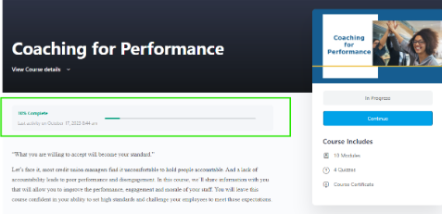
If you chose to reset their course progress, your learner will start the course over again from 0% complete | 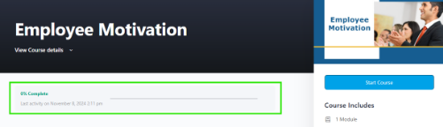
Important Consideration:
- If you’ve assigned a course to a learner at any time in the past, and want to ask them to complete the course again (e.g. you assign Service Excellence this year as part of an annual requirement and/or as part of new employee onboarding, and you want them to take it again in 6 months as a refresher), you don’t have to “Assign” the course out again through the “Assign Courses” tab. Simply use the “Update Due Date” tab and use the “Select All” feature, and input the new due date. With this, you’ll be “Re-Assigning” the course to your learners with the new due date.

