Managing Events

What’s New:
- Courses included in event bundles will show up as events to assign out, rather than bundles to assign out. E.g., if you purchased 5 New Employee Bundles, you’ll see 5 available seats to Credit Union PhD, Service Excellence, Becoming a Sales Champion and Defusing Irate Members events, rather than 5 seats to “New Employee Bundle”.
- Available event seats from multiple purchases will be aggregated onto one line. E.g., if you purchased 4 seats to Service Excellence on Jan 2nd and 5 seats again on Jan 15th, you’ll see a total of 9 seats to Service Excellence (assuming you haven’t assigned any seats to your users yet). When you go to assign event seats, we will allocate seats from your earlier purchase before we allocate seats from your most recent purchase.
- We will only show the number of seats you have available to assign, and not the number of seats you have purchased.
Historically, we have presented event seats in this format, which included the order ID, order date, event/bundle name, seats remaining and original purchase amount  Old “Manage Events” view --- | 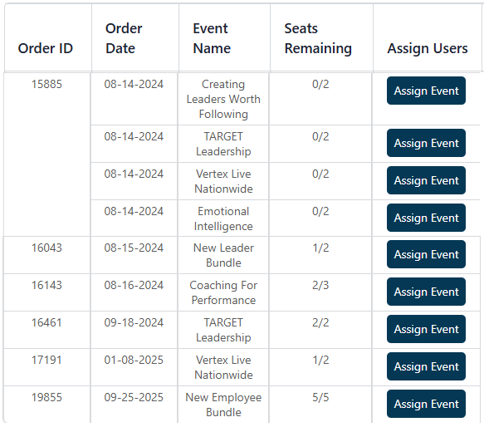
To make it easier to assign your learners to our events, we now present event seats this way, with the event name and the total number of seats you have available to assign. Notice we’ve pulled the event names out of the bundles and present them directly on this screen for you to assign. If you’ve purchased seats to an event in the past, and no longer have any remaining seats to assign out, you’ll see a “-“ in the “Seats Remaining” column.  New “Manage Events” view -- | 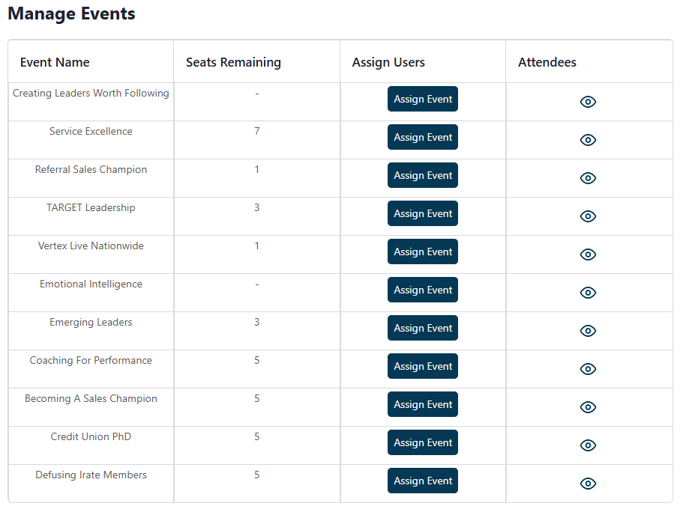
When you select “Assign Event”, you’re taken to the page where you can assign your users. It’s important to note that the number you see under “Seats” is the total number of seats you’ve purchased for this event – not the remaining seats to assign.  In this case, we see we’ve purchased 5 seats to Vertex Live Nationwide.  We can also see the 4 people we’ve already assigned the event to, since their names are checked.  This leaves us with 1 seat left to assign (which is the number of “Seats Remaining” | 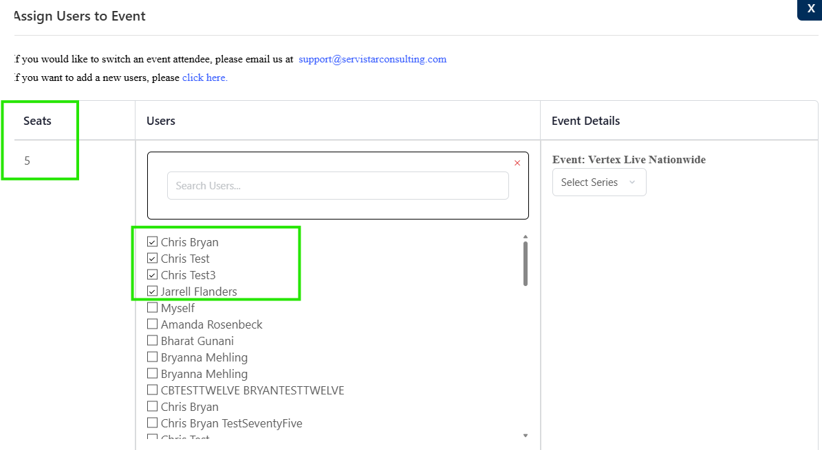
I can assign myself to the Fall 2026 Vertex Live Nationwide event by selecting “Myself”, along with the Fall 2026 event series, and selecting “Save” at the bottom. | 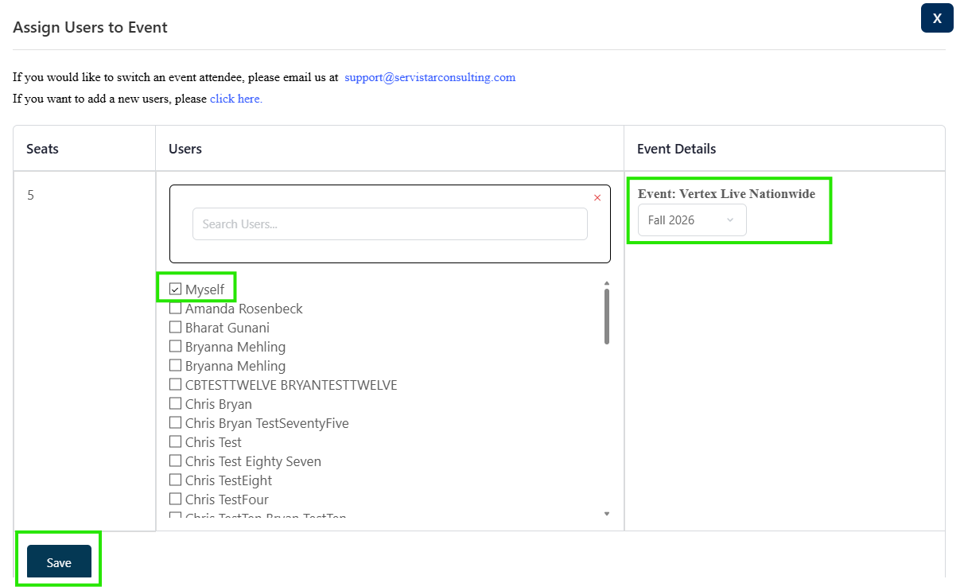
Both the learner and the admin get a confirmation email for the event registration, like they do today. | 