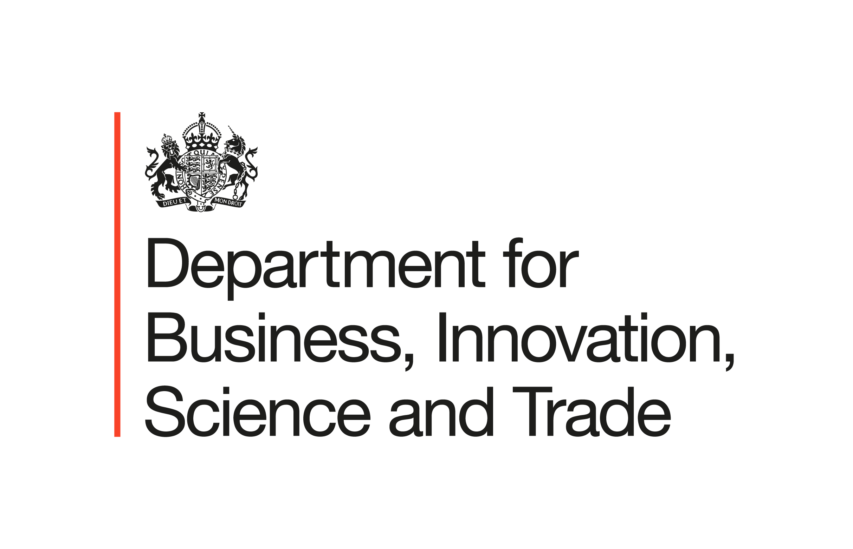

New Creative Trade Forum to boost UK creative industries announced at Edinburgh International Festival

- UK creative businesses from film, TV, music, arts and more set to benefit from new partnership to help them sell more ideas, talent and products overseas.
- New partnership launched at Edinburgh International Festival brings together government and leaders from advertising, gaming and AI to architecture and design.
- £10m new funding from Innovate UK announced to help UK creative technology businesses across the country scale up, helping deliver good growth in every postcode.

Britain's world-leading creative industries will benefit from a new partnership between government and industry leaders focused on helping them sell more ideas, talent and products overseas, government has announced today (26 August).

Minister for Reindustrialisation Blair McDougall will today launch the new Creative Trade Forum – alongside Co-chairs Francesca Hegyi (Edinburgh International Festival) and Michael Frohlich (WPP) - during a visit to the Edinburgh Festivals, which generate around £800 million for Scotland's economy and support thousands of jobs.

This delivers a key commitment of the Creative Industries Sector Plan, as part of the Government's Modern Industrial Strategy.

Reporting to the Creative Industries Council, the Forum brings together leaders from industry and trade bodies, including from YouTube, BBC Studios, WPP, Goalhanger the British Film Institute and the British Council to help creative businesses scale up and showcase the best of UK creative excellence overseas.

It will provide industry-led insight to government, identify barriers to growth, champion UK creative exports, attract investment and help build stronger international commercial partnerships.

The Forum will give creative businesses direct access to industry and government expertise to help them break into new markets and turn UK talent into commercial success.

The announcement today comes as statistics show the UK’s creative industries added over £145 billion to the economy in 2024, supporting thousands of skilled jobs.

Minister for Reindustrialisation Blair McDougall said:

“The Edinburgh Festivals showcase the best of the UK’s world-renowned creative businesses, which is why it’s here that we’re launching the Creative Trade Forum, bringing together industry experts and leaders to drive investment and opportunity for UK firms in new global markets.

“Through our Modern Industrial Strategy, we’re doubling down on one of Britain’s fastest-growing sectors and biggest success stories to boost good growth and jobs in every corner of the country, and cement our world-leading creative reputation.”

Francesa Hegyi, Co-Chair of Creative Trade Forum and CEO, Edinburgh International Festival said:

“The UK’s Modern Industrial Strategy, launched in June 2025, is a clear blueprint for economic growth, and creative industries are a key part of that.

“I'm really pleased that the groundwork we've laid over the past couple of years is now translating into tangible action through the Creative Trade Forum. This will unlock genuine export and investment opportunities for creative businesses right across the UK.”

Michael Frohlich, Co-Chair of Creative Trade Forum and Chief Marketing Officer, WPP said:

“The UK does not have a creativity challenge. It has a scale challenge. We already produce world-class ideas, talent and intellectual property. The opportunity now is to help more UK creative businesses turn that advantage into export growth, investment and commercial success in every major market around the world.

“Today's creative industries sit at the intersection of creativity, technology and commerce, spanning everything from advertising, design and architecture to film, television, gaming and next-generation AI-powered businesses.

“The countries that win over the next decade will be those that treat creativity not just as cultural capital, but as economic infrastructure. The Creative Trade Forum is about helping more UK creative businesses compete, grow and win on the global stage.”

Ian Murray, Minister of State for DCMS said:

"This new, industry-led forum marks a step change in how the Government and the creative sector will work together to unlock global opportunities for our creative businesses.

"Our Creative Industries Sector Plan set out a clear ambition: to break down market access barriers and use trade agreements to grow trade and investment. The Creative Trade Forum will be central to delivering that, and I look forward to working closely with it to build on the world-leading strength of our creative industries."

During his visit to Edinburgh, Minister McDougall will meet with members of the Creative Trade Forum and Edinburgh Fringe Festival Society’s Chief Executive Tony Lankester and take part in a 'Closer to Europe' roundtable with industry leaders aimed at unlocking new opportunities for UK creative firms on the continent.

In addition to the launch of the Forum, the Government is also doubling down on support for businesses scaling up next-generation creative technologies onto the global market.

Innovate UK’s Next Wave is the UK’s leading growth programme for creative technology businesses, helping ambitious micro businesses and SMEs turn breakthrough ideas – like next-generation gaming platforms and AI tools for film production – into scalable products and services, and connect them to new overseas markets.

Following a highly successful £10 million pilot of this programme, which attracted around 700 applicants from creative technology businesses, Innovate UK will launch further funding opportunities in 2027 to back the UK's four frontier creative industries: film and TV, video games, music, performing and visual arts, and advertising and marketing.

Deputy Director Creative Industries, Innovate UK, Dr Joanna Choukeir said:

"The UK is home to extraordinary R&D infrastructure, creative talent and technological ideas. Next Wave is about backing the people pushing the edges of creativity and technology. By connecting ambitious createch SMEs with funding, expertise, markets and investment, we're helping make the UK the #1 place for the next generation of UK creative businesses to start, scale, stay and contribute to societal impact.”

By supporting businesses at the forefront of creativity and technology, the programme will help attract private investment, strengthen exports and support the Government's ambition to double business investment in the creative industries – helping to deliver good growth in every postcode.

ENDS

Notes to editors:

Members of the Creative Trade Forum:

- Francesca Hegyi OBE – Chief Executive of the Edinburgh International Festival
- Michael Frohlich – Chief Marketing Officer & Corporate Affairs Officer, WPP
- Paul Alger – Director of International Business, UK Fashion & Textile Association
- Tracy Brabin – Mayor of West Yorkshire
- Tom Christopherson – Chairman, British Art Market Association
- Deborah Dawton – Chief Executive, Design Business Association
- Elizabeth Diaferia – Associate Director, UK Research & Innovation (UKRI)
- Claire Walker/Hannah Essex – Co-Chief Executive, Society of London Theatre (SOLT)
- Giorgio Fazio – Research Director, Creative Industries Policy and Evidence Centre (Creative PEC)
- Cliff Fluet – Head of Media & Entertainment & Board Member, Lewis Silkin/ Music Tech UK
- Tom Fiddian – Head of AI and Data Economy Programmes, Innovate UK
- Tom Fussell – Chief Executive Officer, BBC Studios
- David Leigh-Pemberton – Director of Corporate and International Affairs, British Fashion Council
- Ross Lewis – Director of International & Projects, PACT
- Alison Lomax – Managing Director, YouTube, UK and Ireland
- Nema Hart – Director SW + Inclusive Innovation, Arts Council England (shared ACE representation)
- Scott McDonald – Chief Executive, British Council
- Nick McDowell – Director of International, Arts Council England (shared ACE representation)
- Natalie Melton – Executive Director, Crafts Council
- Agnieszka Moody - Head of International Relations, British Film Institute (BFI)
- Iain Munro – Chief Executive, Creative Scotland
- Kate O'Connor – Chair of Animation UK
- Nick Poole OBE – Chief Executive, UK Interactive Entertainment (UKIE)
- Chloe Straw – Director of Operations, Goalhanger
- Kate Taylor Tett – Director of the GREAT Britain & Northern Ireland Campaign
- Dr Jo Twist OBE – Chief Executive Officer, British Phonographic Industry (BPI)
- Valerie Vaughan-Dick – Chief Executive, Royal Institute of British Architects (RIBA)
- Stephen Woodford – Chief Executive Officer, Advertising Association
- Adrian Wooton OBE – Chief Executive, Film London
- Department for Digital, Culture, Media and Sport
- UK Export Finance
- Office for Investment

For more detail on Innovate UK’s Next Wave programme, click here: Next Wave: Breakthrough Wave 1 - Innovate UK Business Connect

Statistical sources
- Edinburgh Festivals economic impact
- Creative industries economic contribution
- Creative industries exports

