

# Trip to Costa Rica - BURGIN

*San Jose - Tortuguero - La Fortuna - Bagaces - Monteverde - Manuel Antonio - Piedras Blancas*  
*18 Days / 17 Nights*  
*2 Persons*  
*Reference: BKFI107566*  
*Date of Issue: 29 April 2025*  
**23 January 2025 - 09 February 2025**

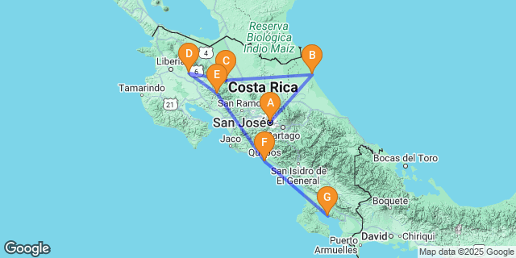

## Introduction

|  |  |  |  |  |  |  |
| --- | --- | --- | --- | --- | --- | --- |
| **Accommodation** | **Destination** | **Start** | **End** | **Basis** | **Room Type** | **Duration** |
| [Hotel Grano De Oro](https://wetu.com/iBrochure/38877_47697) | San Jose | 23 Jan | 24 Jan | B&B | 1x Deluxe Patio | **1 Night** |
| [Tortuga Lodge & Gardens](https://wetu.com/iBrochure/38877_49226) | Tortuguero National Park | 24 Jan | 26 Jan | FB+ | 1x Mr Mishak Suite | **2 Nights** |
| [Amor Arenal](https://wetu.com/iBrochure/38877_190908) | La Fortuna | 26 Jan | 29 Jan | B&B | 1x Cayon Casita Queen | **3 Nights** |
| [Rio Perdido Hotel](https://wetu.com/iBrochure/38877_53903) | Bagaces | 29 Jan | 31 Jan | B&B | 1x West Bunalow | **2 Nights** |
| [Senda Monteverde](https://wetu.com/iBrochure/38877_163991) | Monteverde | 31 Jan | 3 Feb | B&B | 1x Junior Suite | **3 Nights** |
| Hotel Makanda by the Sea | Manuel Antonio | 3 Feb | 6 Feb | B&B | 1x Deluxe Suite Ocean Club (Double) | **3 Nights** |
| [Playa Cativo Lodge](https://wetu.com/iBrochure/38877_53895) | Piedras Blancas | 6 Feb | 9 Feb | Full board | 1x Deluxe Panoramic Ocean View (Double) | **3 Nights** |

**Key**  
B&B: Bed and Breakfast  
FB+: Full Board Plus - Dinner, Bed, Breakfast, Lunch and Activities

## Included

* Program or "similar" hotels, with American or tropical breakfasts
* Program Activities
* Transfer In Airport/Hotel by private sightseeing minivan.
* Manuel Antonio Park entrances
* Flight from Golfito to San José
* Assistance from Domestic airport to international airport
* Car rental with basic insurance and wifi

## Excluded

* Drinks and personal expenses
* Lunches and dinners not mentioned in the program
* All services not mentioned in the program or at an additional cost.
* International flights Europe / Costa Rica / Europe.
* Car rental deposit

## Day 1: Hotel Grano De Oro, San Jose (Thu, 23 January)

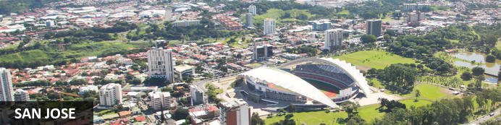

San Jose, affectionately known to its residents as 'Chepe', lies in the heart of Costa Rica and is home to almost two-thirds of the country’s population. With few buildings over 100 years old, the mountainous capital is relatively modern compared to its Latin American counterparts, but still has a significant amount of culture, art and history for visitors to discover. With a number of theatres full of Costa Rican culture, museums that include the largest collection of American jade in the world, and streets full of bright murals and painted buses, San Jose is an eclectic city waiting to be experienced.

Arrival at Juan Santamaría International Airport in San José, our driver will welcome you. Departure by private transport to your hotel in Alajuela.

### Overnight: Hotel Grano De Oro

In Costa Rica, the term “Grano de Oro” is used to refer to the coffee bean, their “Grain of Gold”. The founders of this boutique hotel fell in love with the idea that such a small fruit could be so valuable.

Hotel Grano de Oro was started by a Canadian couple who frequented Costa Rica for vacation. They loved the natural beauty of the country and the people, and particularly the metropolitan city of San Jose. They found that San José was lacking an upscale boutique-style hotel, offering a unique, personalized service – in other words a “Grain of Gold”. The search for the perfect house to be renovated began.

The original tropical Victorian home, which is now known as the Grano de Oro, was a private family residence belonging to the Pozuelo family, built at the turn of the 20th century.

The Hotel Grano de Oro opened its doors in December of 1991, with 21 guest rooms, a gift shop and a modest café. Quickly gaining recognition from local and international agencies for its unique personality and great service, the hotel became a landmark within the city.

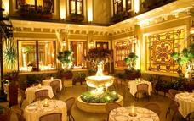

### Basis

Bed and Breakfast

## Day 2: Tortuga Lodge & Gardens, Tortuguero National Park (Fri, 24 January)

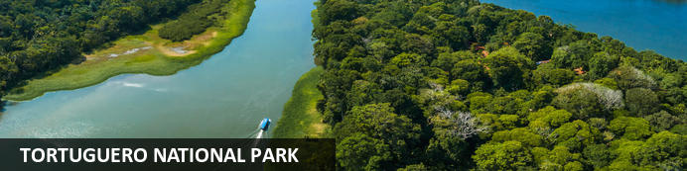

An exuberant blanket of dense rainforest encompasses over 77 000 acres on the northeastern coast of Costa Rica at Tortuguero National Park, a biodiverse wonderland and sanctuary for a rich array of wildlife, including jaguars, monkeys, sloths, and an astonishing variety of bird species. The park's name, meaning "Land of Turtles," highlights its significance as a nesting ground for several sea turtle species, most notably the endangered green turtles. A network of canals weaves through the lush rainforest, offering visitors a unique opportunity to explore by boat or kayak, immersing themselves in the park's unparalleled natural beauty. Pristine beaches, vibrant mangroves, and dense forests make Tortuguero National Park a must-visit destination for nature enthusiasts and conservationists, where adventure and ecological wonders intertwine harmoniously.

|  |
| --- |
| **Breakfast at the Grano de Oro Hotel** |

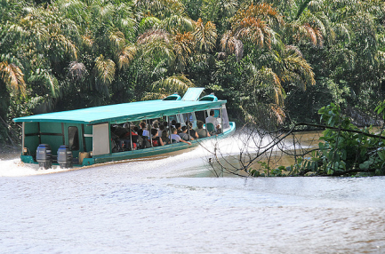

Departure for the Caribbean region by private transport to reach the Tortuguero National Park

Along the way, we'll pass through the lush Braulio Carrillo Park.

To reach your Lodge, you will need 1h30 of navigation in a collective boat (organized by the lodge) on canals where you will not fail to observe the fauna and flora.

Then, transfer by collective boat

### Overnight: Tortuga Lodge & Gardens

Tortuga Lodge & Gardens is situated on 146 acres of private land, in Tortuguero on Costa Rica's northeast Caribbean coast. The Lodge is set on a riverbank and surrounded by jungle. Offering 12 Downstairs Terrace Rooms, 12 Upstairs Balcony Rooms, 2 Downstairs Family Suite and 1 Penthouse Suite. Guests will also enjoy the river views from our social areas, gardens, outdoor pool, and our Restaurant, serving fusion cuisine with Caribbean flavors.

At Tortuga Lodge and Gardens à la carte breakfast and Wi-Fi are included within the rate, as well as nature walks with our Naturalistic Guides, one in the morning at 6:00 am and one in the afternoon, at 3:00 pm. Our Front Desk Staff can help you arrange excursions and tours, such as kayaking, sports fishing trips, visits to local villages and nearby turtle nesting sites when in season. Tortuguero Airstrip is located just across the river from Tortuga Lodge, and San José is a 30-minute flight away. The town of Tortuguero is located at a 10-minute boat ride away from the Lodge. The average temperature in Tortuguero is 80 °F/ 26 °C.

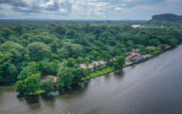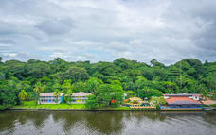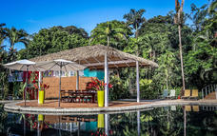

### Basis

Full Board Plus - Dinner, Bed, Breakfast, Lunch (Drinks not included) and Activities

## Day 3: Tortuga Lodge & Gardens, Tortuguero National Park (Sat, 25 January)

This day will be dedicated to discovering the surroundings thanks to 2 activities included in small groups and to be chosen from the lodge.

Among those offered by the Lodge and depending on availability:

* Natural History Boat Tour
* Twilight Tour on the Trails of the Property
* Tortuguero Village & Sea turtle Conservancy Center
* Kayak in Tortuguero
* Tour to Cerro Tortuguero

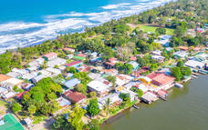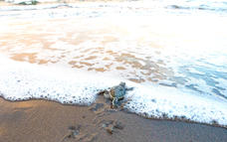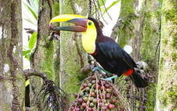

### Basis

Full Board Plus - Dinner, Bed, Breakfast, Lunch (Drinks not included) and Activities

## Day 4: Amor Arenal, La Fortuna (Sun, 26 January)

You will leave the park by boat and then take a private shuttle to the car rental agency, to pick up the car rental

Lunch is not included

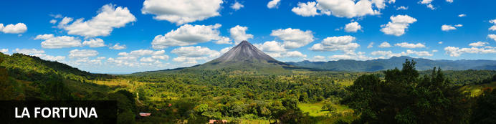

Located just 2-hours drive northwest of San Jose, the little Costa Rican town of La Fortuna rests at the foot of the majestic Arenal Volcano. La Fortuna provides an excellent base for visitors to explore the beautiful surrounding area, most notably the scenic Arenal Volcano National Park. Photographers will delight in the spectacular views provided by several lookout points along sublime hiking trails, which wind through lush rainforests and past idyllic natural hot springs. The glistening Arenal Lake, which is the largest lake in the country, offers fantastic opportunities to practice water sports. Don’t miss the beautiful La Fortuna waterfall and natural pool. Visitors can also look forward to wildlife tours, coffee plantation tours, and cacao farm tours, as well as an array of excellent restaurants and shops in the town centre.

### Overnight: Amor Arenal

Amor Arenal, nestled at the foothills of Arenal Volcano and on the edge of the Virgin Forest Canyon, offers a luxurious escape with breathtaking views of the rainforest. The property features elegantly designed cabins made from tropical hardwoods, each offering direct views of the volcano. Modern amenities include air-conditioning, Wi-Fi, private bathrooms, warm mineral spring pools, and a deck overlooking the canyon.  
Guests can savour organic, locally-sourced dishes at El Rancho restaurant or enjoy tapas at La Jaranita specialty restaurant. The lodge also boasts a full-service spa, providing the perfect opportunity to unwind. With its prime location, guests can easily access jungle trails, enjoy horseback riding, or relax in the hot spring pools directly from their rooms.

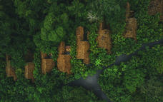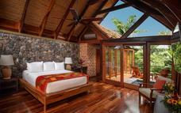

### Basis

Bed and Breakfast

## Day 5: Amor Arenal, La Fortuna (Mon, 27 January)

### Included activity : Guided tour to Arenal Volcano National Park in small group (1968)

Costa Rica has about 112 volcanoes and the Arenal Volcano is one of the most active in the country. From 1968 to 2010, there were numerous lava flows, eruptions, and pyroclastic clouds. For years, this volcano has been the biggest attraction in the area. With a beautiful natural landscape, its characteristic trails, flora and fauna, your certified naturalist guide will take you to the ancient lava fields, where some observation points will surprise you.

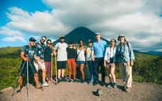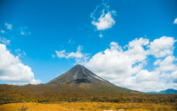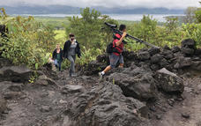

**Included activity : Self-guided tour at the hanging bridge**

This tour of the Arenal Suspension Bridges is a route of eight fixed bridges that are between 8 and 22 meters high and 6 (mobile) suspension bridges that are between 28 and 48 meters high. These bridges comply with the latest construction standards in force, guaranteeing you maximum safety. They were built to allow visitors to discover the forest without harming its conservation. This walk in the treetops will not leave you indifferent and will give you some sensations.

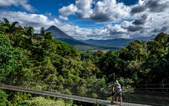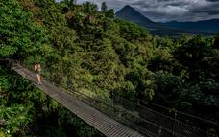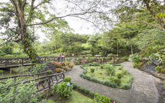

### Basis

Bed and Breakfast

## Day 6: Amor Arenal, La Fortuna (Tue, 28 January)

### Day at leisure

### Basis

Bed and Breakfast

## Day 7: Rio Perdido Hotel, Bagaces (Wed, 29 January)

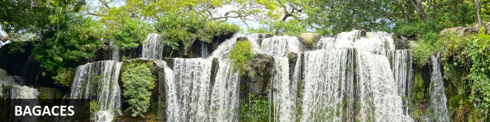

Set in the province of Guanacaste in Costa Rica, Bagaces is best known as the home of the magnificent Llanos de Cortes Waterfall. It serves as the capital of its eponymous ‘canton’, a smaller region within the larger province. The city boasts a rich history and spectacularly scenic natural landscapes. Bagaces provides the perfect stopover and springboard to other nearby attractions including the Miravalles Volcano National Park; the Lomas Barbudal Biological Reserve, an oasis of green; and the Palo Verde National Park, home to many species of migratory birds as well as crocodiles, monkeys, deer, coati, and jaguarondi. Don’t miss the opportunity to taste the deliciously fresh chicken dishes at the Restaurante Pollo Asado Las Lenas (more commonly known as Katia's) and sing karaoke with the locals at one of the many karaoke nights.

### Overnight: Rio Perdido Hotel

Cooled by an ever-present breeze and framed by a unique dwarf forest, Rio Perdido is a sanctuary of well-being and the true embodiment of Costa Rica’s legendary PURA VIDA.  
You will find Rio Perdido in the Guanacaste province, on the western side of the country, just an hour away from Liberia.  
This 600-acre reserve includes a modern eco-lodge featuring 30 bungalows designed to be in perfect harmony with its surroundings. Great care has been taken to preserve this one-of-a-kind setting and its precious resources, while simultaneously providing a very comfortable experience for conscious-minded guests.  
Guests can enjoy dozens of completely natural pools along our very unique mile-long Thermo mineral river, yoga classes, nature walks, whitewater tubing, mountain biking canyon adventures, wildlife watching, and a healthy + authentic gastronomical experience.

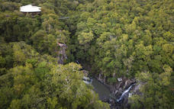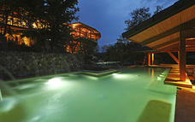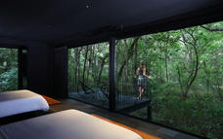

### Basis

Bed and Breakfast

## Day 8: Rio Perdido Hotel, Bagaces (Thu, 30 January)

### Included activity : Private guided night tour

You will visit one of the viewpoints called "Mesa Norte", on a 25-minute guided walk where you can observe the nocturnal activity of the forest, many invertebrates and with a bit of luck, a local mammal. Once at the top, you can enjoy the night view of this place, identifying the villages close to the property, the shadow of the 3 nearest volcanoes and on a clear day you can admire the stars and constellations that adorn the night sky.

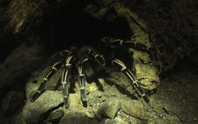

### Basis

Bed and Breakfast

## Day 9: Senda Monteverde, Monteverde (Fri, 31 January)

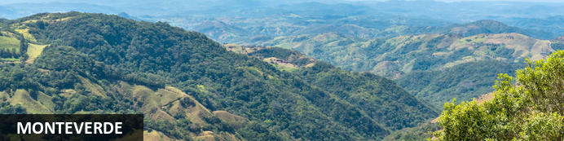

Monteverde, the name of a settlement and a forest described as ‘the jewel in the crown of cloud forests’ by National Geographic, lies in the Cordillera de Tilaran mountain range in Puntarenas, Costa Rica. One of the rarest habitats on the planet and unique from the country’s other rainforests for its constant swathes of mist (which give it its name), the Monteverde Cloud Forest is an incredible wild world filled with thousands of plant species, insects, bird varieties, and animals. Watch brightly-coloured birds at play in the Curi-Cancha Reserve; take a guided hike or horse ride through the dense jungle; watch electric blue frogs jump about at the famous Frog Pond, or take a dip in the pools around the San Luis Waterfall. Must-sees include the Butterfly Gardens, Orchid House, Selvatura treetop suspension bridges, and coffee, chocolate, and sugarcane tour.

### Overnight: Senda Monteverde

You love freedom and ease. You take your own sweet time and don’t mind the spare moments. You make every day count. And you make it all look effortless. We know you have many choices in where to stay in Monteverde, Costa Rica.

If you want to be well-rested and ready to experience all Monteverde offers, you can find everything you need here. Playful contemporary design. Warm, personable service. Luxury essentials. Hyper-local cuisine. And your own Naturalist Guides to help you explore the Cloud Forest. You’ve come to your cozy mountain lodge with all the best luxury essentials. Surrounded by nature, the heart of Monteverde. You’ll find that other hotels are further up the road. Sometimes, a 2-hour walk into town roundtrip. But us? We’re only a 15-minute walk to Monteverde Town.

At Senda, you have the best of both worlds: surrounded by nature with complimentary access to the neighboring Aguti Wildlife Reserve and the convenience of strolling into town for a coffee or visit to a craft beer house.

Senda Monteverde is a luxury eco-hotel for adventurous travelers like you— who seek a peaceful, down-to-earth stay.

Wonder and wander at Senda Monteverde Hotel. Because every day counts.

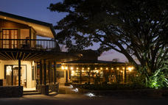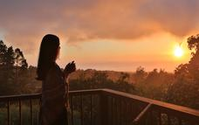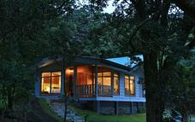

### Basis

Bed and Breakfast

## Day 10: Senda Monteverde, Monteverde (Sat, 1 February)

### Included activity : Private birdwatching tour

The tour starts in the lowest part of a private estate, to walk along nature trails, with a variety of habitats and thus the possibility of observing birds and mammals in open areas of the secondary and primary forest.

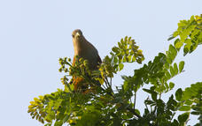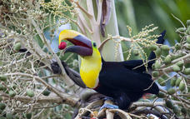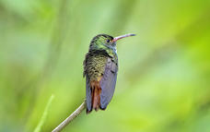

### Basis

Bed and Breakfast

## Day 11: Senda Monteverde, Monteverde (Sun, 2 February)

### Included activity : Private coffee + chocolate + sugar cane tour

You will enjoy three tours in one! Coffee: The first part invites you to discover everything about coffee! The history, culture and a "beneficio" in operation, as well as all the stages of the production of this star product of Costa Rica. Chocolate: The second part takes you into the world of chocolate, an ancestral product that everyone loves! In addition to learning all about cocoa, you will taste the freshly harvested grain and learn how to transform it into delicious chocolate. Sugarcane: The third and final part of the visit will be devoted to sugar cane. Learn about the historical methods of extraction and why many farmers had their own sugar cane mills called "trapiches". Participate in its preparation and enjoy a glass of pure juie

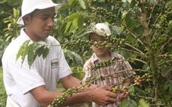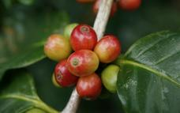

### Basis

Bed and Breakfast

## Day 12: Hotel Makanda by the Sea, Manuel Antonio (Mon, 3 February)

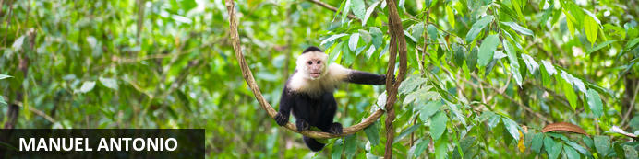

Neighbouring the spectacularly scenic 680-hectare Manuel Antonio National Park and situated along Costa Rica’s Pacific Coast, the bustling beachside village of Manuel Antonio offers a variety of comfortable accommodation options for eco-explorers and adventurers who flock here to explore this beautiful area. The undeniable highlight is the adjacent Manuel Antonio National Park, Costa Rica’s smallest national park, featuring lush biodiverse rainforests, mangroves, lagoons, offshore coral reefs, pristine white-sand beaches and abundant wildlife, including over 100 mammal species and almost 200 bird species. Visitors can enjoy a variety of exciting activities including fishing, swimming, snorkelling, wildlife viewing, bird watching, hiking and relaxing on tropical beaches.

### Overnight: Hotel Makanda by the Sea

Hotel Makanda by the Sea is located between the Biesanz Beach and the famous Manuel Antonio Park in Costa Rica. Accommodation types include guest rooms, suites and villas. Each unit is equipped with a flat-screen TV, air conditioning, a coffee machine, a safety deposit box, hairdryer, internet access and a minibar. The spa area includes an ocean-view terrace for private yoga lessons, a relaxing zone with beach beds, a massage spot, a Jacuzzi and an exclusive natural wood steaming room. Also available is an on-site restaurant.

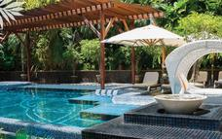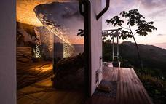

### Basis

Bed and Breakfast

## Day 13: Hotel Makanda by the Sea, Manuel Antonio (Tue, 4 February)

### Included activity : Damas Island Kayak tour in small group

Gently row along the soft currents under a verdant forest canopy, to explore the wonders of the unique Costa Rican mangrove ecosystem. Kayak through natural canals and keep your eyes wide open to spot a variety of bird species, reptiles, ant eaters and white-faced monkeys. Your guide´s knowledge will instruct you through the biodiversity of this habitat, and his trained eyes will seek out herons, kingfishers, ospreys and frigate birds. Navigate through the brackish waters and catch glimpses of Damas Island as you pass beneath natural tunnels created by tree growths. Lunch is provided before or after the kayaking adventure, depending on varying tides. Tour Includes: Transportation, bilingual guide, beverages and lunch.

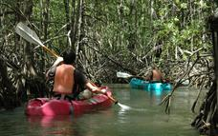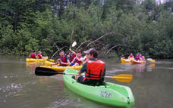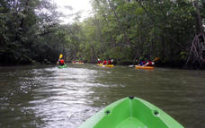

### Basis

Bed and Breakfast

## Day 14: Hotel Makanda by the Sea, Manuel Antonio (Wed, 5 February)

**Included : Manuel Antonio national park entrance fee**

It's one of the smallest parks in Costa Rica, but Manuel Antonio Park is full of natural beauty that will delight you. The Park is covered by a transitional forest where dry and humid tropical forests meet. Among the animals that inhabit the park are white-faced capuchin monkeys, howler monkeys, coatis, agoutis, iguanas, sloths and raccoons. You can visit the park and if you wish, enjoy its beautiful white sand beaches with only the iguanas and capuchin monkeys as guests who have fun stealing the beach towels of tourists. Manuel Antonio National Park is one of Costa Rica's most famous nature reserves. The park is home to several paradisiacal beaches, monkey troops, colourful crabs, sloths, iguanas, and many birds. The second beach of the park, known as Playa Manuel Antonio, is a protected bay and with its calm waters, an ideal place to swim. The Government of Costa Rica has established a new law on environmental conservation, all National Parks in Costa Rica have banned the entry of single-use plastic bottles. Only bottles made from sustainable materials (aluminium, glass, bamboo, etc.) that can be refilled will be allowed. **Closed on Tuesdays**

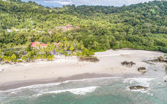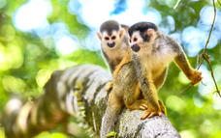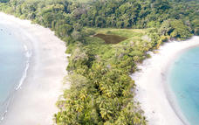

### Basis

Bed and Breakfast

## Day 15: Playa Cativo Lodge, Piedras Blancas National Park (Thu, 6 February)

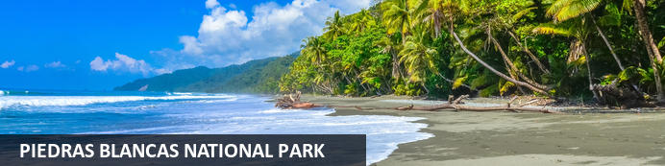

Forming part of the Osa Conservation Area, Piedras Blancas National Park is situated in the Puntarenas Province near the Golfo Dulce on the Southern Pacific Coast of Costa Rica. Renowned for its untouched beaches, glistening bays and lush rainforests, Piedras Blancas is popular with nature lovers. Visitors can look forward to a wide selection of activities including exploring the rugged mountains, discovering rare tropical trees, and spotting an array of wildlife such as a diverse variety of bird, mammal and reptile species. Most notably, the park is among the last remaining habitats for the Jaguar in the whole of Costa Rica. Don't miss the opportunity to meander along the vast network of jungle trails while soaking up spectacular views of the 14 000 hectares of unspoilt natural beauty.

You´ll drop the car off at the car rental office at Golfito, and an hotel representant will then manage to drive to the hotel

### Overnight: Playa Cativo Lodge

Immerse yourself in the beauty of Playa Cativo Lodge, an eco-lodge that harmonizes luxury with nature. With open-air layouts and breathtaking views of the stunning wilderness, our exquisite accommodations invite guests to indulge in raw luxury. Each of the 17 guest rooms overlooks the glistening Golfo Dulce, providing a serene escape to reconnect with nature.

Guests can enjoy unforgettable sunsets, refreshing sea breezes, and the soothing sounds of the jungle and shore. The lodge features a variety of room options, including 2 Deluxe Ocean View, 2 Deluxe Panoramic Ocean View, 1 Premium Ocean View room, a standalone Ocean Front Casita, 8 Luxury Casitas with plunge pools, and two spacious Two Bedroom Ocean View Villas. Each room is elegantly furnished with reclaimed hardwood and handcrafted tilework, equipped with refreshing rain showers, biodegradable amenities, and complimentary Wi-Fi.

Relax by the fresh-water pool, savor delicious meals at El Gavilán Restaurant, and embrace the tranquil surroundings. Playa Cativo Lodge is the perfect retreat for nature lovers and those seeking tranquility.

**Basis**

Full Board (Drinks not included)

## Day 16: Playa Cativo Lodge, Piedras Blancas National Park (Fri, 7 February)

### Included activity : Dolphin & Whale Watching Quest

The Dulce Gulf is one of the four tropical fjords in the world and is home to a variety of marine life, including cetaceans. Two species of dolphins spend their entire life cycle in the Gulf of Dulce, and between July and November, it is possible to witness the arrival of humpback whales and their calves. Sea turtles and seabirds often appear during the tour, combine this tour with snorkeling for a fantastic day on the water

**Included activity : Bioluminescence Expedition**

Bioluminescence is a chemical reaction produced by living organisms to emit light. Even if the daylight disappears, your adventure is about to begin! Schools of fish create a glow-in-the-dark wake that can resemble a luminous cloud in the water. Explore this natural phenomenon by boat, observing how the water beneath your feet shines and sparkles even with the movement of your hands. An experience not to be missed! The best visibility is near the dates of the new moon phase.

### Basis

Full Board (Drinks not included)

## Day 17: Playa Cativo Lodge, Piedras Blancas National Park (Sat, 8 February)

### Included activity : Rio Esquinas mangrove kayaking expedition

We are blessed to have one of the largest and most pristine river systems in Costa Rica just a few short beaches away. The river mouth mangroves lead to picturesque scenes of unspoiled mangrove systems. This diverse terrain allows for some of the best birdwatching in the area. The best time to start this adventure is during high tide, letting us go deep inside the mangrove channels.

Our boat tows your kayak to the mouth of the river, where you will embark on a peaceful adventure and experience the magic of nature while cruising down the river on a kayak through the amazing mangroves and rainforest scenery.

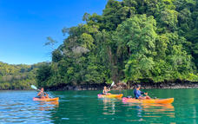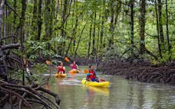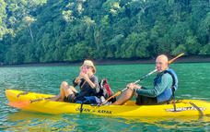

### Basis

Full Board (Drinks not included)

## Day 18: End of Itinerary (Sun, 9 February)

# You will be driven to the regional airport to take a flight and reach San José.

Upon your arrival in San José, You will be greeted by our driver, who will assist you with your luggage for the connection between the domestic and international airports.

End of our services

# Transport

## Car Rentals

|  |  |  |  |
| --- | --- | --- | --- |
| **Start Date** | **Length** | **Vehicle** | **End Date** |
| 26 Jan | 11 Days | Suzuki Vitara 4x4 | 5 Feb |

*To rent the vehicle, it will be necessary to present the original driving license of your country of origin. The international license alone is not enough for rent.*

*Approximative drive duration*

*San José – Tortuguero 3h00 transfer + 1h30 by boat*

*Tortuguero – La Fortuna 1h30 by boat, 30 min transfer then about 2h30 drive*

*La Fortuna – Bagaces 2h30 drive*

*Bagaces – Monteverde 2h00 drive*

*Monteverde – Manuel Antonio 4h00 drive*

*Manuel Antonio – Golfito 3h00 drive*

**Total rate based on 2 adults in USD $ 29 200.00**

Prices valid from **23 January 2026 to 09 February 2026**

Prices in US dollars, based on occupancy, including local taxes.

Rooms are subject to availability.

**Rates for 2026 are not available yet, the price given is based on the 2025 rates. For 2026, we should foresee an +/- 10% rise.**

**Please note that due to high demand, this itinerary is non-refundable and client must have their travel insurance in case of cancelation. Downpayment 80% until 15th May – balance (20%) 15th September 2025**

**Thank you for your booking!**

***Warning***

***The prices of hotel taxes and other services do not depend on our rate policy and may increase without notice (there is now a law that can be accepted for a tax increase in Costa Rica). Thank you for taking note of this and passing this information on to your customers***