EMAIL TEMPLATE 1 Internal email for employees
Subject: Supporting your clients with the National Assistance Card
Body:
Dear Team,
We want to share a valuable resource that can help the people you support feel more confident, independent, and safe in everyday life.
The National Assistance Card is a personalised card for autistic people and people with brain injury. It helps communicate needs in situations where individuals may feel stressed, overwhelmed, misunderstood, or tired of explaining their stories repeatedly, such as at the shops, on public transport, during appointments, or in emergencies.
This is what the Card looks like. You can scan the QR code to see an example of the information people can add (video is optional).
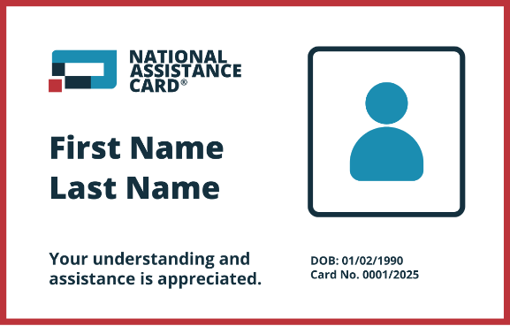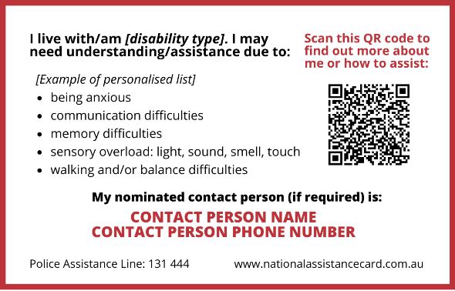
How your clients can apply for the Card:
- Visit www.nationalassistancecard.com.au/apply
- Complete the online application
- Upload a supporting document from a medical or allied health professional
By recommending the National Assistance Card, you can help the people you work with access a simple, practical tool to communicate their needs and navigate daily life with more confidence.
Learn more: www.nationalassistancecard.com.au
Thank you for helping make our communities more inclusive and supportive.
[Sign off]

