Sharing the National Assistance Card with Your Networks

As a disability organisation, sharing information about the National Assistance Card on social media can help more autistic people and people with brain injury access this important tool and get the support they need.

How to share online:

Post on social media to let your networks know what the card is and how it helps people communicate their needs.

When posting to social media, remember to use
#MyCardMyVoice and #NationalAssistanceCard

And tag us
Instagram: @nationalassistancecard
Facebook: @ National Assistance Card
LinkedIn: @ National Assistance Card

For people with disability, autism and brain injury

These social media posts are to share to an audience of families, carers and autistic people or people with brain injury.

POST EXAMPLE 1:
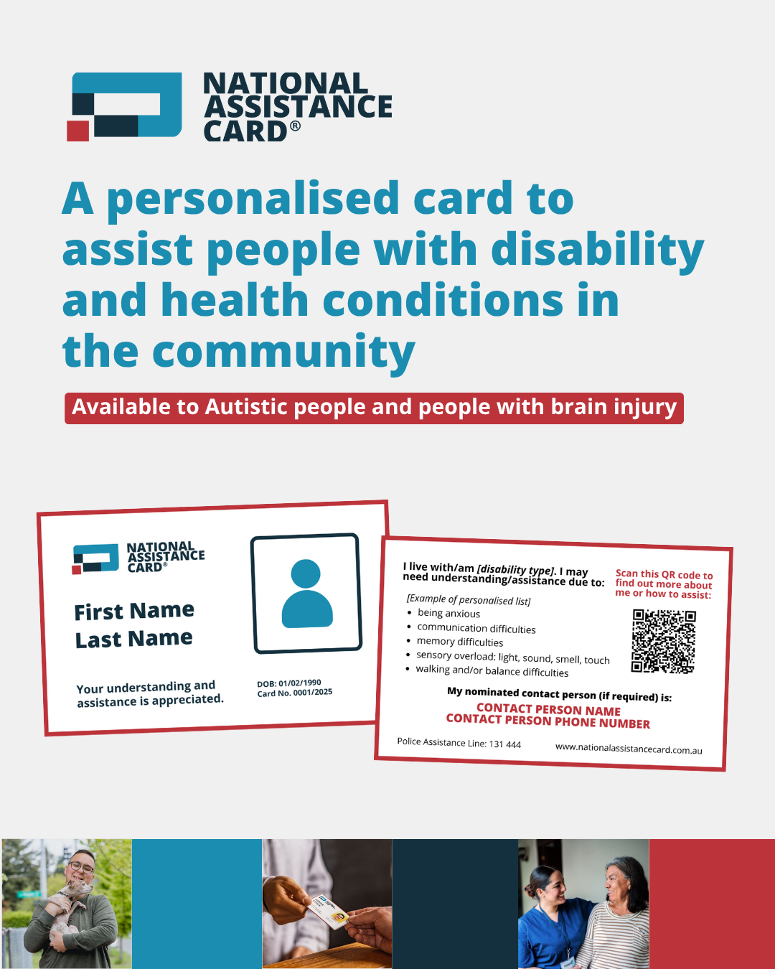
Click here to download the high quality image

Have you heard of the National Assistance Card?

If you are an autistic person or are living with brain injury, the National Assistance Card is a simple way to let others know when you need help – especially in situations where you feel stressed, overwhelmed, or unable to communicate.

The card includes personalised information about the impacts of your disability, helping people understand how to support you in everyday situations, like at the shops, on public transport, at medical appointments, or in emergencies.

The National Assistance Card is now available for all autistic people and people with brain injury across Australia.

Learn more: www.nationalassistancecard.com.au

#NationalAssistanceCard #MyCardMyVoice
@nationalassistancecard

POST EXAMPLE 2:
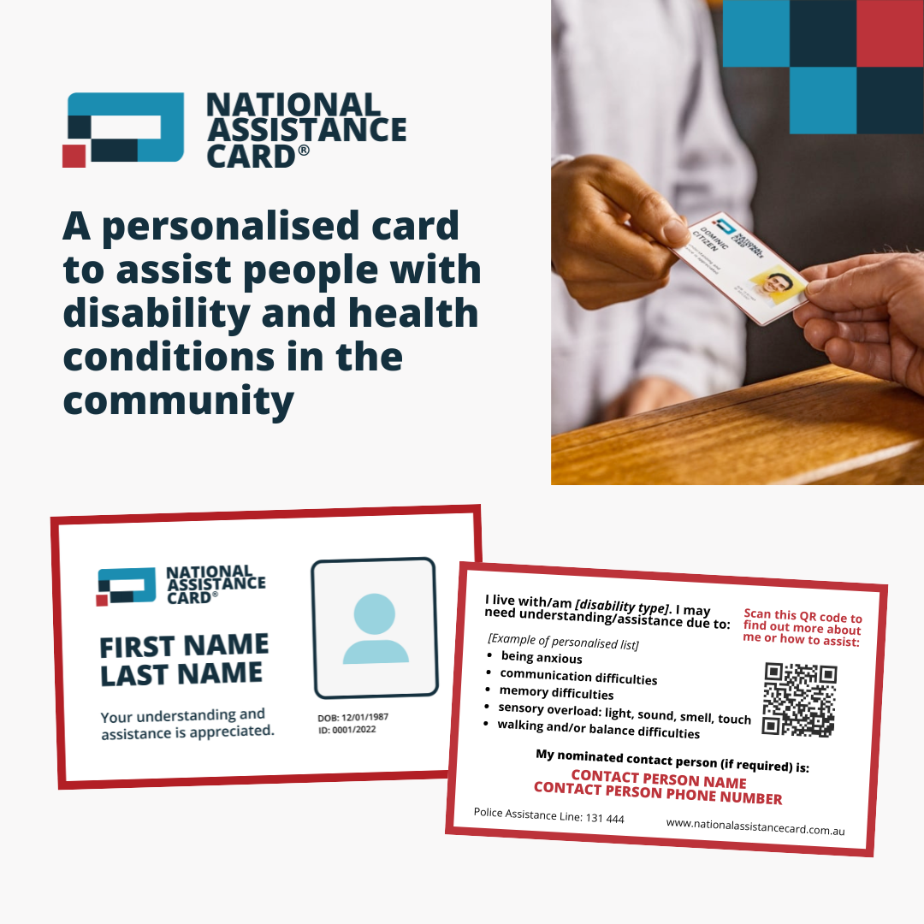
Click here to download the high quality image

Whether it’s at the shops, in the emergency room, at the bank, or on public transport, it can be especially hard for people who have communication difficulties to explain what’s happening or ask for support.

The National Assistance Card can help. Available for autistic people and people with brain injury across the country, the Card has personalised information about your support needs, making it simple to ask for help when it matters most.

Learn more: www.nationalassistancecard.com.au
#NationalAssistanceCard #MyCardMyVoice
@nationalassistancecard

POST EXAMPLE 3: How to sign up

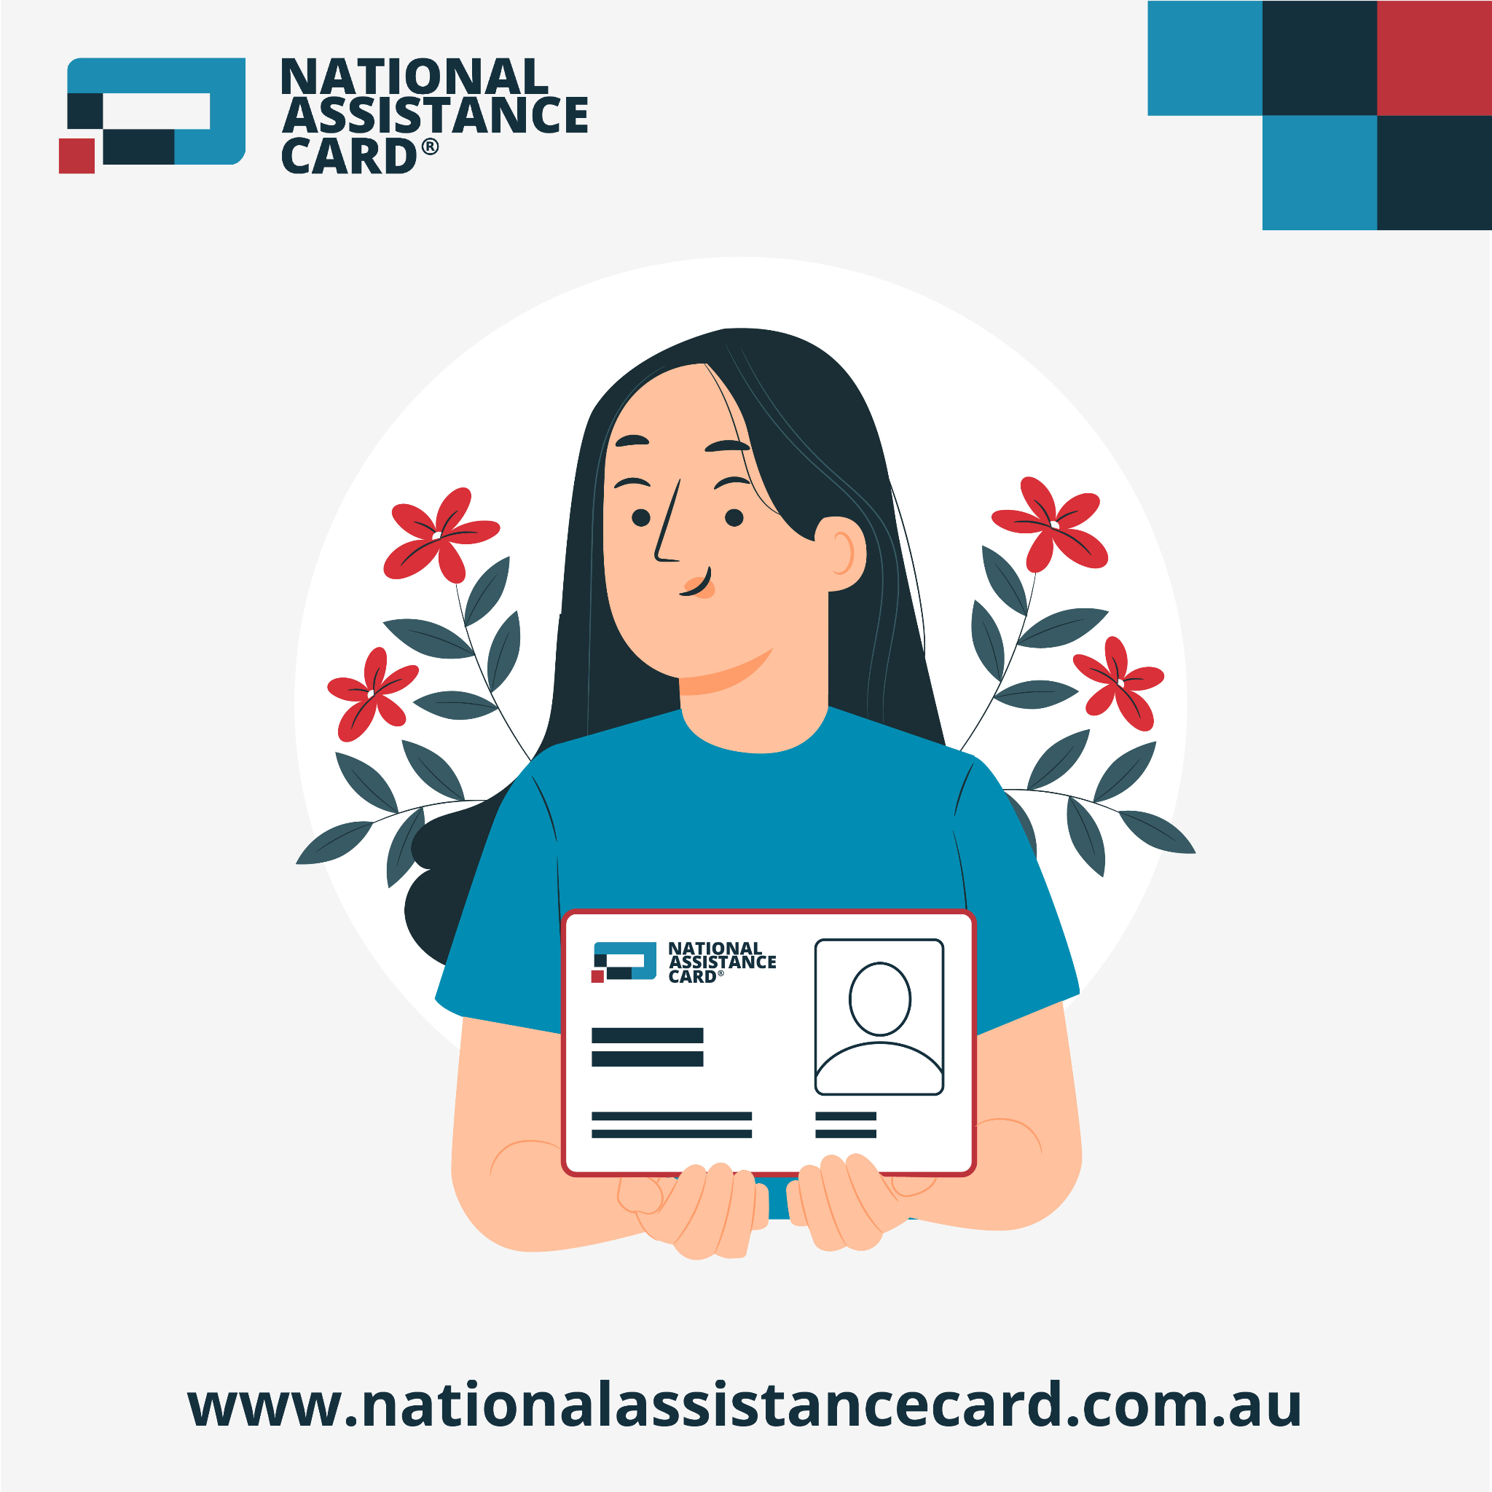
Click here to download the high quality image

Want to apply for your National Assistance Card?

It’s easy to get started! The @nationalassistancecard is a personalised communication tool available for autistic people and people with brain injury across Australia.

Here’s how to apply:
1️⃣ Visit www.nationalassistancecard.com.au/apply
2️⃣ Click “Apply Now”
3️⃣ Follow the steps to enter your details
4️⃣ Upload a document from a medical or allied health professional that supports your application
5️⃣ Submit!

You can also watch helpful video guides on the website to walk you through each step.
Family members, friends or support workers can help with your application too.

Learn more or start your application today www.nationalassistancecard.com.au/apply

#NationalAssistanceCard #MyCardMyVoice
@nationalassistancecard

For family, carers and support workers

POST EXAMPLE 4:

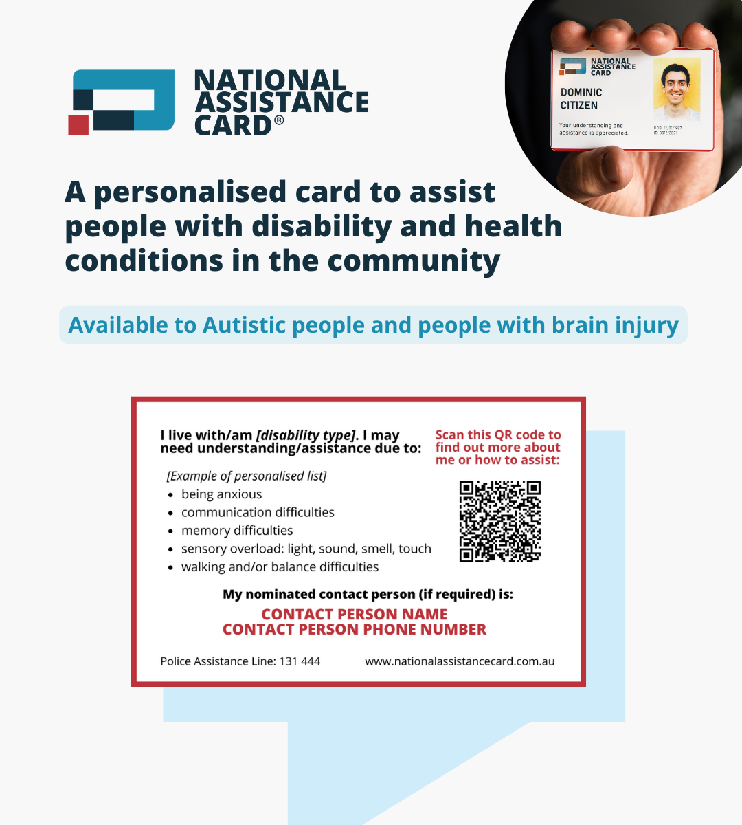
Click here to download the high quality image

Are you supporting someone who is autistic or has brain injury?
Have you heard of the National Assistance Card?

The @nationalassistancecard provides a simple way for people with disability or health conditions to let others know when they need help, especially in situations where they may feel stressed, overwhelmed, or unable to communicate.

Each card includes personalised information about the cardholder, and can be used in everyday situations, like at the shops, on public transport, at medical appointments, or in emergencies.

The National Assistance Card is now available for autistic people and people with brain injury across Australia.

Learn more: www.nationalassistancecard.com.au

#NationalAssistanceCard #MyCardMyVoice
@nationalassistancecard

For your professional network
This social media post is intended to be shared with those within your professional network on LinkedIn.

POST EXAMPLE 5:

The @National Assistance Card is a practical tool for autistic people and people with brain injury to communicate their needs in everyday situations or times of stress, whether at the shops, on public transport, at appointments, or in emergencies.

If you work in the disability sector, you can make a real difference by recommending the Card to the people you support.

How to support your clients in getting a card:
1️⃣ Visit www.nationalassistancecard.com.au/apply
2️⃣ Follow the step-by-step online application
3️⃣ Upload supporting documentation from a medical or allied health professional

By learning about the Card and encouraging clients to apply, we can empower more people with disability to navigate their communities with confidence and independence.

Learn more and start recommending the National Assistance Card today www.nationalassistancecard.com.au

#NationalAssistanceCard #MyCardMyVoice
@nationalassistancecard

