POST EXAMPLE 1: For Instagram / Facebook

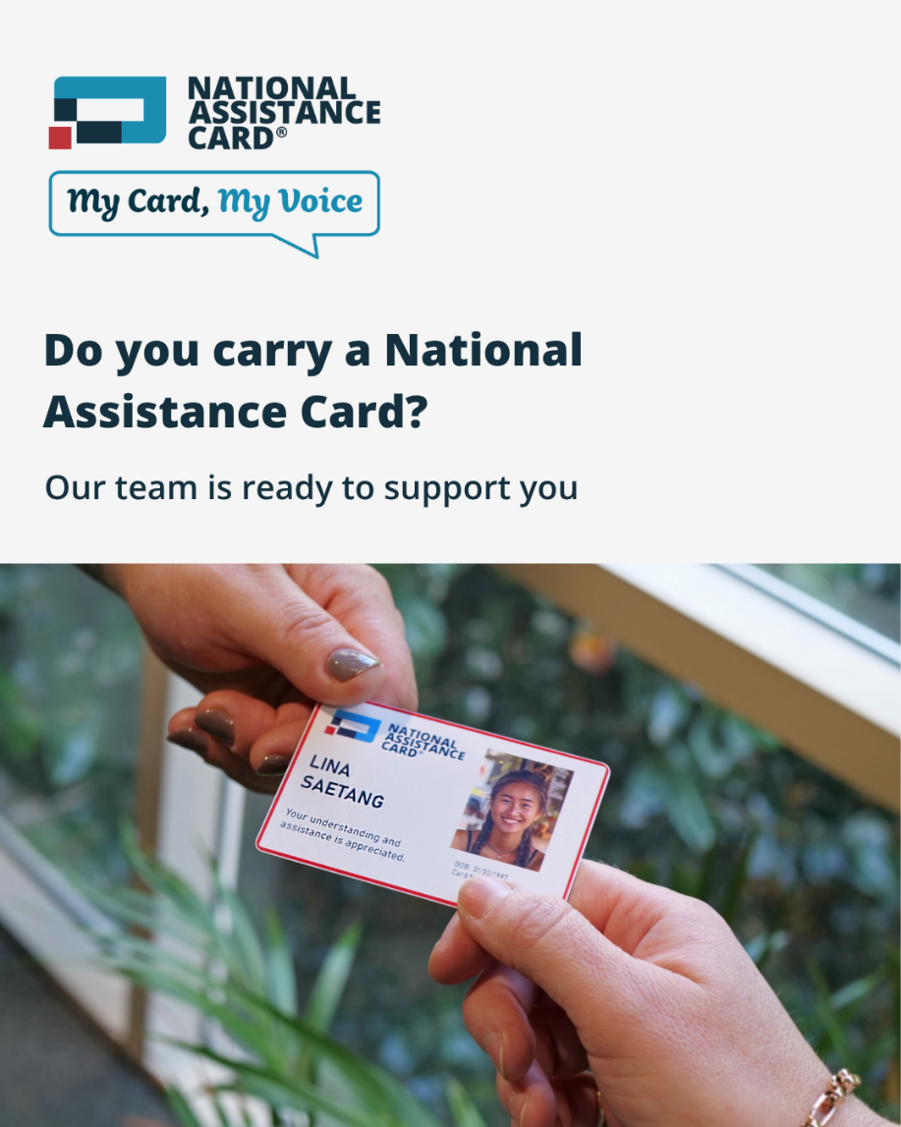

Click here to download the high quality image

We’re proud to support the National Assistance Card, a tool that helps people with disability communicate their needs and ask for help in emergencies.

To help our community stay safe, we’ve trained our teams to recognise and respond when someone shows their National Assistance Card. That means if someone needs help, our trained staff will be ready to assist. It’s a small but vital way we’re building a safer, more inclusive community.

The National Assistance Card is now available for all autistic people and people with brain injury across Australia. Learn more: www.nationalassistancecard.com.au

#MyCardMyVoice #NationalAssistanceCard
@nationalassistancecard

POST EXAMPLE 2: For LinkedIn

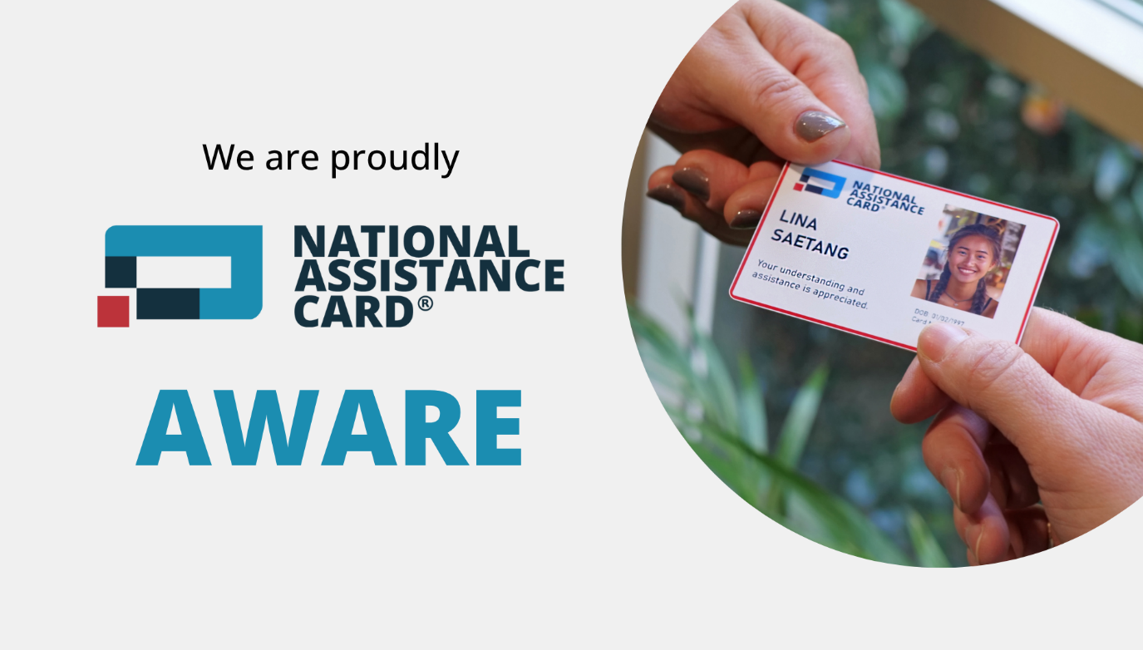

Click here to download the high quality image

We are committed to keeping our community safe, and that includes people with hidden disabilities.

Emergency situations can be stressful and unpredictable, and people who are non-verbal or have communication difficulties are at greater risk. That’s why we’ve trained our teams to recognise and respond to the @National Assistance Card, a tool used by autistic people and people with brain injury to communicate their needs during times of distress.

We encourage other emergency services and teams across Australia to become National Assistance Card-aware. Proper recognition and response can make a critical difference in the safety and wellbeing of the people we serve.

Learn more about the National Assistance Card: www.nationalassistancecard.com.au

