Sharing the National Assistance Card online

Sharing information about the National Assistance Card on social media can let autistic people and people with brain injury know that they can get the support they need.

How to share online:
When posting to social media, remember to use #MyCardMyVoice and #NationalAssistanceCard

And tag us
Instagram: @nationalassistancecard
Facebook: @ National Assistance Card
LinkedIn: @ National Assistance Card

POST EXAMPLE 1: For Instagram / Facebook

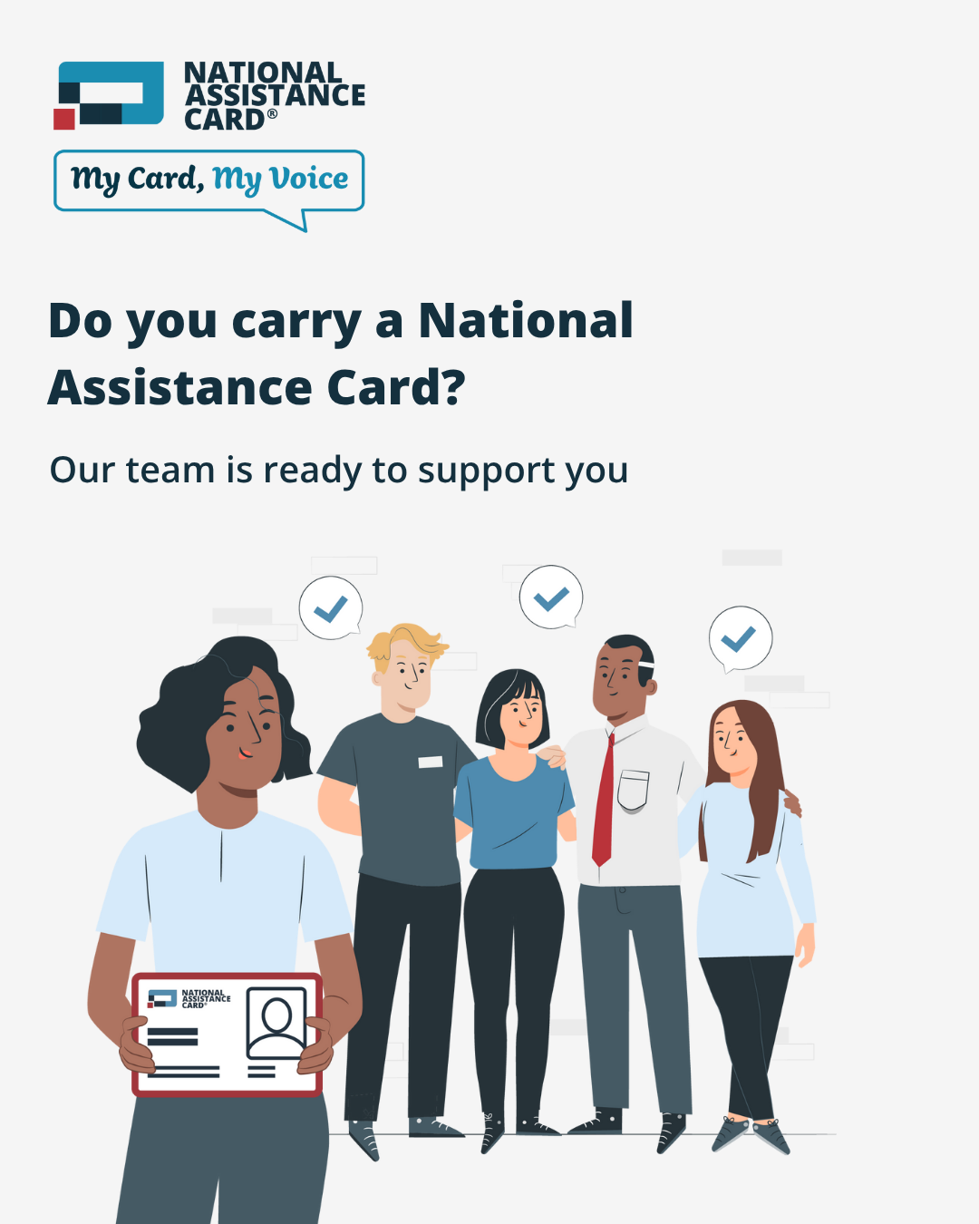
Click here to download high quality image

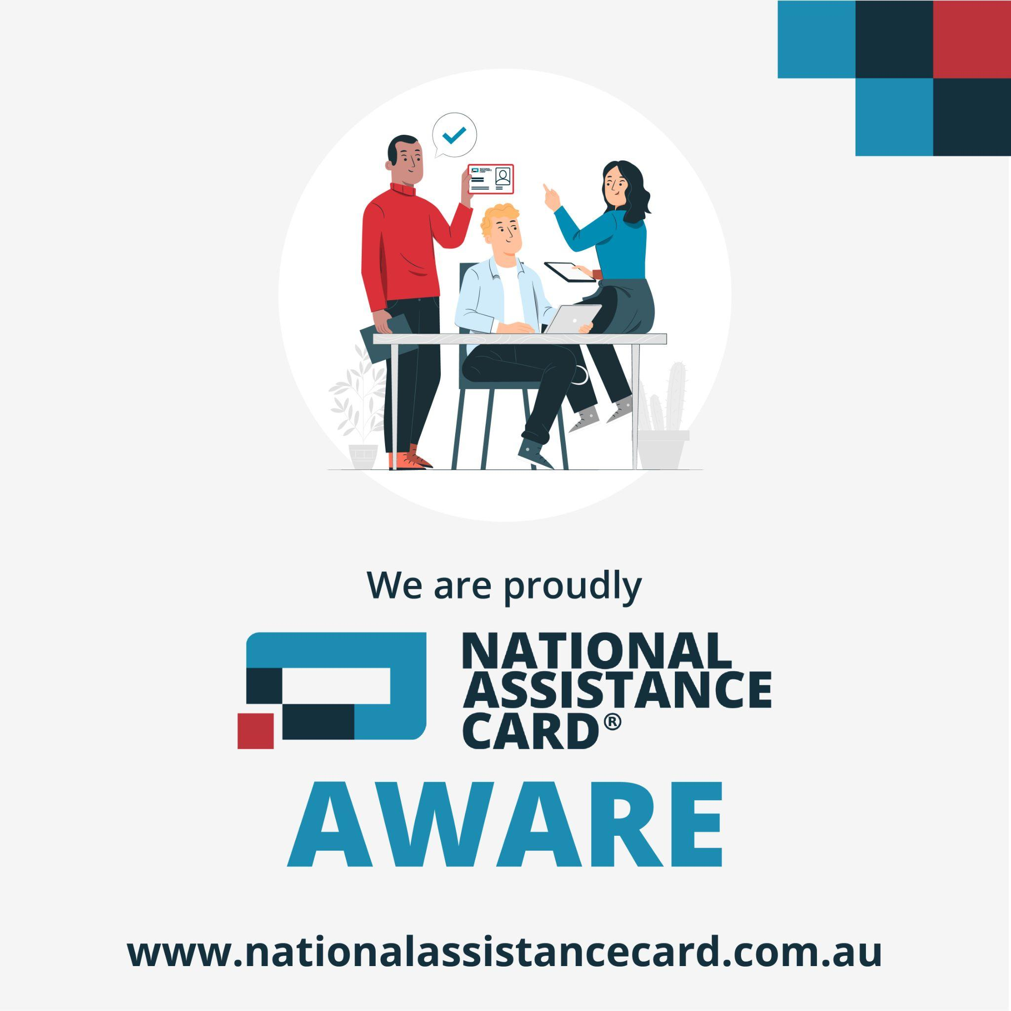
Click here to download high quality image

We’re proud to support the National Assistance Card, a tool that helps people with disability or health conditions communicate their needs in stressful or emergency situations.

To help our [customers/clients/community] feel safe and supported, we’ve trained our employees on how to recognise and respond when someone shows their @nationalassistancecard. That means, if you ever need help, our friendly staff will be ready to assist. It’s a small but important way we’re building a safer, more inclusive community for everyone.

The National Assistance Card is now available for all autistic people and people with brain injury across Australia. Learn more: www.nationalassistancecard.com.au

#MyCardMyVoice #NationalAssistanceCard
@nationalassistancecard

POST EXAMPLE 2: For LinkedIn

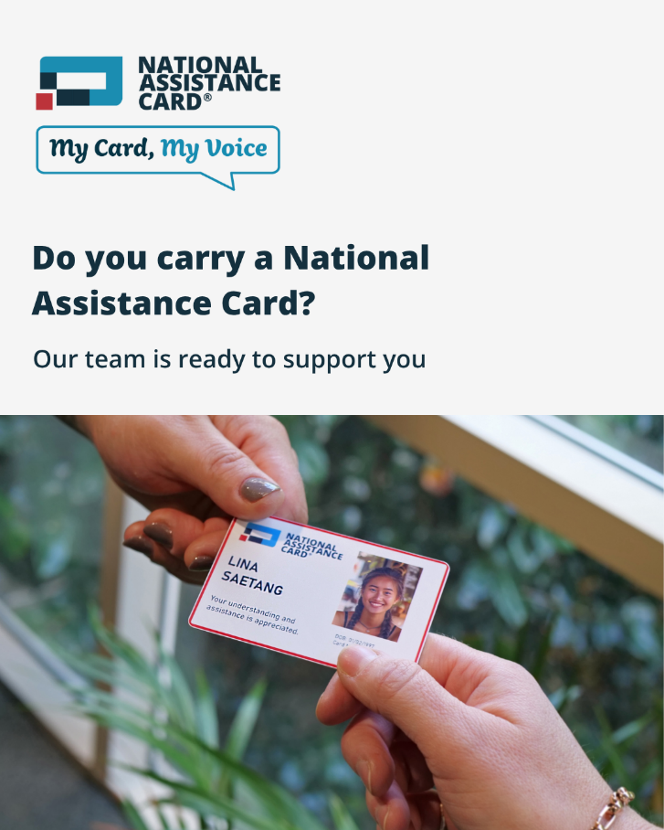
Click here to download high quality image

At [Business name], we’re committed to creating a safe and welcoming environment for everyone, including people with hidden disabilities.

That’s why we’ve trained our employees to recognise and respond to the @National Assistance Card, a tool that helps autistic people and people with brain injury communicate their needs in stressful or emergency situations.

Our team are here to provide support when it’s needed and make interactions safer and less distressing for people who have communication difficulties.

We encourage other businesses and employees across Australia to join us in becoming National AssistanceCard-aware”. Every trained staff member helps build a stronger, more inclusive community.

Learn more about the National Assistance Card here: www.nationalassistancecard.com.au

