EMAIL TEMPLATE 2 External email for people with disability or families and carers
Subject: Your Card, Your Voice – discover the National Assistance Card
Body:
Dear [Recipient name],
If you’ve ever found yourself in a situation where it’s hard to ask for help or explain your disability or health conditions, you’re not alone. Everyday activities, like going to the shops, attending appointments, and travelling, can be stressful, especially for people with communication difficulties or hidden disabilities.
The National Assistance Card can help. Now available for autistic people and people with brain injury across Australia, this personalised Card allows you to communicate your needs and request support when you need it most.
Here’s how it works:
- The Card includes information about you and the support you might need.
- You can show the Card to others when you need help in everyday situations or emergencies.
- You can choose to include a QR code on the Card. When scanned, it shows a personalised message from you with information on how others can help.
This is what the Card looks like. You can scan the QR code to see an example of the information people can add (video is optional).
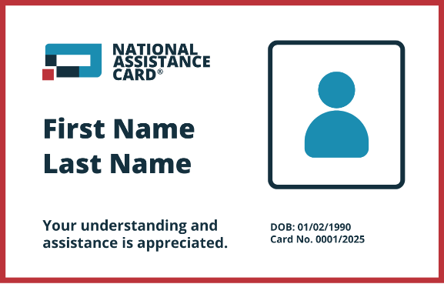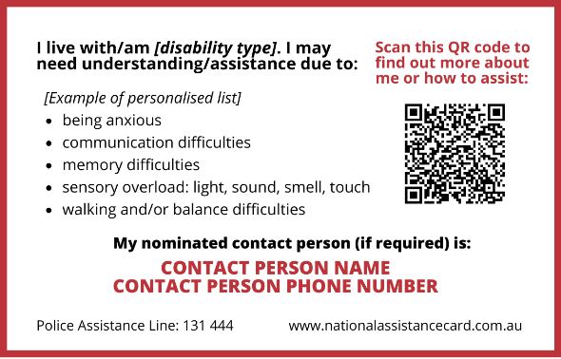
Click here to download high quality image
Getting your card is easy:
Visit www.nationalassistancecard.com.au/apply and follow the step-by-step instructions. You’ll need to provide a supporting document from a medical or allied health professional.
The National Assistance Card has helped many autistic people and people with brain injury feel more confident and independent. It’s a simple way to ensure your needs are understood wherever you go.
Learn more and apply today: www.nationalassistancecard.com.au
[Sign off]

