EMAIL TEMPLATE 1 Internal email for employees (business and government)

Subject: Supporting our community by recognising the National Assistance Card

Body:
Dear Team,

We want to share an important resource that helps make our workplace and services more inclusive for people with disability.

The National Assistance Card is a personalised card used by autistic people and people with brain injury to communicate their needs in everyday situations or times of stress. The Card can be presented in settings such as shops, offices, public transport, medical appointments, or in emergencies.

Here’s how you can help if someone shows you their card:
- Read the Card to understand the unique impacts of the cardholder’s disability
- Ask the cardholder how you can assist
- Scan the QR code if provided to access more information
- Help to contact emergency services or a nominated contact person if needed
This is what the Card looks like. You can scan the QR code to see an example of the information people can add.
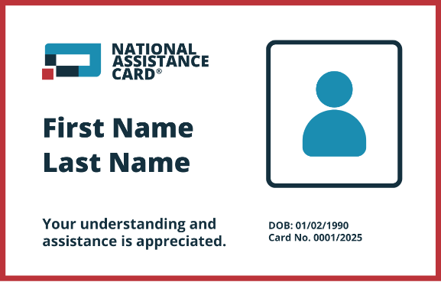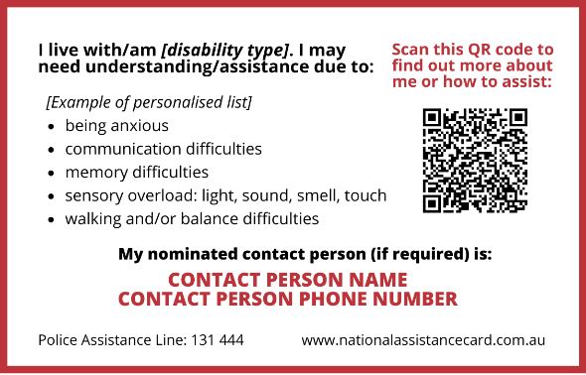
Click here to download high quality image

Recognising the Card and responding appropriately is a simple way to create a more inclusive, safe, and supportive environment for everyone.

Learn more about the card and how it works here www.nationalassistancecard.com.au

Thank you for helping us build a more accessible and understanding workplace.

[Organisation name]

