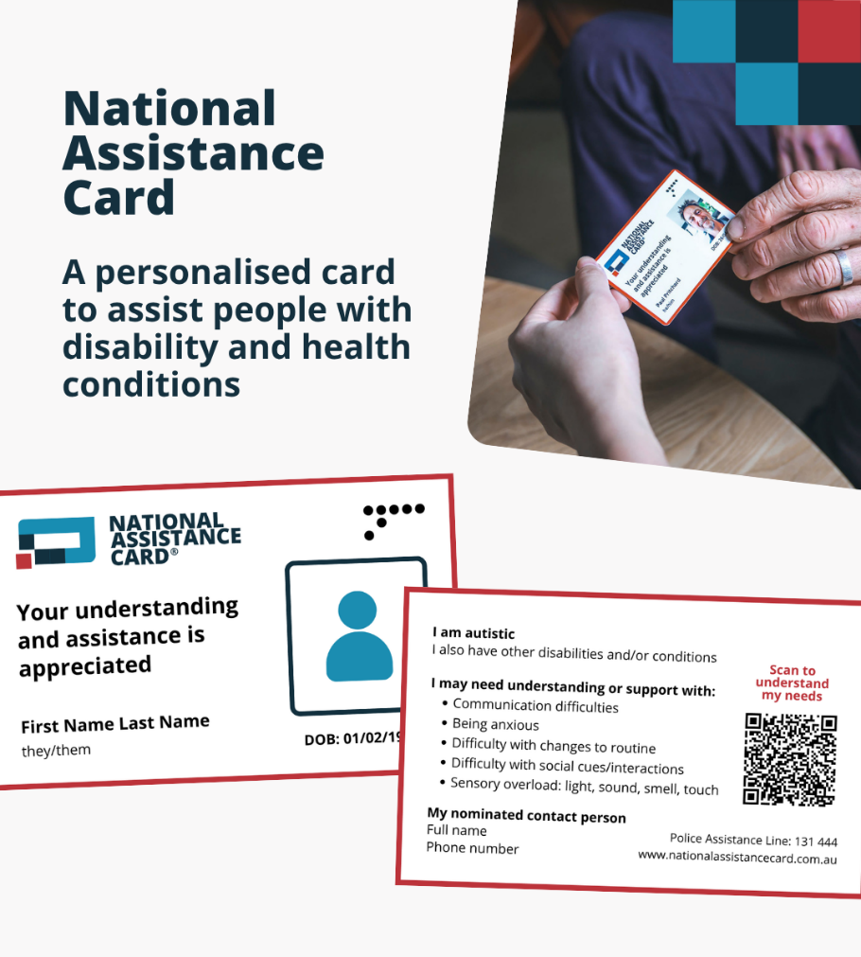
Click here to download the high quality image
Suggested wording:
Have you heard about the National Assistance Card? It’s now available for people with brain injury and Autistic people across the country.

The Card helps a person communicate their unique needs. This is useful for daily tasks, like shopping, or in emergencies.

Each Card is personalised. Cardholders can:
✔️ List the impacts of their disability on the Card
✔️ Add their own message to the QR code – written or video
✔️Add 2 support documents to the QR code, such as the Epilepsy Management Plan and Learning Support Plan

Current cardholders report that the Card gives them more confidence and independence. It makes them feel more comfortable accessing services in the community.

Find out more and apply: www.nationalassistancecard.com.au

