EMAIL TEMPLATE Internal email for employees (emergency services)

Dear Team,

As emergency service workers, you play a vital role in supporting our community. We want to share an important resource that helps make your work more inclusive and effective when responding to people with invisible disabilities.

Emergency situations can be especially challenging for people who find it difficult to communicate. The National Assistance Card is a personalised card used by autistic people and people with brain injury to communicate their needs in times of distress.

The Card has a distinct appearance:
- a white background
- a red border
- the cardholder’s photo
- the National Assistance Card logo.
This is what the Card looks like. You can scan the QR code to see an example of the information people can add.
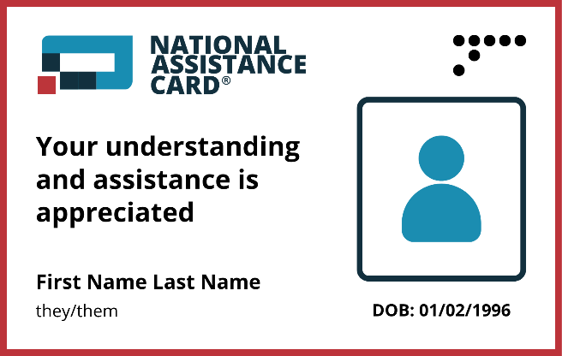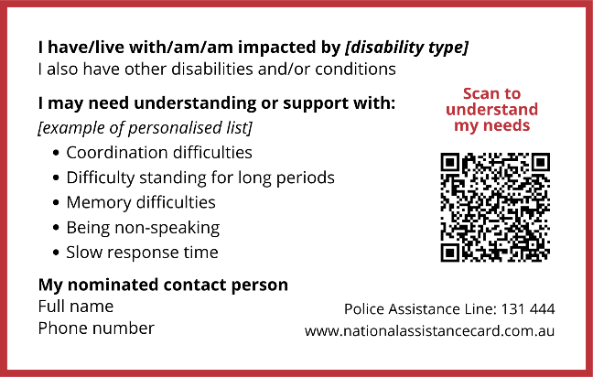
Click here to download high quality image
Here’s how you can help if someone shows you their card:
- Acknowledge you recognise the Card
- Read the card to understand the unique impacts of the cardholder’s disability
- Ask the cardholder how you can assist
- Scan the QR code if needed to access more information
- Call the cardholder’s contact person if requested or you need to.

It’s important that all emergency services personnel become familiar with the card.

You can watch and share this short video here: https://www.youtube.com/watch?v=V-OyncemJGE&t=2s

Thank you for helping build a safer, more supportive, and inclusive community. By recognising and responding to the National Assistance Card, you can ensure that people with hidden disabilities receive the help and understanding they need in times of emergency.

Learn more: www.nationalassistancecard.com.au

[Organisation name]

